# Name: ________________________

Hour: ____ Date: ___________

# Chemistry: *Stoichiometry and Baking Soda (NaHCO3)*

**Purposes:** 1. Calculate theoretical mass of NaCl based on a known mass of NaHCO3.

1. Experimentally determine the actual mass of NaCl produced.

3. Calculate the percent yield for your experiment.

**Reaction Equation:** NaHCO3(s) + HCl(aq) 🡪 NaCl(s) + CO2(g) + H2O(l)

**Materials:** safety glasses baking soda (NaHCO3) concentrated HCl and dropper

evaporating dish ring stand with ring bunsen burner and matches

watch glass wire gauze tongs

**Procedure:**

1. Find the mass of the evaporating dish and watch glass. Record this mass in the Data Table.

2. Add 1/3 of a teaspoon of baking soda to the evaporating dish, and record the total mass in the Data Table.

3. Cover the evaporating dish with the watch glass so that only the spout of the evaporating dish is exposed.

4. Use the dropper to drip HCl down the spout and into the dish. Add HCl until the fizzing ceases.

5. Leaving the watch glass in place, boil off the liquid until only table salt (NaCl) remains in the dish.

6. Let the dish cool for five minutes, then weigh it again and record the mass in the Data Table.

7. Clean up by rinsing your equipment with water and wiping dry with a paper towel.

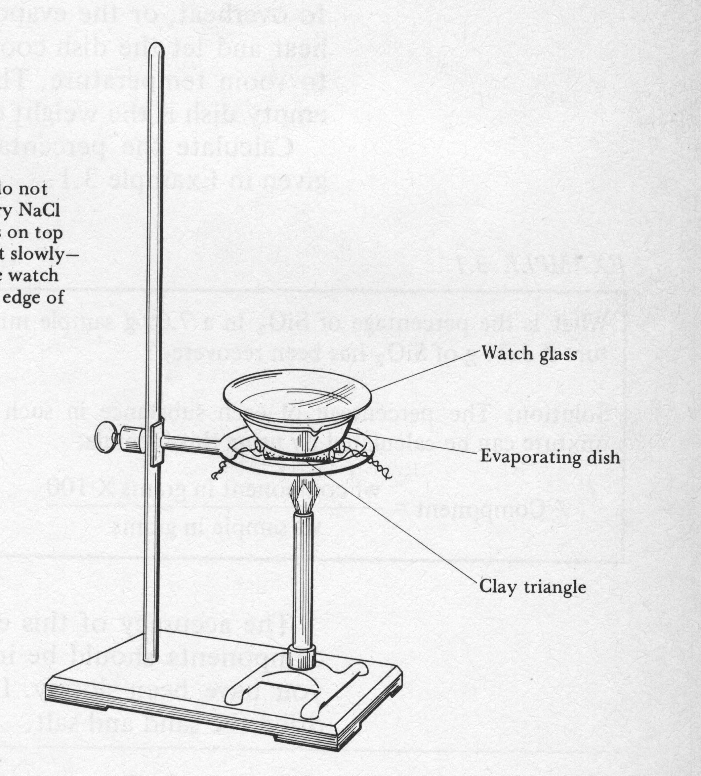

**Data Table: (please include units)**

|  |  |
| --- | --- |
| Quantity Measured | ***Mass*** |
| evaporating dish, watch glass |  |
| evaporating dish, watch glass, NaHCO3 |  |
| evaporating dish, watch glass, NaCl |  |

**Calculations:**

1. Find the theoretical mass of NaCl that would be produced if your experiment were perfect.

2. Find the actual mass of NaCl that you obtained.

3. Find the percent yield for your experiment. If your percent yield is greater than 100%, provide at least one possible source of error that might have caused you to get more than 100% yield.