APPC, Mechanics: Unit γ HW 1 Name: ________________________________________
Hr: ____ Due at beg of hr on: ______________

Uγ, HW1, P1
Reference Videos: (1) “Momentum Basics”
(2) “Momentum and Types of Collisions in Physics”
(3) “Types of Collisions in Physics (Part II)”
YouTube, lasseviren1, MOMENTUM playlist

A. In the first video, the narrator tells us that the prime symbol, i.e. ‘ , means…

B. Write the simplest equation for the conservation of total momentum.
Use ONE prime symbol and TWO vector symbols in your answer.

C. The equation you wrote in your Part B answer holds only if the ______ force on the system is __________.

D. For each type of collision, circle ALL correct answers.

i. elastic ii. perfectly (or completely) inelastic iii. (partially) inelastic

mechanical energy conserved mechanical energy conserved mechanical energy conserved

momentum conserved momentum conserved momentum conserved

objects bounce off each other objects bounce off each other objects bounce off each other

objects stick to each other objects stick to each other objects stick to each other

E. In each scenario below, a mass approaches a wall. For each type of collision, do the following:

i. Next to the mass at t₂, write the type(s) of energy present AND how many joules of each. In some
cases, you may need to MAKE UP reasonable values for energies; any possibly-true values are fine.

ii. Draw WHERE the mass would be at t₃. Again, write the type(s) of energy and how much of each.

elastic perfectly (or completely) inelastic (partially) inelastic
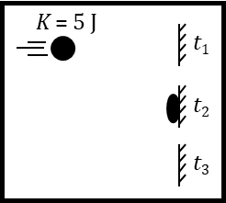

F. When using momentum conservation, there ARE forces exerted on various parts of the system. How-ever, these are _____________________ forces; therefore, the F_{net} ON the entirety of the system is still ________.

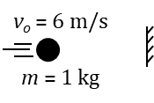
G. Based on the figure, determine the CHANGE in the mass’s momentum if:

i. the mass sticks to the wall ii. the mass bounces back with a speed of 3 m/s

Uγ, HW1, P2
Reference Video: “Collisions in Two Dimensions”
YouTube, lasseviren1, MOMENTUM playlist

A. Write equations for the following statements. You’ll need TWO vector symbols for each answer.

i. “Net force is the time-rate-of-change of momentum.”

ii. “Net force in the x-direction is the time-rate-of-change of momentum in the x-direction.”

iii. “Net force in the y-direction is the time-rate-of-change of momentum in the y-direction.”

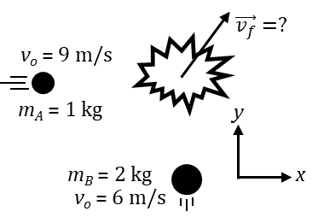
B. To summarize Part A: If there is a net force on a system, then the momentum of the system will be ______________________ with time; that is, the momentum of the system will be either ________________________ or ________________________ as time goes on. On the other hand, if the net force on a system IS zero, then the time-rate-of-change of momentum is __________, which means that ‘earlier’ and ‘later’ momenta are ____________. Only in this latter case is momentum ___________________________.

C. In the figure at right, two masses eventually collide in a completely inelastic collision. Determine each quantity below, showing your work.

i. x-momentum before the collision

ii. y-momentum before the collision

iii. Use your Part Ci answer to help you determine the x-comp-
onent of the combined mass’s velocity after the collision.

iv. Use your Part Cii answer to help you determine the y-comp-
onent of the combined mass’s velocity after the collision.

v. Use your Parts Ciii and Civ answers to deter-
mine $\vec{v_{f}}$ (both magnitude and direction).
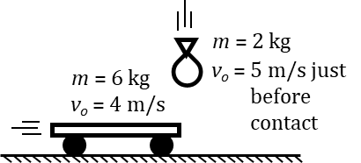
D. Circle your answers below. Assume ZERO friction between the cart and the floor.

We wish to find the final velocity of the cart-bag system. Therefore, the
cart bag floor is NOT a part of the system. What this means is that
(look at the picture!), any force that is exerted ON the cart bag floor BY the cart bag floor OR ON the cart bag floor BY the cart bag floor is NOT relevant to the analysis. The irrelevant forces you dealt with in the previous sentence act in the x y direction; therefore, in this collision, momentum will be conserved ONLY in the x y direction. To be clear, there ARE forces acting in the direction of momentum conservation, but these are internal external forces.

E. Now, determine the final velocity of the cart-bag system.

Uγ, HW1, P3
Reference Video: “Ballistic Pendulum Problems”
YouTube, lasseviren1, MOMENTUM playlist

A. According to the narrator, WHY – in ballistic pendulum problems – can you NOT use energy conservation exclusively? I.e., Why, at some point, MUST you use conservation of momentum?

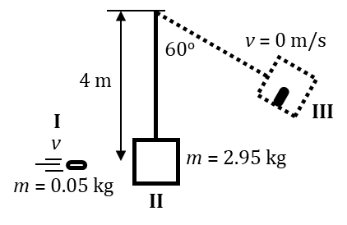
B. A bullet approaches the block of a ballistic pendulum at some unknown speed. Our ultimate goal is to determine this unknown speed. The bullet embeds in the block and the combination mass rises, as depicted. Somewhat ironically, we will work backwards in time...

i. What is the total mass at Point III?

ii. We now wish to find the ‘initial’ speed of the combined mass at Point II, just after the bullet has
embedded in the block and as the combined mass begins to swing toward Point III. Since the
collision has already happened AND because there is no friction
between Points II and III, we will use conservation of…

iii. Carry out your Part Bii answer and find the speed of the combined mass at Point II.

iv. Now, let’s start to find the incoming speed of the bullet, at Point I. To analyze
the bullet slamming into the block, we will have to use conservation of…

v. Explain your Part Biv answer. Why do we need THAT conservation law instead of some other?

vi. Use your answers to Parts Biii and Biv to determine the incoming speed of the bullet.

vii. Determine the number of joules of internal (basically, thermal) energy that are generated in the
collision between the bullet and the block.

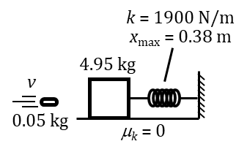
C. In this figure, the bullet becomes embedded in the block and then the spring
compresses. Again, work backwards in determining the following quantities:

i. the speed of the combined mass just before the spring starts to compress

ii. the speed of the incoming bullet

iii. the internal energy generated by the collision between the bullet and the block
Uγ, HW1, P4
Reference Videos: (1) “Review of Momentum (Part I)”
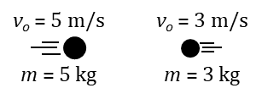
(2) “Review of Momentum and Impulse (Part II)”
YouTube, lasseviren1, MOMENTUM playlist

A. The masses shown collide and stick. Determine:

i. the final velocity of the two-mass system

ii. the impulse of the 5 kg mass on the 3 kg mass

iii. the impulse of the 3 kg mass on the 5 kg mass

iv. If the time of impact (before a common velocity is reached) is 0.5 s, find
the average force the 5 kg mass exerts on the 3 kg mass over that time.

v. Based on your Part Aiv answer, find the average force the
3 kg mass exerts on the 5 kg mass over the same time.

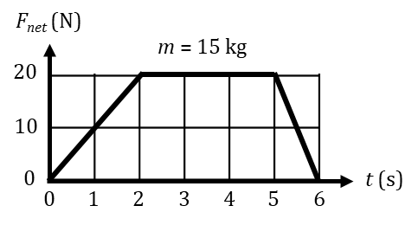
B.
If the initial velocity is –2 m/s,
find the final velocity.

C. A 2 kg mass has the momentum-time function $p\left(t\right)=2t^{3}-4t^{2}-2t+5$ . Determine the:

i. net force on the mass at t = 2 s ii. acceleration of the mass at t = 2 s

D. Initial and final velocity vectors are shown below. For each scenario, draw a vector to show the direction of the net force that must have acted. x- and y-velocity components are shown as dashed arrows. The tick-marks on the vectors give you an idea of a vector’s magnitude; basically, either one, two, or three units of magnitude. It may be helpful to lightly sketch plausible components of each net force vector and then Pythagorize these components using a darker line to show your final answer.
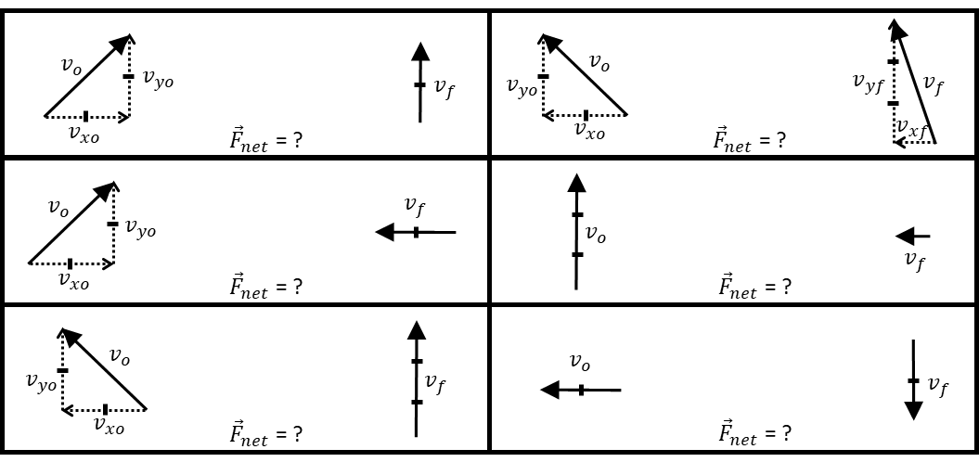

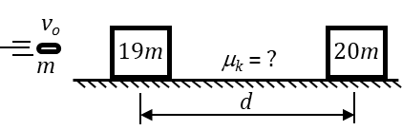
Uγ, HW1, P5
Reference Video: “Review of Momentum and Impulse (Part III)”
YouTube, lasseviren1, MOMENTUM playlist

A. The figure shows a bullet (mass m) heading toward a block (mass 19m) at a known speed v_{o}. After the bullet embeds in the block, the combined mass slides along a horizontal surface a distance d before stopping. Your ultimate goal is to derive an expression for the surface’s coefficient of friction μ_{k}.

i. In terms of v_{o}, determine the speed of the combined
mass v_{comb} immediately after the collision.

ii. State which conservation law you used in Part Ai. Also, explain WHAT IT WAS about the physical
situation that prompted you to use this particular law at this particular point in the analysis.

iii. State which conservation law you DIDN’T use in Part Ai, and tell why you DIDN’T use it.

iv. Use your Part Ai answer, a fundamental constant, and given quantities to find an expression for μ_{k}.

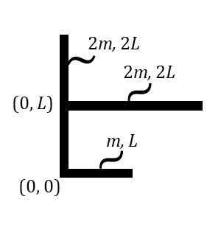
B. The object shown consists of three straight, connected bars: one of length L (and mass m) and the other two of length 2L (and mass 2m). One corner of the object is situated at the origin; one other coordinate is also given. The mass of each bar is uniformly distributed. Determine the coordinates of the object’s center of mass, i.e., determine its x_{com} and its y_{com}. HINT: Recall that any center-of-mass equation has the basic form: $z_{com}=\frac{1}{m_{tot}}\left(m_{1}z_{1}+m_{2}z_{2}+⋯\right)$ .

C. Two objects, I and II (not necessarily of equal mass), approach each other, collide, and
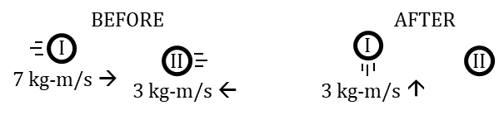
bounce off. Determine Object II’s final...
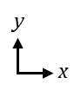
i. x-momentum
ii. y-momentum
iii. total momentum

Document your answers by drawing arrows on Object II in the AFTER depiction. Label
the three arrows with quantitative values. Also, draw in and label the angle of the total momentum.

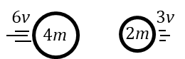
D. Use the general form of any center-of-mass equation
shown in Part B to determine the velocity of the center
of mass, i.e., the v_{com}, of the two-object system shown.

E. Suppose the objects of Part D collide in a perfectly inelastic collision. Use the conservation of momentum to show that the system’s v_{com} remains unchanged, after the collision.

F. In Part E, the objects DO exert forces on each other. Explain, then, why the v_{com} remains unchanged...?

