Rotational Mechanics Name: ____________________
A spinning object rotates about its...

Video
w03
(6:37)
translational motion:
--
-- object is considered to be a...

rotational motion:
-- object must be considered to be an _____________ _______
if the rotation is crucial to the motion

In translational motion, an object’s resistance to changing its state of motion is its...
-- the greater the mass...

In rotational motion, an object’s resistance to changing its state of motion is its...
-- also called rotational inertia
-- the more mass that is farther from the axis of rotation...

Moment of inertia formulas have been compiled for simple shapes, e.g.,
I = -- a solid sphere spinning about its central axis

I = -- a point mass M revolving at radius R

I = -- a hollow sphere rotating about its axis


I = -- a thin disc rotating about its axis

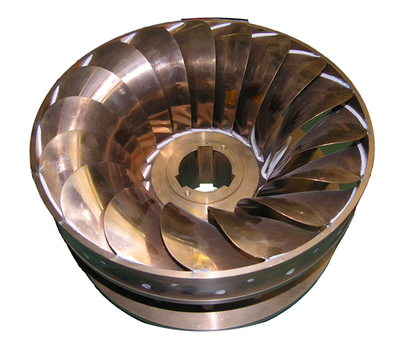
A large moment of inertia means that if the object is…
Video
w06
(8:35)
…rotating, then it “wants quite …NOT rotating, then it “wants quite
badly” to keep rotating. badly” to keep NOT rotating.

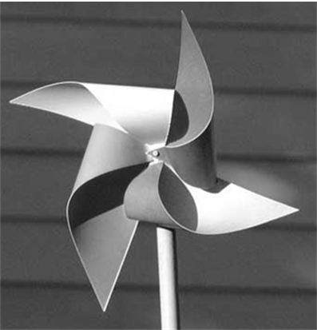
A small moment of inertia means that if the object is…
…rotating, then it “only kinda …NOT rotating, then it “only kinda
wants” to keep rotating. wants” to keep NOT rotating.

An object’s moment of inertia has NOTHING to do with the rotational speed of the object, but it
has EVERYTHING to do with the object’s mass and geometry (i.e., its physical configuration).

Video
w09
(4:00)
Angular Momentum If the mass of the Earth is 6.0 x 10²⁴ kg
and its mean radius is 6.4 x 10⁶ m, find
the mag. of the angular momentum of
the Earth as it spins on its axis.


A 68 kg man sits 3.2 m from the axis of a spinning wooden
Video
w12
(4:39)
plank of mass 95 kg and length 7.8 m. The axis goes
through the center of the plank, which spins at 1.3 rad/s.
Find the mag. of the angular momentum of this system.

Video
w15
(5:52)
Law of Conservation of Angular Momentum For a closed system, the angular
momentum of the system is conserved.
A merry-go-round of mass 115 kg and radius 2.0 m spins at 2.6 rad/s
Video
w18
(4:29)
while a 65 kg student stands at the edge. Find the new angular speed
after the student has moved to a distance of 0.50 m from the axis.

Video
w21
(4:36)
Rotational Kinetic Energy If the mass of the Earth is 6.0 x 10²⁴ kg
and its mean radius is 6.4 x 10⁶ m,
find the rotational kinetic energy of
the Earth as it spins on its axis.

Video
w24
(4:11)
torque: τ = torque (N-m)
**
F = applied force (N)
d = dist. between force & pivot pt. (m)
F
θ
d
EX. A 62 N force is applied to end of wrench. Force makes a 129º angle
^{w}/handle. Distance between force and bolt is 39 cm. Find mag. of the torque.

Video
w27
(7:47)
Newton’s 2nd Law for Rotation A football player applies a net torque of 0.082 N-m
to a football having a moment of inertia of
5.7 x 10^{–4} kg-m². If it starts from rest, what is the
angular acceleration of the ball over the time the
QB takes to throw it?

EX. A compact disc has mass 8.0 g and radius 6.0 cm. Starting from rest, the CD
speeds up to 220 rpm in 1.6 s. What net torque does the disc player apply to the CD?

Video
w30
(7:17)
Static 1. forces acting on AND 2. torques acting on
Equilibrium object are balanced object are balanced

EX. A 4.0 m horiz. beam is supported at ends. Point load of
1.0 x 10³ N acts 3.2 m from left end. Find support
reactions. Neglect beam’s mass.

A 12 m horiz. beam is supported at ends. point
Video
w33
(9:00)
loads of 3.0 x 10² N, 4.0 x 10² N, and 5.0 x 10² N
act 3.0 m, 5.0 m, and 7.0 m (respectively) from left.
Find support reactions. Neglect beam’s mass.

EX. Find support reactions. Neglect beam’s mass.
R_{A}
210 N
7.0 m
6.0 m
3.0 m
630 N
850 N
R_{B}

R_{A}
800 N
2 m
1500 N
R_{B}
4 m
2000 N
3 m
2 m
Video
w36
(8:51)
Find reactions. Ignore beam’s weight.

R_{A}
510 N
5.0 m
75 N/m
2.0 m
930 N
R_{B}
2.0 m
3.0 m
2.0 m
EX. A 14 m horiz. beam is supported at 4.0 m
and 12.0 m from left end. Point loads of
510 N and 930 N act 2.0 m and 9.0 m
(respectively) from left. Beam’s weight acts
as a uniformly distributed load of 75 N/m
along entire beam. Find support reactions.
R_{A}
510 N
2.0 m
930 N
R_{B}
2.0 m
3.0 m
2.0 m
To deal ^{w}/distributed load…

Concentrate distributed load into a point load
by taking...
This _______ N point load acts at centroid of
the dist. load.

