Fluids Name: _______________________
Video z03
(2:35)

fluid: a material ^{w}/the ability to
Video z06
(5:14)
flow and change shape

(mass) density, ρ =
 | Gases | Liquids
Particle spacing
Fixed shape?
Fixed volume?
Compressible?

Equation:

For a particular object:

For a particular fluid:

-- Unless we say otherwise, when we say “density,” we mean “mass density.”

-- In SI, the unit for density is…

-- In proper SI units, the density of water is…

Liquids and solids have “fixed” densities; gases don’t.

A substance’s specific gravity (γ) is a unitless number that compares Equation:
the density of that substance relative to the density of…

γ_{fresh water} γ_{iron or steel} γ_{aluminum}

γ_{salt water} γ_{mercury} γ_{ethanol}

EX. Given the specific gravities of steel and ethanol above, determine the densities of these
materials, using the proper SI units.

Video
z09
(4:12)
pressure: Equation:

SI unit for pressure:

At sea level, air pressure is about…
Pressure in Fluids
Video
z12
(8:36)

Fluid pressure _________ with depth because…

-- For gases in the atmosphere, pressure is greatest at…

→
→

-- For liquids, the pressure-depth relationship is linear because liquids are…
→

EX. Determine the pressure on the bottom surface of each tank, due to the water.

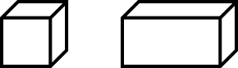
1 m x 1 m x 1 m 2 m x 1 m x 1 m

**

Gauge pressure equation:

Video
z15
(6:26)
P does NOT depend on total volume of liquid, only type of liquid, gravity, and depth.

The P in the equation P = ρ g h (i.e., the gauge pressure) does
NOT account for the pressure AT the liquid’s surface (from
gases above it). To find the total pressure (P_{tot}) at a given depth,
simply add the surface pressure (P_{o}) to the gauge pressure at that depth.

Total pressure equation:

EX. Given that the specific gravity of gasoline is 0.68, find both the gauge AND total pressures
1.4 m below the surface of a tank of gasoline that has air space at the top. Assume the air
pressure to be 101.3 kPa.

EX. Repeat the calcs for a depth of 2.8 m in gasoline.

Video
z18
(6:23)
submerged object floating object hole in side of container
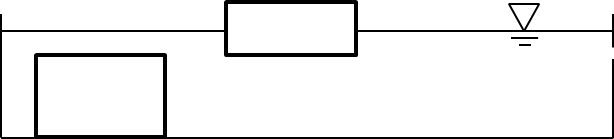

In a fluid, the pressure at a given depth is exerted…

→ And pressure always acts _______________ to any surface.
Video
z21
(4:29)

Fluids flow away from points of ________ P toward points of _________ P (even though
there might be quirky things happening ^{w}/P in btwn these pts; more on this later).

Video
z24
(9:13)
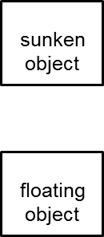
bouyant force, F_{B}:

-- F_{B} is the result of the difference in…

-- Pressures on the sides of the object…

-- The F_{B} on a completely submerged object is
NOT affected by…
-- F_{B} IS affected by…

Because of buoyancy, the net force on an immersed object is always the object’s weight.
Video
z27
(5:22)

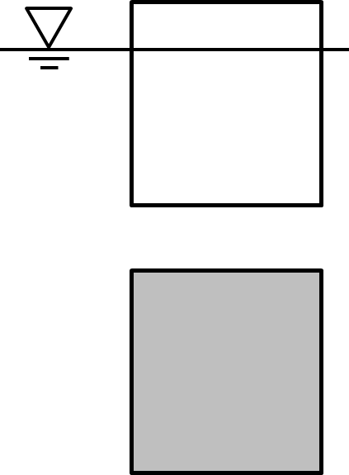

This net force we call the apparent weight (F_{app}). Equation:

Objects that are floating: weight buoyant force

Objects that aren’t: weight buoyant force

EX. A 43 kg rowboat is loaded with 185 kg worth of fishers and fishing equipment. What is the
buoyant force on the boat when it is out on the lake?

EX. A 28.4 g lead sinker used by a fisherman has an apparent weight of 0.254 N in water. Find
the buoyant force on the sinker.

Video
z30
(7:40)
Archimedes’ Principle Any object in a fluid experiences an upward buoyant force
equal to the weight of the fluid that the object displaces.

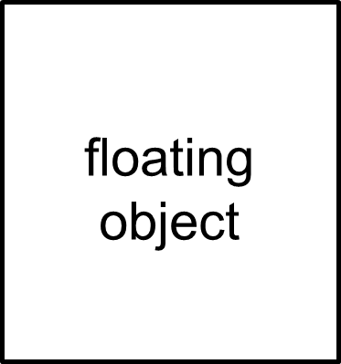
-- For a floating object:
→ the displaced fluid’s weight the object’s weight
→ the displaced fluid’s volume the object’s volume

Handy equation for floating objects:

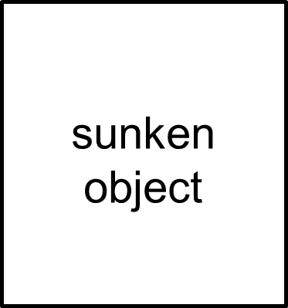
-- For a sunken object:
→ the displaced fluid’s weight the object’s weight
→ the displaced fluid’s volume the object’s volume

**
Equation for buoyant force:

From density, we see that… m_{df} = ρ_{f} V_{disp}, and so…

** It is the _________ of the immersed object, NOT its ____________, that affects the buoyant force.

A life preserver greatly increases “your” _________ but barely increases “your” ____________.
Video
z36
(3:59)
A floating tree trunk has
specific gravity 0.41 and a
volume of 0.79 m³. Find the
log’s apparent weight, the
buoyant force on it, and the
volume of water it displaces.

A solid copper cube – 0.112 m
Video
z39
(3:41)
on a side – is under water. Its
apparent weight is 109.16 N.
Find copper’s specific gravity.

Video
z42
(4:57)
Pascal’s Principle External pressure applied to a confined fluid is transmitted
equally to every point in the fluid.
e.g.,
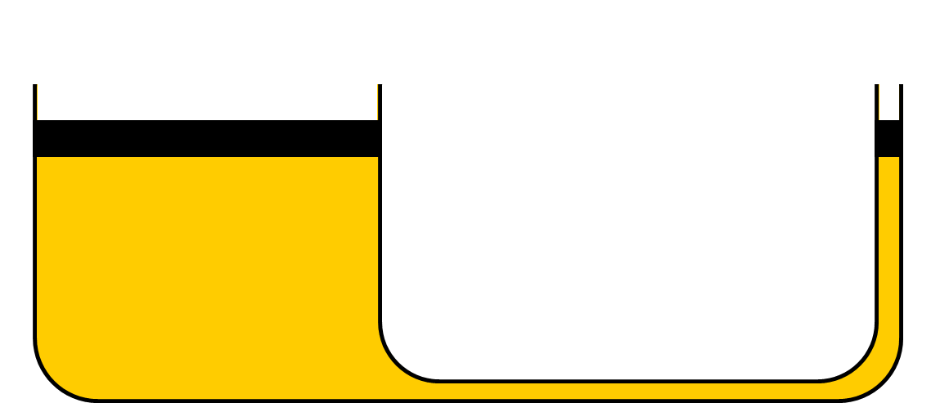
A hydraulic lift has two pistons, one that is
much larger in surface area than the other.

Equation:

The effect of a hydraulic lift is that we get to input a small force and transform it into a larger one,
but the price we pay is that…

** In physics, this is analogous to the behavior exhibited by…
A hydraulic lift’s pistons have areas of
Video
z45
(3:06)
0.0254 m² and 1.33 m². What minimum
force is needed for us to elevate a 1420 kg
car with the aid of the hydraulic lift?

EX. For the problem above, find
the pressure on each piston.

Video
z48
(2:10)
Fluids in Motion

flow rate:
-- units could be either OR

Video
z51
(3:40)
Two Types of Fluid Flow

laminar flow: each fluid “particle” perfectly follows the
model profile of
laminar flow in a pipe
particle just ahead of itself along a smooth
trajectory called a streamline

--
--

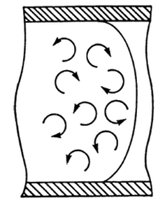
turbulent flow:

--
-- eddies (or vortices) are clear indicators of turbulent flow
--
Principles
of Fluid
Flow
For a fluid
Video
z54
(6:18)
confined flow rate at flow rate at
in a pipe: “EARLIER” POINT “LATER” POINT
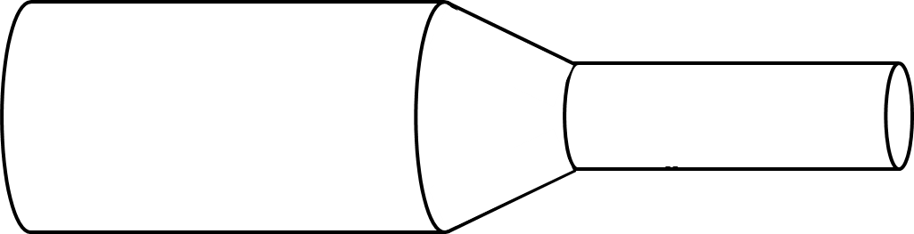

Using volumes…

The units here would be…
An equivalent expression, then, which deals with the cross-sectional areas of two different
points along the pipe – and the speeds of the fluids through those cross-sections – is called
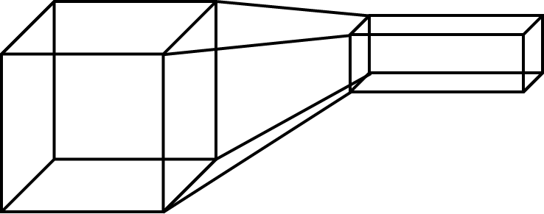
the continuity equation:

What are the units here?

Conceptual --
examples:
--

In a water-treatment plant, water
Video
z57
(2:26)
flows at 0.86 m/s through a 0.64 m
diameter pipe. Find the water’s
speed when this flow narrows
into a pipe of diameter 0.28 m.
Video
z60
(6:56)
Bernoulli’s Principle

For a fluid traveling // to a surface:
FAST
SLOW
-- FAST-moving fluids exert _____ pressure.
-- SLOW-moving fluids exert _____ pressure.

EX. airplane wing / helicopter propeller

Resulting Forces

EX. frisbee

EX. windows and high winds (e.g., tornadoes) EX. roof in a windstorm
TALL BUILDING

Video z63
(5:59)
Bernoulli’s principle can be rationalized in two ways:

1. Newton’s 2nd law 2. conservation of “energy”


a level pipe of varying diameter

For each pipe section, the sum
of the following is a constant:

-- “KE” from fluid’s motion

_____ speed _____ speed -- PE_{g} due to elevation of fluid

_____ pressure _____pressure -- PE due to fluid’s pressure
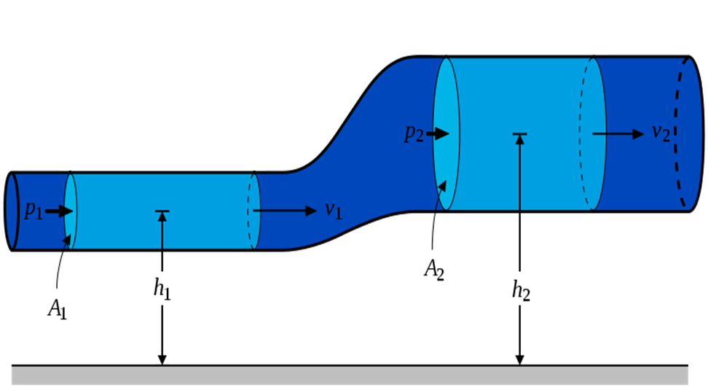

The conservation of energy idea brings
Video
z66
(6:26)
us nicely to the Bernoulli Equation (which
IS the conservation of energy, but with
units of pascals instead of _________).

EX. A level pipe carries water under pressure. At one point, the water’s speed is 0.48 m/s and its
pressure is 24,500 Pa. In an adjacent section, the pipe is constricted; the water’s speed
increases to 3.27 m/s. Find the pressure in the adjacent section.

A pipe carries water under pressure in a factory. At one point, the speed is 2.46 m/s and
Video
z69
(5:38)
the pressure is 31,500 Pa. In an adjacent section, the pipe is 1.75 m lower; there, the
pressure is 26,700 Pa. Find the speed in the adjacent section.

