Circular Motion and Gravity Name: _______________________
Video
703
(7:08)

axis: line about which circular motion occurs
rotation:
revolution:
Video
706
(6:04)
Angular Kinematics
angular displacement:

A spinning circle of
radius r…

The angular displacement Δθ of any part (or ALL) of a rotating object…

r
r
1 rad

radian: the angle subtended by an arc that is the same length as the

circle’s radius

Video
709
(4:01)
If arc subtended by basket between loadings is 3.8 m, find angular displacement, in rad.
r = 11.5 m
r = 7.5 m
Ferris wheel

Through what arc length does bear move, between stops?

If Ferris wheel rotates at constant In linear kinematics… In angular kinematics…
Video
712
(8:08)
angular speed, it takes 18 s to go
around once. Find avg. ang. speed.

EX. Same Ferris wheel takes 2.2 s to go In linear kinematics… In angular kinematics…
from rest to its avg. ang. vel. Find
mag. of its ang. accel.

Video
715
(4:58)
Find ang. speed of Earth:
-- spinning on its axis -- revolving around Sun

Angular Kinematics Linear Kinematics
Sign Conventions for
Δθ, ω, and α...
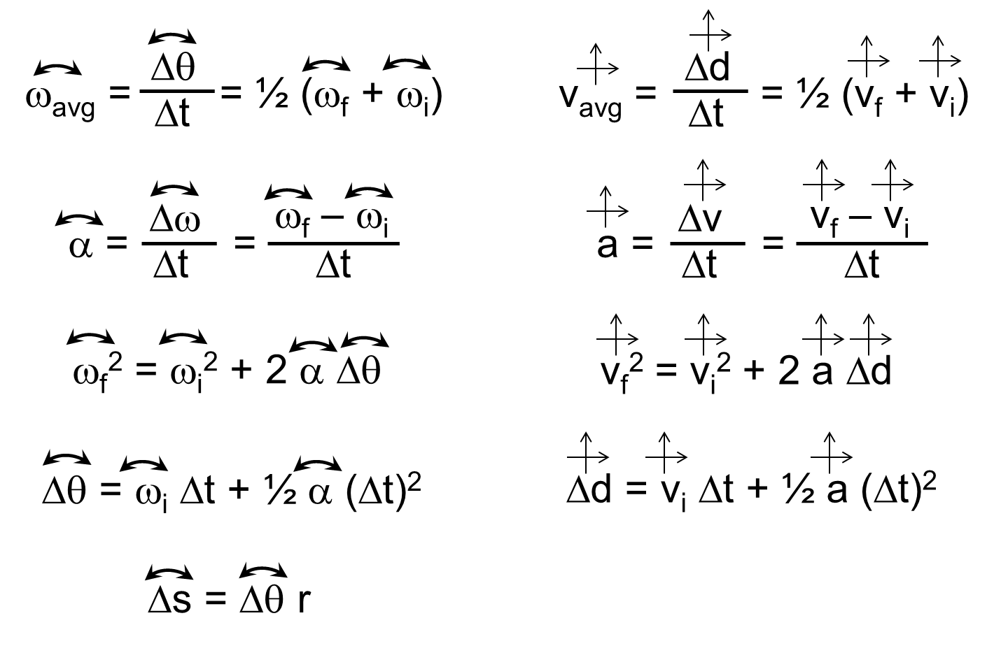

Car wheel initially rotates at 52 rad/s. After braking for 7.3 s, wheel is at rest. Find…
Video
718
(8:02)
a. …wheel’s avg. ang. accel.

b. …wheel’s ang. displ.

EX. Find mag. of ang. accel. of Earth… …spinning on its axis.

…revolving around Sun.

Video
721
(7:37)
Bike wheel ^{w}/outer radius 36 cm has init. ang. speed 5.2 rad/s. Wheel’s
speed increases to 9.8 rad/s. The ang. accel. has mag. 0.68 rad/s².

a. How much time elapses?

b. Find ang. displ. over this time.

c. Wheel goes around how many times?

d. What linear distance is covered?

$\text{tangential speed }=\frac{\text{linear distance}}{\text{time}}$
r
ω
v_{t}
Video
724
(5:50)

period, T: time (in s) to go around once
frequency, f: # of cycles in one second (Hz)

Since $ω=\frac{\text{ΔΘ}}{Δt}$ , then… and…
r
α
a_{t}

tangential acceleration:

Video
727
(5:20)
Bike wheel spinning initially at 5.8 rad/s speeds up to 9.3 rad/s over 15 s. Find tangential
acceleration for reflector and valve stem. (r_{stem} = 41 cm; r_{reflector} = 32 cm)

valve stem…

reflector…

EX. Find tangential speed after 15 s for both valve stem and reflector.

valve stem… reflector…

Video
730
(7:20)
Earth-Sun distance is 1.5 x 10¹¹ m. Find Earth’s linear speed around Sun, in m/s.

EX. Normal, IL is at 40.5º N latitude. Find tangential speed of Normal
Normal
axis
equator
6.38 x 10⁶ m
around Earth’s axis. Earth’s radius is 6.38 x 10⁶ m.

r
ω
v_{t}
a_{c}
Video
733
(9:36)
centripetal acceleration (a_{c}): acceleration toward the center

For circular motion, tangential acceleration (a_{t})
may be zero or nonzero…
(i.e., when α = 0)
but…

EX. Earth-Moon distance is 3.84 x 10⁸ m.
a. Find tangential and centripetal accelerations of Moon around Earth.

b. Find resultant (i.e., the net) acceleration of Moon.

a_{t} and a_{c} are component vectors of the net accel.
axis of
motion
object
a_{t}
a_{c}
Add like any two vectors.
a_{t}
a_{c}
a_{r}

c. Find tangential speed of Moon around Earth.

d. With what force does Earth pull on Moon? Mass of Moon is 7.36 x 10²² kg.
Recall Newton’s 2nd Law:
r
ω
v_{t}
a_{c}, F_{c}
centripetal force:

Video
736
(3:27)
2.6 kg stone at end of 0.74 m rope is whirled in horizontal
circle at constant rate. Period is 1.1 s. Find rope’s tension.

Video
739
(3:02)
At bottom of circular loop of radius 16 m, roller coaster car
(m = 250 kg) travels at 13 m/s. Find force of track on car.

Centrifugal Force
Video
742
(6:18)

centrifugal =
“Centrifugal force”: --
--
(aerial view)
axis
you
--

Consider an amusement park ride:
axis
axis
FROM YOUR FRAME
OF REFERENCE
FROM A BIRD’S FRAME
OF REFERENCE

EX. Student (m = 55 kg) rides bus moving 15 m/s around curve of radius 16 m
and is pressed against window. Find “centrifugal force” student senses.

Video
745
(6:43)
Gravity Brahe:
Kepler:
Kepler’s Laws:
1.
2.

3.
EX. Earth is 1.50 x 10¹¹ m from Sun; Jupiter is 7.78 x 10¹¹ m from Sun.
How long does it take Jupiter to go once around Sun?

Video
748
(4:50)
Newton:

Newton’s Law of Gravity
m = objects’ masses (kg)
r = separation between objects’ centers of mass (m)
G =

Cavendish:

EX. 45 kg girl and 53 kg boy are 14 m
apart at jr. high dance. Find force of
gravity acting to bring them together.

Video
751
(7:06)
Earth has mass 5.97 x 10²⁴ kg and radius 6.38 x 10⁶ m. Find force of
gravity on 34.0 kg rock.

For any object of mass m and mean radius r:
EX. Mars has radius 3.40 x 10⁶ m. If a 12.0 kg rover weighs 44.5 N on Mars, find mass of Mars.

What is g on Mars?

Video 754
(8:07)
Gravitational Field

-- arrow direction shows how a dropped object would accelerate
--


At the Earth’s surface…

Einstein’s Idea of Gravity: The General Theory of Relativity

Masses don’t attract other masses via gravity. Masses (especially, large ones) alter the “curvature” of space (and time) around them. The paths of nearby objects are then affected by this curvature of space. Thus, a dropped pencil falls – NOT because there is a force between its mass and that of the Earth – but because the space around the Earth is “curved” in a particular direction (i.e., downward) and the pencil must follow the curvature of space.

SUN

