Waves and Sound Name: ____________________

Simple Harmonic Motion
Video
903
(5:05)

restoring force:
When a stable system at equilibrium is tweaked, often
some kind of restoring force naturally kicks in.

In simple harmonic motion (SHM), the restoring force is directly proportional
to the displacement from equilibrium, i.e.,

As Δx , F . As Δx , F . When Δx = 0, F
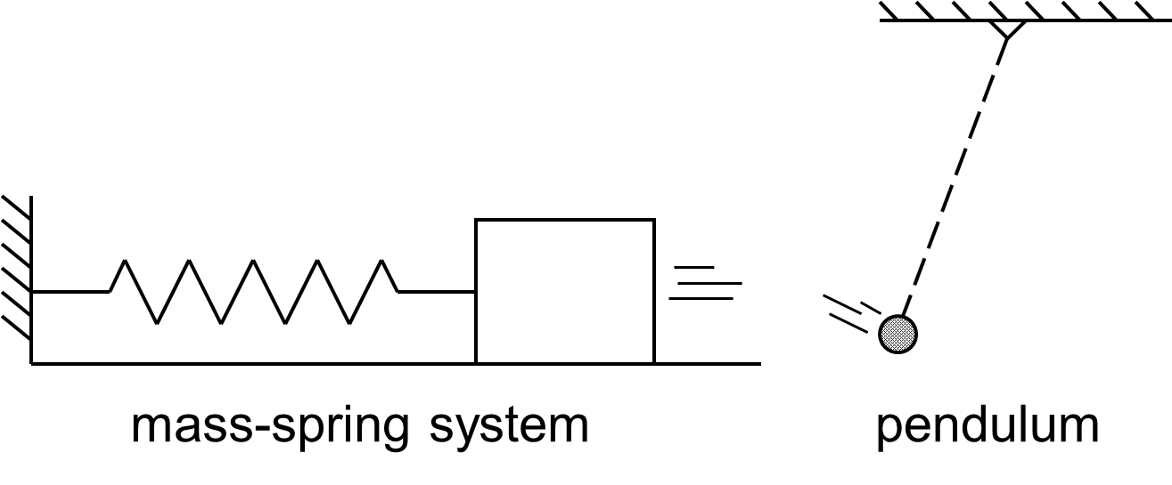

We will learn about two cases
that exhibit (or nearly so) SHM.

amplitude:
For m-s systems: For pendulums:
-- symbolized A -- symbolized θ
-- measured in -- measured in

Mass-Spring
wall
equilibrium position
frictionless floor
System
Video
906
(9:39)

Mass-Spring System
frictionless

Δx_{max} is better known as the…

At that point, we also have maximum…

Energy of a Mass-Spring System
Energy (J)

Video
909
(6:48)
Pendulum
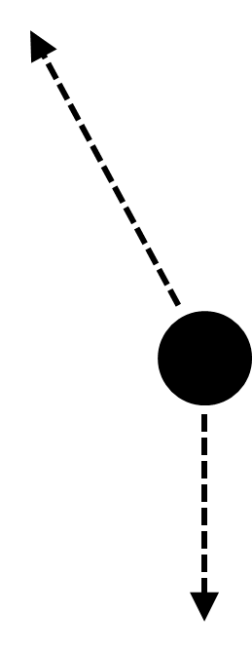
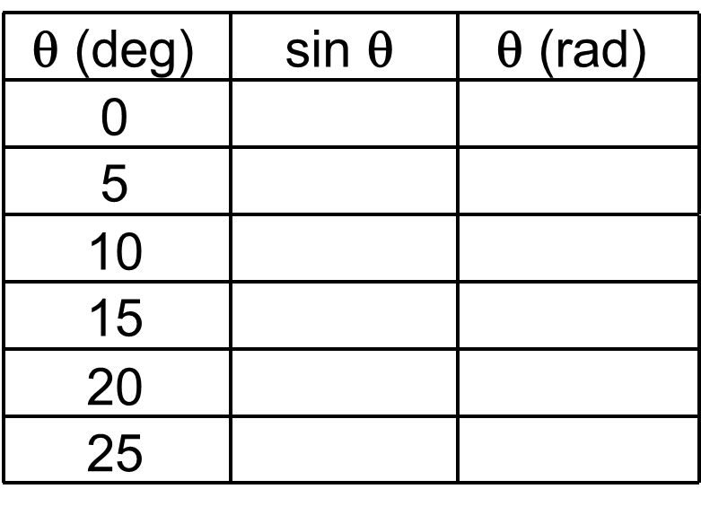

Energy of a Simple Pendulum
Energy (J)

period, T: frequency, f:

For mass-spring systems: m = mass (kg)
k = spring constant (N/m)

Video
912
(5:54)
A 5.5 kg cat is attached to a fixed horizontal spring of stiffness 22.8 N/m
and is set in motion on a frictionless surface. Find the period of motion of…

…the cat.

…a 120 g mouse, with the same spring and surface.

What stiffness must a spring have so that the period of the mouse’s motion is the same as
that of the cat?

A 1645 kg car carries two passengers with masses 75 kg and 86 kg. The
Video
915
(4:26)
car has four shock absorbers, each with a spring constant of 1.7 x 10⁴ N/m.
Find the freq. of the vehicle’s motion after it hits a pothole.

For simple pendulums: Period T is independent of…
Video
918
(6:44)
EX. The period of a pendulum is 5.2 s. Find…

A. …its length

B. …the mass of the bob

EX. On Io, a moon of Jupiter, a 0.87 m pendulum has a period of 8.74 s. What is g on Io?

Video
921
(7:13)
Waves → vibrations moving through space and time

medium: the matter through which the energy of mechanical waves moves

transverse waves: particles of medium move
to direction of wave travel

longitudinal (compressional) wave: particles of
medium move to direction of wave travel

pulse wave:
vs. periodic wave:

Video 924 (2:27)

For mechanical waves: If A doubles, energy…
If A triples, energy…
If A drops to, say, 35% of the original level, energy…

Wave Reflection fixed boundary vs. free boundary
Video
927
(2:55)

Wave Interference Two waves (unlike two objects) can occupy the same place at the same time.
Video
930
(4:06)
constructive interference: destructive interference:

Video 933
(6:18)
Wave Velocity Equation: v (m/s); f (Hz); λ (m)

EX. A wave of wavelength 8.5 m washes past a boat at anchor every 4.75 s. Find wave’s velocity.

The speed of any mechanical wave depends only on
the properties of the medium through which it travels.
e.g.,

The speed of sound in air is related to the air temperature:

Standing Waves Incident and reflected waves interfere to produce an unchanging wave
pattern. Antinodes have a max. amplitude, while nodes have zero amplitude.
Video
936
(5:24)

Standing waves are most
easily visualized on a string,
where nodes remain
motionless and antinodes
go from max. (+) to
max. (–) displacement.

wavelength of the n^{th} harmonic on a string:

EX. Waves travel along a 96.1 cm guitar string at 492 m/s. Find fundamental frequency of string.
Video
937
(4:06)

Find the frequency of the 5th harmonic.

frequency of the n^{th} harmonic:

Video
939
(6:35)
Standing Waves in Open Tubes Closed Tubes

wavelength of the wavelength of the
n^{th} harmonic of an n^{th} harmonic of a
open tube: closed tube:

EX. Find fundamental freq. for an open tube of length 1.24 m. Air temp. is 20.0ºC.

EX. Find fundamental freq. for a closed tube of length 1.24 m. Air temp. is 20.0ºC.

doubling (or halving) of frequency =

100 Hz 200 Hz 400 Hz 800 Hz

Video
942
(6:42)
Sound compression:
rarefaction:



20 Hz 20,000 Hz

Fundamental frequency determines pitch.

high f = low f =

The # and intensity of an instrument’s harmonics give it its unique sound quality, or _______.
f₁ f₂ f₃ f₄
f₁ f₂ f₃ f₄
f₁ f₂ f₃ f₄
f₁ f₂ f₃ f₄

The Doppler Effect Relative motion between wave source and observer
Video
945
(5:27)
causes a change in the ____________ frequency.

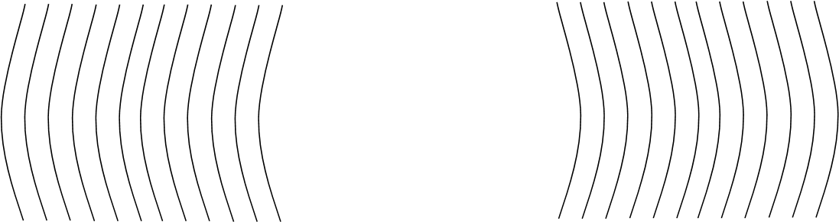

Sun
most stars
R O Y G B V
Other examples of
the Doppler effect:

Video 948 (4:54)
Traveling Very Fast

supersonic: “faster than sound” (vs. subsonic)

shock wave:
sonic boom:

Sound Intensity Equation:
Video 951
(3:30)

EX. If a piano’s power output is 0.302 W, find the sound intensity at a distance of…

A. …1.0 m B. …2.0 m

Video 954
(4:31)
Intensity is related to volume (or relative intensity):

--
-- measured in decibels (dB)

A difference of 10 dB changes the
sound intensity by a factor of 10 50 dB vs. 40 dB 60 dB vs. 90 dB
and the volume by a factor of 2.

Beats → alternating loud-and-soft
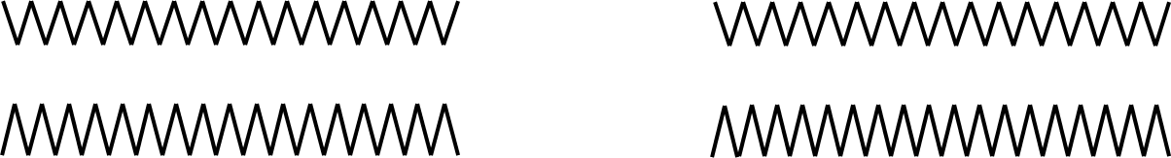
sounds resulting from
Video
957
(5:16)
interference between two
slightly-different frequencies

Equation:

Forced Vibrations and Resonance
Video
960
(5:50)

natural frequency:

forced vibration:
resonance:

-- result of resonance =

Examples:

