*Mathematics Review*

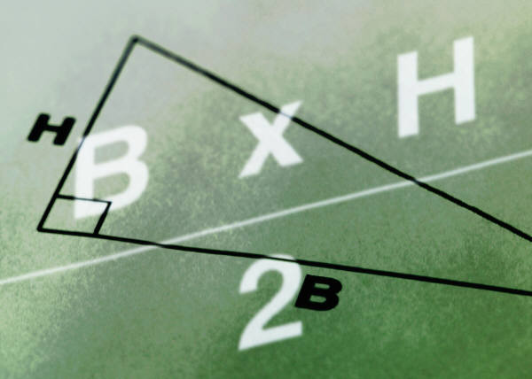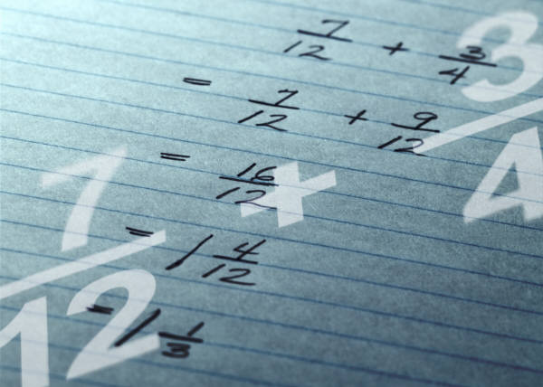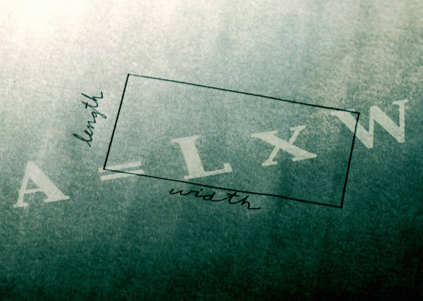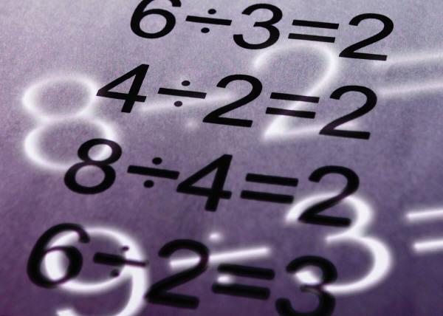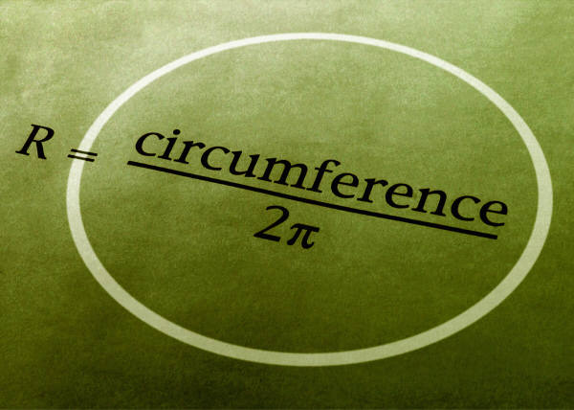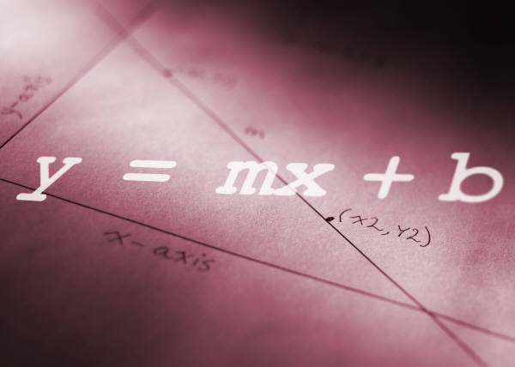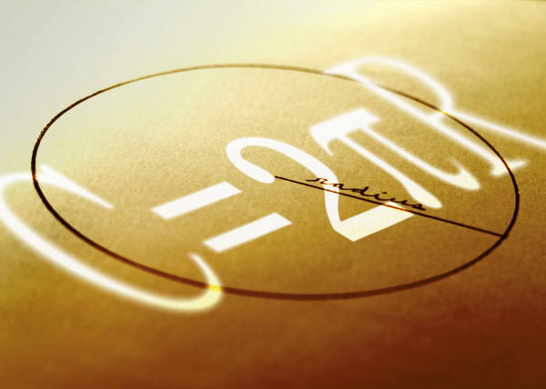

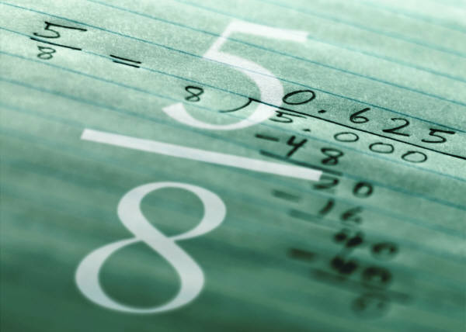

# Table of Contents

Table of Contents 2

Objectives 3

SI Prefixes and Conversions 4

Scientific or Exponential Notation 4

Significant Digits 5

Performing Mathematical Operations 5

Addition and Subtraction 5

Multiplication and Division 5

Scientific Notation 6

Solving Algebraic Equations 6

Example 1 6

Trigonometry of Right Triangles 7

Elements of a right triangle 7

Trigonometric Functions 7

Determining lengths of sides 7

Determining angle measures 7

Pythagorean Theorem 8

Radians 8

Converting From One Unit to Another 9

Example 1 9

Example 2 9

Example 3 9

Practice – Scientific Notation 10

Practice – Significant Figures 10

Practice – Solving Algebraic Equations 11

Practice – Right Triangle Trigonometry 11

Practice – Converting From One Unit to Another 12

Answers 13

Answers – Scientific Notation 13

Answers – Significant Figures 13

Answers – Solving Algebraic Equations 14

Answers – Right Triangle Trigonometry 14

Answers – Using Conversion Factors 14

# Objectives

The following is a list of skills that a student entering physics should have learned in previous math and science classes. You are responsible for this material for the duration of this course.

1. Memorize the meaning and symbols of the following SI prefixes: Giga-, Mega-, kilo-, centi-, milli-, micro-, nano-, pico-. These will be used throughout the year and you are expected to know them.
2. Convert numbers between decimal form and scientific notation.
3. Multiply, divide, add, and subtract numbers in scientific notation with a calculator.
4. Identify the number of significant digits in a measurement.
5. Properly apply rules for significant digits in performing calculations.
6. Use unit cancellation to convert from one unit to another.
7. Algebraically manipulate equations to solve for a given variable.
8. Use the trigonometry of right triangles (Pythagorean Theorem and sine, cosine, and tangent functions) to determine relationships between angles and sides of triangles.
9. Create and interpret graphical representations of data.
10. Know how to use a scientific calculator and its various functions.

# SI Prefixes and Conversions

Prefix Symbol Value Example Conversions using the meter

exa E 1018 1018 m = 1 Em or 1 m = 10–18 Em

peta P 1015 1015 m = 1 Pm or 1 m = 10–15 Pm

tera T 1012 1012 m = 1 Tm or 1 m = 10–12 Tm

giga G 109 109 m = 1 Gm or 1 m = 10–9 Gm

mega M 106 106 m = 1 Mm or 1 m = 10–6 Mm

kilo k 103 103 m = 1 km or 1 m = 10–3 km

hecto h 102 102 m = 1 hm or 1 m = 10–2 hm

deka da 101 101 m = 1 dam or 1 m = 10–1 dam

standard unit (e.g.,gram, etc.) 100 100 m = 1 m

deci d 10–1 10–1 m = 1 dm or 1 m = 101 dm

centi c 10–2 10–2 m = 1 cm or 1 m = 102 cm

milli m 10–3 10–3 m = 1 mm or 1 m = 103 mm

micro  10–6 10–6 m = 1 m or 1 m = 106 m

nano n 10–9 10–9 m = 1 nm or 1 m = 109 nm

pico p 10–12 10–12 m = 1 pm or 1 m = 1012 pm

femto f 10–15 10–15 m = 1 fm or 1 m = 1015 fm

atto a 10–18 10–18 m = 1 am or 1 m = 1018 am

# Scientific or Exponential Notation

1. Often, it is desirable to express very large and very small numbers exponentially. In scientific notation, numbers are expressed as the product of a number and 10 raised to some power. A power, or exponent, tells how many times a number is repeated as a factor.

102 (ten repeated as a factor two times) = 10 x 10 = 100

103 (ten repeated as a factor three times) = 10 x 10 x 10 = 1000

105 (ten repeated as a factor five times) = 10 x 10 x 10 x 10 x 10 = 100,000

1. By definition, any number raised to the zero power = 1, so 100 = 1.
2. By definition, any number with a negative exponent indicates the reciprocal of the same number with a positive exponent.

10–1 = = = 0.1 10–3 = = = 0.001

1. Examples: 106 = 1,000,000 10–1 = 0.1

105 = 100,000 10–2 = 0.01

104 = 10,000 10–3 = 0.001

103 = 1,000 10–4 = 0.000 1

102 = 100 10–5 = 0.000 01

101 = 10 10–6 = 0.000 001

100 = 1

1. Numbers that are not whole number powers of 10 may be written as a product of two numbers, the first being a number equal to or greater than one and less than 10, and the second being a power of 10. In proper scientific notation, the first number is always written with only one figure to the left of the decimal point.

5400 = 5.4 x 1,000 = 5.4 x 103

627 = 6.27 x 100 = 6.27 x 102

1,637,000 = 1.637 x 1,000,000 = 1.637 x 106

0.0037 = 3.7 x 0.001 = 3.7 x 10–3

0.00059 = 5.9 x 0.0001 = 5.9 x 10–4

1. Entering numbers in scientific notation into your calculator:
   1. To enter the number 5.4 x 103 into your calculator, enter **5.4**, then press the or key followed by the number **3**. [Do not press ‘x’ or the number ‘10’.]
   2. To enter 3.7 x 10–3 into your calculator, enter **3.7**, press the or key followed by the key and the number **3** (On some calculators, the number must be pressed before the key; make sure you know how your model works.)
   3. Many calculators display scientific notation with an “E.” In other words, 5.4 x 103 is displayed as 5.4E3. You may use this convention as well.

# Significant Digits

**In science, the numbers used in calculations are assumed to be measured values**. Since there is no perfect measuring tool, all measurements contain **uncertainty**. We will assume (as does the entire scientific community) that the last digit of a measurement is an estimate, and therefore contains uncertainty. Statistical methods are used to address these uncertainties and provide meaningful results, but simple rules have been developed to help us obtain meaningful results in our calculations. These rules help us to determine which digits are significant(or meaningful) and which digits we can discard.

1. All non-zero digits are significant. (56.1 has three significant digits)

2. Zeros between significant digits are significant. (3.1008 has five significant digits)

3. Any zero at the right end of a number and to the right of the decimal point is significant. (4.320 has four significant digits, but 4,320 has only three)

4. Zeros whose function is simply to space the decimal point are not significant. (400 has only one significant digit and 0.0026 has only two significant digits)

**Alternatively, you can use the Box and Dot method:**

Place a box around all digits from the leftmost to the rightmost nonzero digit. If a decimal point is located anywhere in the number, also box in all zeros at the right end of the number. All boxed digits are significant.

## Performing Mathematical Operations

### Addition and Subtraction

Add or subtract quantities, then round answers to the placevalue of the least precise place value of the quantities involved (4.1 is precise only to the tenths place. If 4.1 is the least precise value being added or subtracted, then the answer should be rounded to the tenths place.)

Ex: 11.31 m + 33.264 m + 4.1 m = 48.674 m (what your calculator will display)

= 48.7 m (the number rounded correctly)

***Round your answer to the least precise place value.***

### Multiplication and Division

Multiply or divide quantities, then round answers to the number of digits in the value that contained the fewer number of significant digits (If 3.24 is the quantity with the fewest number of significant digits, then the answer should be rounded so it contains only three significant digits.)

Ex: 50.284 m ÷ 3.24 m = 15.519753086 m (what your calculator will display)

= 15.5 m (the number rounded correctly)

***Round your answer to the fewer number of significant digits.***

Note: Physical Constants and multiplying factors are not taken into consideration when determining the number of significant digits in your answer.

### Scientific Notation

To obtain the correct number of significant digits, you may need to state a number in scientific or exponential notation. For example, if after calculating, you arrive with a value of 4000 m, but your answer needs 4 significant figures, you will need to rewrite your answer in scientific notation. 4000 m only has one significant digit (see Rule 4 above), but when rewritten as 4.000 x 103, you now have a value that contains the required number of significant digits (see Rule 3 above).

# Solving Algebraic Equations

To solve an algebraic equation for a specific term, rearrange the equation to:

1. Get the term into the numerator, and then…
2. Isolate the term on one side of the equation.

Follow the steps listed above to find the value of the term '**a**' in the equation F = ma.

1. '**a**' is already in the numerator.
2. Isolate '**a**' by dividing both sides of the equation by '**m**'. Remember what you learned in algebra - "Whatever operation you perform on one side of an equation, you must also perform on the other side of the equation."



'm' cancels out on the right side of the equation, leaving .

The unknown (the variable you are solving for) is usually placed on the left side.

Therefore, .

Note: Know how to solve for a variable within a radical (square root sign) by squaring both sides of the equation, or within the trig functions (i.e., sin, cos, and tan) by undoing the trigonometric function (with sin–1, cos–1, and tan–1, respectively).

### Example 1

Solve the following equation for the term '**x**': 

1. Get '**x**' into the numerator by multiplying both sides of the equation by '**x**'.



In step a), '**x**' cancelled out on the left, leaving '**x**' in the numerator on the right.



1. Isolate '**x**' by multiplying both sides of the equation by .



The terms '**c,**' '**b,**' and '**s**' cancel out on the right side of the equation, leaving



Rewrite with '**x**' on the left side: 

# Trigonometry of Right Triangles

## Elements of a right triangle

A right triangle contains one 90˚ angle. The angles are labeled A, B, and C. The side opposite angle A is side a. The side opposite angle B is side b, and likewise for angle C.



## Trigonometric Functions

Three common ratios for right triangles are sine (sin), cosine (cos), and tangent (tan). The following equations show the ratios for the triangle above.

Sin (angle) = SOH sin A =

Cos (angle) = CAH cos A =

Tan (angle) = TOA tan A =

## Determining lengths of sides

Determine the lengths of sides a and b in the above diagram if angle A is 30˚ and the length of the hypotenuse is 8 cm. (Note that, in this case, you will only have one significant figure in your answers.)

Side A Side B

1)  1) 

2)  2) 

3)  3) 

4)  4) 

## Determining angle measures

Determine the value for angle B in the above diagram if side a = 11 cm and side b = 15 cm.

1) We know that side b is opposite to angle B and side a is adjacent to angle B.

2) Tangent (angle) =

3) Therefore, 

4) We now know that tan B = 1.36. To solve for B, we must find the inverse tangent of 1.36 or arctan 1.36, written tan–**1** 1.36. This can easily be done on your calculator to find that B = 53.7˚.

Note: It is important to realize that 

Determine the value for angle A using the tangent function and the previously given information.

1) We know that side b is adjacent to angle A and side a is opposite to angle A.

2) Tangent (angle) =

3) Therefore, 

4) If tan A = 0.733, then A = tan–1 0.733. Using your calculator, you will find A = 36˚.

## Pythagorean Theorem

Determine the length of side c (hypotenuse) using the Pythagorean Theorem.

**c2 = a2 + b2**  = (11 cm)**2** + (15 cm)**2**

c**2** = 346 cm**2**



c = 19 cm

## Radians

Angle measures can be stated in either degrees (deg) or radians (rad). There are 360 degrees or 2 radians in one complete circle, so 360˚ = 2 rad = 6.283 rad. Be sure when working with angle measures and trigonometric functions that your calculator is set in the correct mode (Deg or Rad). We will usually use Deg mode in our work.

# Converting From One Unit to Another

The study of physics requires skill in handling units and solving problems. You can develop these skills with a little practice. Problems consist of three parts: a known beginning, a desired end, and a connecting path or conversion method. There are four basic steps in converting between different units.

1) Write “X” and the unit you need in your answer.

2) Set the “X” term equal to your given information.

3) Use the conversion factor(s) that will allow the units to cancel.

4) Solve the expression.

### Example 1

Find the number of inches in 3.0 feet. Use the four steps outlined above.

GIVEN: 3.0 ft.

UNKNOWN: X in.

CONVERSION: 12 inches = 1 foot

Any conversion factor can be written in two different ways. Use the one most appropriate for your problem.

 or 

SOLUTION:



### Example 2

Determine the number of centimeters in 25 meters.

GIVEN: 25 m

UNKNOWN: X cm

CONVERSION: 100 centimeters = 1 meter

SOLUTION:



### Example 3

At a meeting, 32 people are given three pens each. If there are eight pens in one package, priced at $1.88 per package, what is the total cost of the pens that were given away? (In this problem, you will need to use several conversion factors until you reach the desired unit of the solution.)

GIVEN: 32 people

UNKNOWN: X $

CONVERSIONS: 3 pens = 1 person, 8 pens = 1 pkg., $1.88 = 1 pkg.

SOLUTION:



# Practice – Scientific Notation

*Put into proper scientific notation form. Retain appropriate significant figures.*

1. 1,000 6. 0.086

2. 30,300 7. 0.032 x 10–6

3. 86.04 8. 0.493 x 10–4

4. 720.1 9. 63 x 104

5. 5 10. 0.000 009 31

*Write out in decimal form. Retain appropriate significant figures.*

11. 1 x 102 17. 123 x 10–6

12. 3 x 104 18. 0.09 x 10–2

13. 4.56 x 10–3 19. 0.000 198 x 104

14. 12 x 10–2 20. 0.004 56 x 106

15. 1 x 108 21. 10–3

16. 4 x 101 22. 860 x 103

*Express your answers in proper scientific notation. Retain appropriate significant figures.*

23. (3.2 x 102) (2.0 x 104) 28. 100 ÷ (2 x 102)

24. (43 x 103) (2 x 102) 29. 14 ÷ (7 x 10–1)

25. (3.2 x 102) (2 x 10–3) 30. (3 x 102) (3.1 x 103)

26. (6.2 x 1017) ÷ (4.12 x 1016) 31. (0.06 x 102) (0.02 x 10–3)

27.  32. 

# Practice – Significant Figures

*Part 1 – Underline the significant figures in the following measurements.*

1. 1278.50 6. 8.002 11. 0.007 30

2. 43.050 7. 823.012 12. 6.70 x 10–4

3. 300,900 8. 0.005 304 789 13. 0.006 52

4. 120,000 9. 6,271.91 14. 0.005 356

5. 90,027.00 10. 542,200 15. 540 x 108

*Part 2 – Round the following numbers to three significant figures.*

1. 123,100 3. 4.53214 5. 0.000 876 9

2. 5.457 4. 43.659 6. 876,493

*Part 3 – Record your answers to the correct number of significant figures.*

1. 23.4 x 14 3. 0.005 – 0.0003 5. 0.0945 x 1.47

2. 7.895 + 3.4 4. 7.895 ÷ 34 6. 0.2 + 0.000 5

# Practice – Solving Algebraic Equations

1. Solve the following equations for the term 'v.'

a.  b.  c.  d. 

1. Solve the equation  for ‘a’ and ‘t.’
2. Solve the equation  for the term 'x.'
3. Solve each of the equations for 'E.'

a.  b.  c. 

1. Solve the equation  for ‘p.’
2. Solve for θ: 

# Practice – Right Triangle Trigonometry

1. a. Which side of the triangle is opposite angle R?

b. Which side is adjacent to angle R?

c. Write equations for the sine, cosine, and tangent of angle R.



2. One angle of a right triangle is 35˚. The length of the side opposite the angle is 25 cm. Calculate the length of the side adjacent to the angle. Use the correct significant figures.

3. One angle of a right triangle is 2.0 x 101°. The length of the hypotenuse is 6.0 cm. What are the lengths of the other two sides?

4. Determine the angle 'x' in the following right triangle.



# Practice – Converting From One Unit to Another

*Using* ***unit cancellation****, perform the following conversions.* ***Please show all work****. When converting, consider only the number of significant digits in the original given value. Conversion factors* ***do not*** *affect the number of significant figures in an answer. Answers should have* ***same number*** *of significant figures as the original measurements.*

1. 0.45 millimeters to meters

2. 0.45 micrometers to meters

3. 0.45 cm to meters

4. 3.5 years to seconds

5. 1.67 x 104 minutes to hours

6. 452 g to kg

7. 21,200 km to nanometers

8. 67 pm to mm

9. 400 g to g

10. 24 years to months

# Answers

### Answers – Scientific Notation

1. 1 x 103

2. 3.03 x 104

3. 8.604 x 101

4. 7.201 x 102

5. 5 x 100

6. 8.6 x 10–2

7. 3.2 x 10–8

8. 4.93 x 10–5

9. 6.3 x 105

10. 9.31 x 10–6

11. 100

12. 30,000

13. 0.00456

14. 0.12

15. 100,000,000

16. 40

17. 0.000123

18. 0.0009

19. 1.98

20. 4,560

21. 0.001

22. 860,000

23. 6.4 x 106

24. 9 x 106

25. 6 x 10–1

26. 1.5 x 101

27. 2.0 x 104

28. 5 x 10–1

29. 2 x 101

30. 9 x 105

31. 1 x 10–4

32. 2.0 x 1012

### Answers – Significant Figures

PART 1 (number of sig. figs. is shown)

1. 6

2. 5

3. 4

4. 2

5. 7

6. 4

7. 6

8. 7

9. 6

10. 4

11. 3

12. 3

13. 3

14. 4

15. 2

#### PART 2

1. 123,000

2. 5.46

3. 4.53

4. 43.7

5. 0.000877

6. 876,000

#### PART 3

1. 330

2. 11.3

3. 0.005

4. 0.23

5. 0.139

6. 0.2

### Answers – Solving Algebraic Equations

1a. 

1b. 

1c. 

1d. 

2.  

3. 

4a. 

4b. 

4c. 

5. 

6. 

### Answers – Right Triangle Trigonometry

1a. r

1b. s

1c.   

2. 36 cm

3. 5.6 cm, 2.1 cm

4. 68o

### Answers – Using Conversion Factors

(scientific notation or decimal is acceptable)

1. 0.00045 m

2. 4.5 x 10–7 m

3. 0.0045 m

4. 1.1 x 108 s

5. 278 h

6. 0.452 kg

7. 2.12 x 1016 nm

8. 6.7 x 10–8 mm

9. 0.0004 g

10. 290 mos.