# Physics: *DC Circuits*

*Directions*: Refer to the diagrams to properly complete each table. Use the correct unit for each table entry.

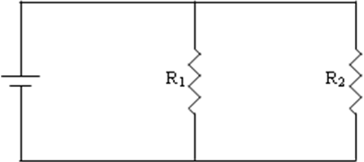

|  |  |  |  |  |
| --- | --- | --- | --- | --- |
| **#1** | **V** | **I** | **R** | **P** |
| **Battery** | **12 V** |  |  |  |
| **R1** |  |  | **2 ** |  |
| **R2** |  |  | **4 ** |  |

|  |  |  |  |  |
| --- | --- | --- | --- | --- |
| **#3** | **V** | **I** | **R** | **P** |
| **Battery** |  |  |  |  |
| **R1** |  | **2 A** |  |  |
| **R2** |  | **3 A** | **12 ** |  |
| **R3** |  | **1 A** |  |  |

|  |  |  |  |  |
| --- | --- | --- | --- | --- |
| **#4** | **V** | **I** | **R** | **P** |
| **Battery** | **12 V** | **2 A** |  |  |
| **R1** |  |  | **6 ** |  |
| **R2** |  |  | **4 ** |  |
| **R3** |  |  | **15 ** |  |

|  |  |  |  |  |
| --- | --- | --- | --- | --- |
| **#5** | **V** | **I** | **R** | **P** |
| **Battery** | **50 V** | **5 A** |  |  |
| **R1** |  | **2 A** |  |  |
| **R2** | **25 V** |  |  |  |
| **R3** | **10 V** |  |  |  |
| **R4** |  | **3 A** |  |  |

|  |  |  |  |  |
| --- | --- | --- | --- | --- |
| **#6** | **V** | **I** | **R** | **P** |
| **Battery** | **24 V** |  |  |  |
| **R1** | **8 V** |  |  |  |
| **R2** |  | **4 A** |  |  |
| **R3** |  | **2 A** |  |  |

|  |  |  |  |  |
| --- | --- | --- | --- | --- |
| **#2** | **V** | **I** | **R** | **P** |
| **Battery** |  |  |  |  |
| **R1** |  | **2 A** | **4 ** |  |
| **R2** |  |  | **6 ** |  |
| **R3** |  |  | **8 ** |  |

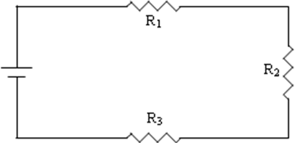

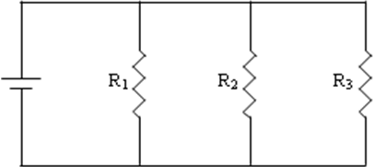

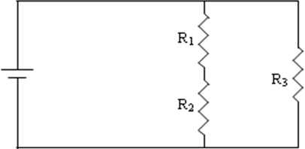

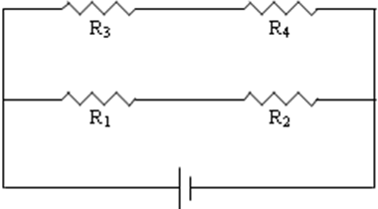

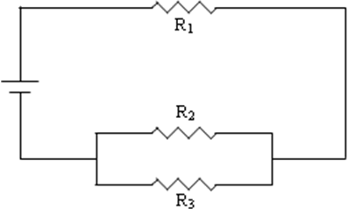

|  |  |  |  |  |
| --- | --- | --- | --- | --- |
| **#7** | **V** | **I** | **R** | **P** |
| **Battery** |  |  |  |  |
| **R1** | **12 V** |  | **2 ** |  |
| **R2** |  |  | **4 ** |  |
| **R3** | **24 V** |  | **4 ** |  |
| **R4** |  |  | **8 ** |  |

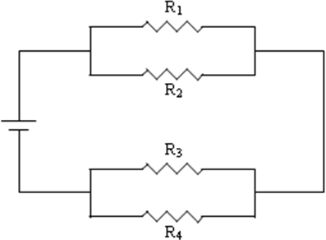

|  |  |  |  |  |
| --- | --- | --- | --- | --- |
| **#8** | **V** | **I** | **R** | **P** |
| **Battery** | **30 V** |  |  |  |
| **R1** | **6 V** | **3 A** |  |  |
| **R2** |  | **2 A** |  |  |
| **R3** |  |  | **3 ** |  |
| **R4** |  | **1 A** |  |  |
| **R5** | **8 V** |  |  |  |
| **R6** |  |  |  |  |

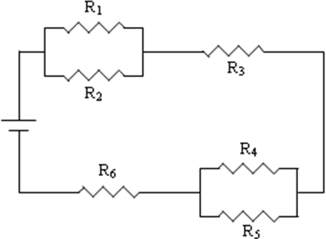

|  |  |  |  |  |
| --- | --- | --- | --- | --- |
| **#9** | **V** | **I** | **R** | **P** |
| **Battery** |  | **12 A** |  |  |
| **R1** |  |  |  |  |
| **R2** | **18 V** | **2 A** |  |  |
| **R3** |  |  | **3 ** |  |
| **R4** |  |  | **4 ** |  |
| **R5** |  |  | **2 ** |  |
| **R6** |  | **8 A** |  |  |
| **R7** | **6 V** |  |  |  |

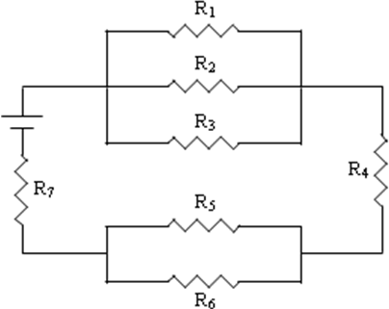

|  |  |  |  |  |
| --- | --- | --- | --- | --- |
| **#10** | **V** | **I** | **R** | **P** |
| **Battery** |  |  |  |  |
| **R1** |  |  | **20 ** |  |
| **R2** | **10 V** |  |  |  |
| **R3** |  |  | **4 ** |  |
| **R4** |  | **1 A** |  |  |
| **R5** |  | **5 A** | **5 ** |  |
| **R6** |  |  | **6 ** |  |

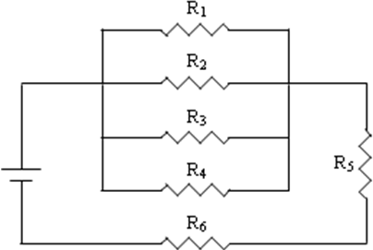

|  |  |  |  |  |
| --- | --- | --- | --- | --- |
| **#11** | **V** | **I** | **R** | **P** |
| **Battery** | **2000 V** |  |  |  |
| **R1** |  |  | **10 ** |  |
| **R2** |  |  | **25 ** |  |
| **R3** |  |  | **30 ** |  |
| **R4** |  |  | **40 ** |  |
| **R5** |  |  | **50 ** |  |
| **R6** |  |  | **35 ** |  |
| **R7** |  |  | **15 ** |  |
| **R8** |  |  | **60 ** |  |
| **R9** |  |  | **300 ** |  |
| **R10** |  |  | **100 ** |  |

