Name _________________________________

Section 6: HOW ARE VALUES OF CIRCUIT VARIABLES MEASURED?

INTRODUCTION

People who use electric circuits for practical purposes often need to measure QUANTITATIVE values of electric pressure difference and current. To do this, they use instruments called – respectively – voltmeters and ammeters. Here in Section 6, you will learn how to properly use these instruments.

6.1 Commentary: Voltmeters, Ammeters, and Multimeters

A voltmeter measures the DIFFERENCE in electric pressure between two parts of a circuit, i.e., it gives a quantitative measure (in volts, V) of the PRESSURE-COLOR DIFFERENCE between two parts of a circuit. In this section, instead of saying, “There is a red-to-blue pressure difference between the two battery terminals,” we’ll be able to say something like, “We have measured a 4.5-volt electric pressure difference between the two battery terminals.” Typically, the two parts of the circuit (that you are finding the pressure difference between) have SOMETHING in-between them: a battery perhaps, or a bulb, or a series of bulbs, or possibly the two plates of the capacitor. Perhaps you can understand why it is senseless to use a voltmeter to measure, say, the pressure difference between one end of a wire and the other end of the same wire: You learned previously that the pressure-colors of those two parts of the circuit are the SAME, and so a voltmeter would measure the DIFFERENCE in electric pressure between those parts of the circuit to be…Can you guess? Put your answer here: _____________

An ammeter measures the flow rate of charge through a circuit element; that is, an ammeter measures current. The unit for current is amperes (or amps), which are symbolized with a capital A, and so it is a good thing if you can associate AMPS with ARROWTAILS. (Amps: Arrowtails. They both start with “A”, get it? Anyway…) In this section, instead of saying, “The current passing through this bulb is three arrowtails,” we’ll be able to say something like, “The current passing through this bulb is 0.16 amperes.”

You learned in Section 5 that it is electric pressure DIFFERENCE that drives charge through the elements of a circuit. You also have learned that the RATE at which charge flows determines important characteristics of the circuit, such as bulb brightness. Perhaps you can see how important it is for us to be able to measure electric pressure and current in a precise, quantitative fashion (i.e, a specific number of volts or amperes, often to two decimal places). In the real world, this is far more useful than using the ballpark-quantitative approach we’ve employed so far, e.g., speaking of an “orange-to-yellow” pressure difference or “two arrowtails.” Suffice it to say that humans didn’t manage to land on the Moon and return safely to Earth by talking of the O₂ tanks, CO₂ scrubbers, guidance
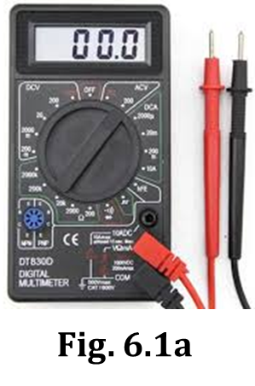
systems, and altimeters in the spacecraft as having “orange-to-yellow” electric
pressure differences or “two arrowtails” of current.

A multimeter is a device that combines various types of electrical meters into a single unit. Besides acting as a voltmeter or an ammeter and measuring electric pressure difference and current, multimeters can also be set to measure quantities such as resistance and capacitance. All that’s required is to turn the dial to a different setting and perhaps move a wire to a new plug-in location. Figure 6.1a shows a multimeter similar to what we will use in this Section.

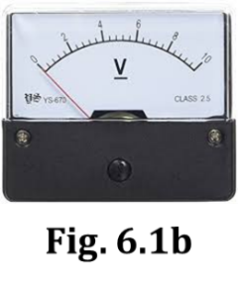
The multimeters we will use are digital devices, which means the measured quantity is displayed on the screen to a certain decimal precision. Some electrical meters are analog devices, which have a movable needle that passes in front of a scaled background. With analog devices, the measured quantity and its appropriate precision must be determined by the user. An analog voltmeter is shown in Figure 6.1b.

INVESTIGATION ONE: WHAT DOES A VOLTMETER DO?

6.2 Activity: Using a Voltmeter, Part 1
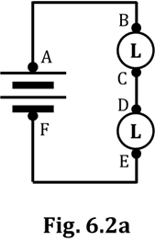
You will begin by using the multimeter as a voltmeter.

1. Set up the circuit shown in Figure 6.2a. Notice that there are TWO D-cells.

2. Color-code the circuit of Figure 6.2a. ALSO, draw some appropriate arrowtails next to the battery and bulbs, AND draw some appropriate starbursts next to the bulbs.

3. Note that each connection-point in Fig. 6.2a is designated by a letter. List the two-letter combinations that have a pressure difference between them (i.e., a COLOR DIFFERENCE between them) of...

a. zero (HINT: THREE two-letter combos have NO pressure-color difference; AB is ONE of them...)

b. the highest possible pressure difference (There are FOUR two-letter combos that apply here.)

c. a “medium” pressure difference (There are EIGHT two-letter combos that apply here.)

4. List here the TWO pressure-colors that apply to your answers to Q3b.

5. List here the TWO PAIRS of pressure-colors that apply to your answers to Q3c.

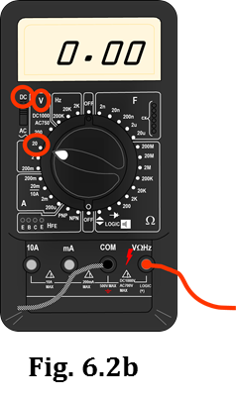
6. Obtain a multimeter from the available materials.

7. There is usually a “kickstand” on the back of the multimeter; using this will prop the unit up so the screen can be easily read. Try this now.

Adjust the settings on your multimeter so as to utilize it as a voltmeter, as described next. Figure. 6.2b might (or might not) be of help…

8. Plug the RED lead into the VΩ port and the BLACK lead into the COM port.

NOTE: When using our multimeters, there is NO SUCH THING as a negative number; you need to report ALL values as POSITIVE. To ensure that the screen displays only (+) values, the RED lead should always be closest to the (+) battery terminal (i.e., the “spring”) and the BLACK lead closest to the (–) battery terminal (i.e., the “nub”). Your OTHER OPTION is… to NOT worry about which-lead-is-closest-to-what-terminal, and just always report any value that appears on the device’s screen (whether + or –) as a (+) value. Understand?
9. Somewhere/some way/somehow on the device, there is a way to choose either AC volts or DC volts. Some way/somehow, choose DC VOLTS.

10. Besides defining WHAT KIND of electrical quantity you want to measure, the DIAL also allows you to choose the SCALE, so you can measure – as appropriate – larger or smaller values of the quantity. When using our multimeters as voltmeters, we always need the dial to point at 20 V. Do that now.
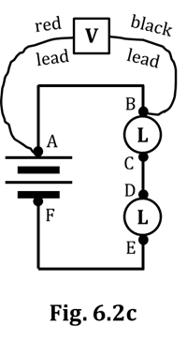
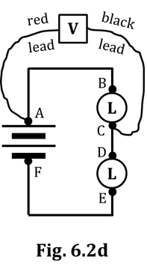
Now, you will use the voltmeter to quantify electric pressure differences.

11. After setting up the circuit of Fig. 6.2a, use the leads of the voltmeter to measure the electric pressure differences between EVERY possible two-letter combination. When making the connections, hold the leads FIRMLY onto the connection points to get a good contact. Probably, the number on the voltmeter will fluctuate a bit; DON’T WORRY about this, as it will probably NOT settle down and stop. So, clearly, there is no point in waiting for it to stop changing; just pick one of the fluctuating values. Record these below.
Also, PUT A “V” AFTER EACH VALUE, so we know that the unit is _____________.

Figs. 6.2c and 6.2d show you how to obtain the AB and AC pressure differences. Measure these AND all of the others. Put a “V” after each.

AB = ____________ BC = ____________ CE = ____________

AC = ____________ BD = ____________ CF = ____________

AD = ____________ BE = ____________ DE = ____________

AE = ____________ BF = ____________ DF = ____________

AF = ____________ CD = ____________ EF = ____________

12. Compare your answers of Q11 to your answers of Q3. Aside from some small differences caused by variations in the manufacture of the long bulbs, do your answers from those two questions generally agree with each other?

13. In the circuit we have been using, hopefully you see that, instead of measuring 15 different pressure differences, we REALLY only need to measure THREE: AF, BC, and DE. Suppose we do that, i.e., measure ONLY those three: Why then DON’T we need to measure the pressure differences of…

(a) AB, CD, and EF?

(b) AE, BE, and BF?

(c) AC, AD, and BD?

(d) CE, CF, and DF?

14. Examine the labeling on one of your D-cells and find the number of volts of pressure
difference that exist between the (+) and (–) battery terminals (of that D-cell) due
to the chemical reactions occurring inside it. How many volts does the label say?

15. Given your answer to Q14 and the number of D-cells in your circuit: How does your AF pressure difference (OR, for that matter, your AE or BE or BF pressure differences) align with this?

16. PRETEND you were to insert a third D-cell into the circuit. About how many volts would AF be?
6.3 Activity: Using a Voltmeter, Part 2

Here, you will continue using your multimeter as a voltmeter. If you have forgotten how to correctly set up your voltmeter, REFER BACK to Steps 6-10 of Activity 6.2, on pages 2 and 3 of this packet.

Because we are measuring electric pressure DIFFERENCES, from now on we will symbolize this quantity as ΔV. Δ is the capital Greek letter ‘delta’ which, in science and engineering, universally means “difference in.” We use “V,” of course, because electric pressure is measured in VOLTS; thus… ΔV.

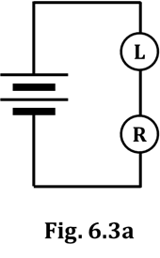
1. Look at, but DO NOT set up (YET!) the circuit of Fig. 6.3a. With the understanding that we have reached the steady-state condition, color-code Figure 6.3a, based on what you learned about pressure difference, flow rate, and resistance back in Section 5. ALSO, place appropriate starbursts around the bulbs AND appropriate arrowtails next to the battery and bulbs.

2. In Fig. 6.3b below, MAKE PREDICTIONS about the electric pressure difference values – i.e., the ΔV values – that you would obtain if you placed your voltmeter at the specified locations. HINT: ONE of these values you should be PRETTY-DARN SURE about; for the other two, make reasonable estimates.

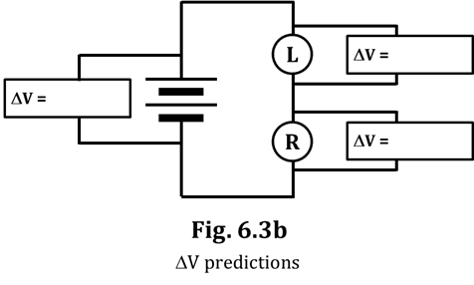
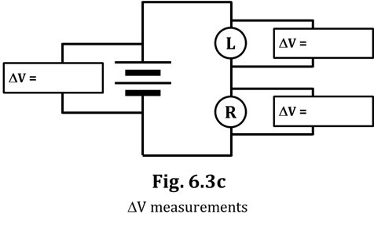

3. Now set up the circuit shown near the top of the page, in Fig. 6.3a. Your task is to use your voltmeter to measure the differences in electric pressure for the three locations shown in Fig. 6.3c. Use ONLY ONE voltmeter (not three); move it around to test each location by firmly holding the leads to the appropriate metal contact points, as you did in an earlier activity. If you think of it, make sure the RED lead is closest to the (+) terminal (“spring”) and the BLACK lead is closest to the (–) terminal (“nub”); this will ensure that all your values come out (+). Otherwise, just take the absolute value of any number that appears on your screen. WRITE your measurements into Fig. 6.3c.

4. For both your predictions (Fig. 6.3b) AND your measurements (Fig. 6.3c), there is a clear mathematical relationship between the ΔV across the battery and the ΔVs across the resistors in a series circuit. Using the variables ΔV_{batt}, ΔV_{res 1}, and ΔV_{res 2}, write this
mathematical relationship here, in the form of an equation.

5. State how your predictions compared to your measurements. Which of your measurements was…

(a) …REALLY close to your prediction?

(b) …QUITE A BIT SMALLER than your prediction?

(c) …QUITE A BIT LARGER than your prediction?
Perhaps you are now seeing how the use of electrical instruments to measure electric pressure differences can give us a MUCH clearer picture of reality, far beyond what straightforward R/O/Y/G/B color-coding can do.

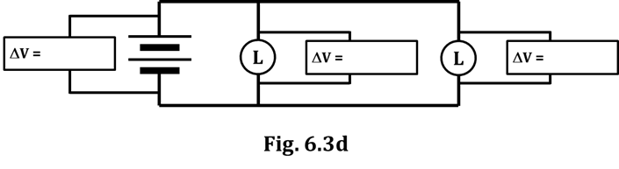
6. Figure 6.3d shows a circuit with
two D-cells and two long
bulbs, as well as the locations
where we could take ΔV
measurements with a voltmeter.
Are these bulbs in series or in parallel?

7. Measure the ΔV values shown, and write them into Fig. 6.3d. Be sure to write a “V” after each.

8. Was there much of a surprise as to how these three values compared to each other? Explain.

6.4 Exercise: Does a voltmeter have a high resistance or a low resistance?
Should a voltmeter be wired in series or in parallel with the other circuit elements?

Based on what you’ve done with the voltmeter up to this point, you probably ALREADY KNOW the answer to the second of the two questions posed above.

1. CIRCLE the correct answer: Voltmeters should be wired in SERIES PARALLEL .
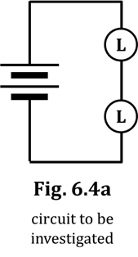
To begin this exercise, consider again the first circuit we saw in
Activity 6.2. That circuit is shown again here, as Fig. 6.4a.

2. Color-code Fig. 6.4a, and show appropriate starbursts on the bulbs.

For any circuit we want to investigate using electrical instruments, we need to be sure that our instruments DON’T ALTER the circuit in any way. In other words, we want the circuit to behave exactly the same way when we have the voltmeter “IN THERE” – taking measurements – as when we DON’T. We’re going to do four Thought Experiments to see if we can reason out some things. In a Thought Experiment, you don’t actually set anything up, you just…THINK.

NOTE: In these Thought Experiments, when we say LOW resistance, we mean REALLY LOW, like what a wire has; when we say HIGH resistance, we mean REALLY HIGH, like – basically – an insulator.

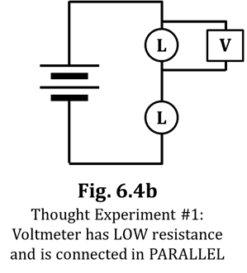
Thought Experiment #1: Let’s assume the voltmeter has LOW resistance
and should be connected in PARALLEL.

3. Color-code Fig. 6.4b, based on the description given in the figure.

4. Draw appropriate starbursts, based on your color-coding.

5. Do your starbursts of Fig. 6.4b match those of Fig. 6.4a?

6. If your answer to Q5 is “NO,” then put a big “X” through Fig. 6.4b.
If your answer to Q5 is “YES,” raise your hand and ask your teacher for help.
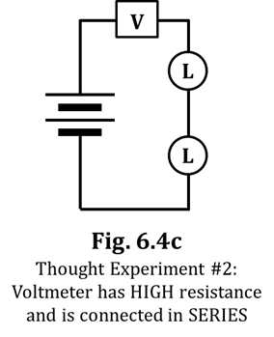
Thought Experiment #2: Let’s assume now that the voltmeter has HIGH
resistance and should be connected in SERIES.

7. State what the bulbs would do in Fig. 6.4c, based on the assumption
above. Remember, a HIGH resistance means “insulator-like.”

8. Will this circuit perform anything like the circuit of Fig. 6.4a?

9. If your answer to Q8 is “NO,” then put a big “X” through Fig. 6.4c.
If your answer to Q8 is “YES,” ask your teacher for help.
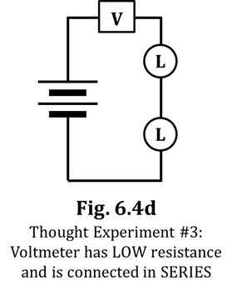
Thought Experiment #3: We now assume that the voltmeter has LOW
resistance and should be connected in SERIES.

10. Color-code Fig. 6.4d, based on the description given in the figure.

11. Draw appropriate starbursts, if any, based on your color-coding.

12. Do the starbursts in Figs. 6.4d and 6.4a match each other?

Hopefully, you answered “YES” to Q12. (If you didn’t, ask your teacher
to help you.) So this is the first possibility that MIGHT actually work:
A voltmeter having a LOW resistance and being wired in SERIES. But…

13. …as you recall, the PURPOSE of a voltmeter is to measure electrical
pressure DIFFERENCE. Look again at your color-coding of Fig. 6.4d: What WOULD
BE the electrical pressure DIFFERENCE measured by the voltmeter in Fig. 6.4d?

14. You would rationalize your answer to Q13 by saying something like: “When I color-coded Fig. 6.4d, I made the _____________ on each side of the voltmeter the same because we assumed the voltmeter had virtually _________ resistance. Therefore, the electric _________________________ on each side of the voltmeter WOULD ALSO be the same, and therefore the electrical pressure DIFFERENCE measured by the voltmeter in Fig. 6.4d would be __________.”

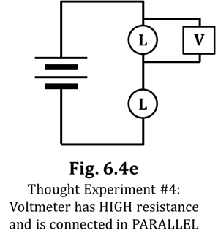
15. You should now feel confident in drawing a big “X” through Fig. 6.4d.

Thought Experiment #4: Finally, let’s assume that the voltmeter has HIGH
resistance and should be connected in PARALLEL.

16. Color-code Fig. 6.4e, based on the description given in the figure.

17. Draw appropriate starbursts, based on your color-coding.

18. Do your starbursts of Fig. 6.4e match those of Fig. 6.4a?

19. Is the voltmeter in Fig. 6.4e fulfilling its purpose, i.e.,
Is it measuring an electrical pressure DIFFERENCE?

20. If your answers to Q18 and Q19 are both “YES,” then circle Fig. 6.4e and draw a bunch of smily-faces next to it. You may also do a happy-dance and/or high-five your partner or teacher and/or hum whatever parts of Kool and the Gang’s song “Celebration” that you know.

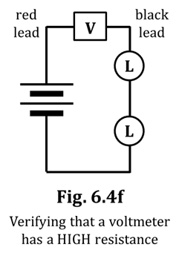
Let’s verify that, one more time, voltmeters have a HIGH
resistance, and that they SHOULD NOT be wired in series.

21. Build the circuit of Fig. 6.4f, shown at right. For this circuit, note
that you will need only TWO wires; the leads of the voltmeter
will be used to connect the battery to the top bulb.

22. What do the bulbs do, in Fig. 6.4f?

23. What is the reading on the voltmeter?

24. Given what you should already know about the NUMBER of the pressure
difference that exists across TWO D-cells, what does your answer to Q23 tell you about how this
circuit in Fig. 6.4f should be color-coded?

25. Put a big “X” through Fig. 6.4f. Feel free to write “BOGUS!” through Fig. 6.4f as well.

26. To summarize what we’ve learned in this exercise:

Voltmeters have a ___________ resistance and should be wired in _____________________.

INVESTIGATION TWO: USING A VOLTMETER WITH A CAPACITOR

6.5 Activity: How do the pressures on capacitor plates change over time?
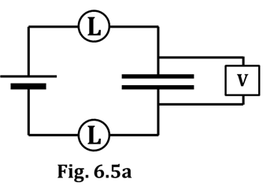
We will use the setup shown in Figure 6.5a in this next investigation, and you will make the FINAL connection at a battery terminal. DON’T make the final connection yet, but otherwise construct the circuit. Use one of the large, 0.10 F capacitors in this investigation; make sure it is uncharged, by touching both terminals simultaneously with a wire. If you have forgotten how to correctly set up your voltmeter, REFER BACK to Steps 6-10 of Activity 6.2, on pages 2 and 3 of this packet.

One partner should hold the leads of the voltmeter firmly on the CAPACITOR terminals; this partner should also watch the display on the voltmeter, once the final connection is made (NOT YET!).

1. What does the voltmeter read before you make the final connection? Include units.

Now, with someone watching the display, make the final connection at a battery terminal.

2. State what happens to the ΔV (i.e., the voltmeter reading) over the next, say, ten seconds.

3. While keeping the voltmeter leads firmly in contact with the capacitor terminals, remove the battery by disconnecting both clips from the battery terminals. What happens to the ΔV reading?

4. Your answer to Q3… What does it MEAN, with regard to the capacitor? In other words, what does a capacitor DO, once it is charged, if you simply take the battery away?
5. Write here the ΔV reading displayed now on your voltmeter. Include the correct unit.

6. Explain why your answer to Q5 makes sense, for this circuit.

7. Now, with the voltmeter leads in solid contact with the capacitor plates, DISCHARGE the capacitor by touching-together the clips that were formerly connected to the battery.
What do you observe about the ΔV reading over the next, say, ten seconds?

8. Repeat the charging/discharging sequence, using – first – TWO D-cells, and then THREE D-cells. In each case, record here the initial ΔV (before making the final connection), the ΔV when the capacitor is fully charged, and the ΔV when the capacitor is fully discharged. NOTE: Your answers to the three blanks in the “1 D-cell” line ARE your answers to Q1, Q5, and Q7 above.

Initial ΔV (V) ΔV when capacitor is fully charged (V) ΔV after discharge (V)

1 D-cell ______________ ______________ ______________

2 D-cells ______________ ______________ ______________

3 D-cells ______________ ______________ ______________

9. Your next task will be to make a graph (in Fig. 6.5b) that shows how the ΔV readings change over time for each number of D-cells. We will walk you through this, so follow the directions carefully.
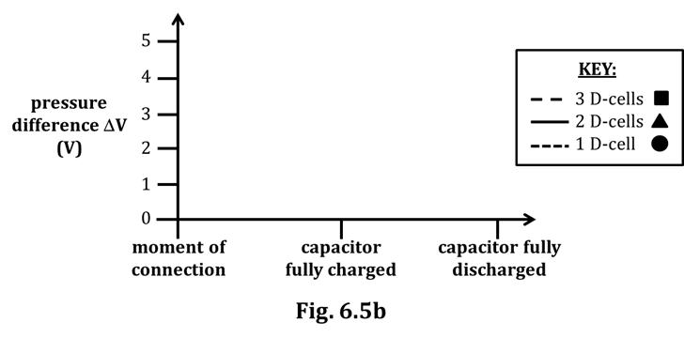

a. Start by marking three POINTS on the graph of Fig. 6.5b… Look at the MIDDLE column of numbers you wrote in Q8. You need to put those THREE data points – using SYMBOLS – in the MIDDLE of Fig. 6.5b; specifically, above the “capacitor fully charged” label. Symbolize the points with the shapes shown in the KEY of Fig. 6.5b; namely, draw a small circle for the 1 D-cell data point, a small triangle for the 2 D-cell data point, and a small square for the 3 D-cell data point. When you’re done, there will be THREE SHAPES IN A VERTICAL LINE above the “capacitor fully charged” label.

b. Now, look at your “Initial ΔV” column in Q8. Designate these three data points on the graph next to the “moment of connection” label with a tiny, TINY, TINY! “x".

HINT: You will probably need only ONE “x” to designate all three points.
c. Now, graph the three “ΔV after discharge” data points next to the
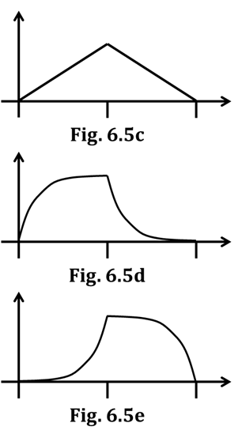
“capacitor fully discharged” label on the graph. Use another
tiny, TINY, TINY! “x"; again, you will probably need only ONE.

d. Lastly, you need to CONNECT the three 1 D-cell values with a DOTTED
curve, the three 2 D-cell values with a SOLID curve, and the three
3 D-cell values with a DASHED curve. But how? Here’s how…

Hopefully, you will agree – based on your
answers to Q8 – that each of these lines will..

-- START AT ZERO,
-- INCREASE up to the value indicated by
the shape on your graph, and then
-- DECREASE BACK DOWN TO ZERO.

So…How should the increasing (and decreasing)
curves look? There are three options:

i) straight line segments, as in Fig. 6.5c
ii) curves that are STEEP initially, and then taper off, becoming
LESS STEEP until the final values are reached, as in Fig. 6.5d
iii) curves that are NOT VERY STEEP initially, and then become
increasingly more steep until the final values are reached, as in Fig. 6.5e

Your job is to decide WHICH of the three figures (6.5c, 6.5d, or 6.5e) best applies to the charging and discharging of a capacitor, and then use THAT curve shape three times in completing Fig. 6.5b. Once more: Out of Figs. 6.5c, 6.5d, and 6.5e, there is only ONE general shape that is correct, and you must use THAT curve shape three times in Fig. 6.5b.

HINT: The magnitude of the SLOPE of the curve at every instant of time is proportional to the bulb BRIGHTNESS over time, during both charging and discharging.

Once you’ve made your choice, check with your teacher, and then draw the three curves into Fig. 6.5b.

You did it!

INVESTIGATION THREE: WHAT DOES AN AMMETER DO?

6.6 Exercise: Does an ammeter have a high resistance or a low resistance?
Should an ammeter be wired in series or in parallel with the other circuit elements?

Here, we are going to repeat the Thought Experiments that we met in Exercise 6.4, but this time with an ammeter instead of a voltmeter. The circuit we are targeting is shown as Fig. 6.6a.
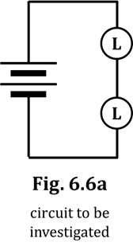
1. Color-code Fig. 6.6a, and show appropriate starbursts on the bulbs.

Recall that we can’t allow our instruments to ALTER our circuit in any way; the circuit should behave exactly the same when we have the ammeter “IN THERE” – taking measurements – as when we DON’T.

NOTE: Recall also that LOW resistance means REALLY LOW, like a wire;
HIGH resistance means REALLY HIGH, like an insulator.
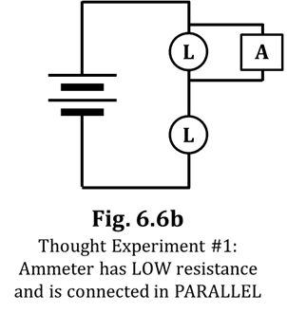
Thought Experiment #1: Let’s assume that the ammeter has LOW resistance
and should be connected in PARALLEL.

2. Color-code Fig. 6.6b, based on the description given in the figure.

3. Draw appropriate starbursts, based on your color-coding.

4. Do your starbursts of Fig. 6.6b match those of Fig. 6.6a?

5. If your answer to Q4 is “NO,” then put a big “X” through Fig. 6.6b.
If your answer to Q4 is “YES,” ask your teacher for help.

Thought Experiment #2: Now assume that the ammeter has HIGH
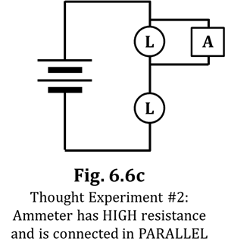
resistance and should be connected in PARALLEL.

6. Color-code Fig. 6.6c, based on the description given in the figure.

7. Draw appropriate starbursts, if any, based on your color-coding.

8. Do the starbursts in Figs. 6.6c and 6.6a match each other?

Hopefully, you answered “YES” to Q8. (If you didn’t, ask your teacher
to help you.) So this possibility MIGHT actually work: An ammeter
having a HIGH resistance and being wired in PARALLEL. But…

9. …as you recall, the PURPOSE of an ammeter is to measure CURRENT /
flow rate / arrowtails, which can ONLY be measured when the current
flows THROUGH the meter. Look again at Fig. 6.6c: The ammeter is described as having a
HIGH resistance. Thus, what WOULD BE the current measured by the ammeter in Fig. 6.6c?
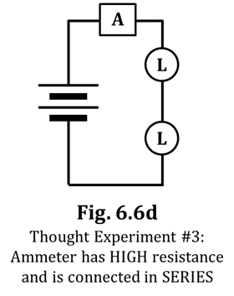
10. You should now feel confident in drawing a big “X” through Fig. 6.6c.

Thought Experiment #3: Let’s now assume that the ammeter has HIGH
resistance and should be connected in SERIES.

11. State what the bulbs would do in Fig. 6.6d, based on the assumption
above. Remember, a HIGH resistance means “insulator-like.”

12. Will this circuit perform anything like the circuit of Fig. 6.6a?

13. If your answer to Q12 is “NO,” then put a big “X” through Fig. 6.6d.
If your answer to Q12 is “YES,” ask your teacher for help.

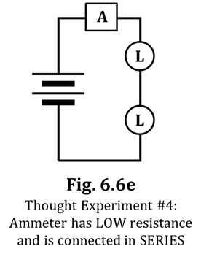
Thought Experiment #4: Finally, assume that the ammeter has LOW
resistance and should be connected in SERIES.

14. Color-code Fig. 6.6e, based on the description given in the figure.

15. Draw appropriate starbursts, based on your color-coding.

16. Do your starbursts of Fig. 6.6e match those of Fig. 6.6a?

17. Is the ammeter in Fig. 6.6e fulfilling its purpose, i.e., Is it allowing current
to flow through it, and can thus measure that current?

And there you have it: Ammeters have LOW resistance and must be wired in SERIES.

DIRE WARNING: While using the multimeter as a VOLTMETER, it is nearly impossible to damage the meter because, as we learned previously, a voltmeter has a VERY HIGH RESISTANCE. It turns out that a meter is damaged by LARGE CURRENTS (i.e., HIGH flow rates of charge, i.e., LOTS of arrowtails) passing through it, and the extremely high resistance of a voltmeter prevents large currents from occurring.

An AMMETER, as we’ve just learned, has a VERY LOW RESISTANCE, pretty much like a wire. This means that using an ammeter incorrectly can EASILY result in large currents flowing through the ammeter, which WILL destroy the meter. Therefore, you must NEVER wire an ammeter in PARALLEL, AROUND another resistor. We stress this crucial point at this time because you have just had LOTS of practice wiring the voltmeter in parallel, which you must NEVER do with an ammeter. You must ALWAYS wire an ammeter in series with (“in line with”/ “right-after-or-right-before”) a resistor, such as a light bulb.

You WILL NOT FAIL in this mission.

6.7 Activity: Measuring currents in a series circuit with an ammeter

As stated previously, an ammeter is used to measure electric current (i.e., the flow rate of charge, i.e., the arrowtails). The variable denoting current is the capital letter I, which originated from the French phrase intensite de courant (“current intensity”). You might recall that the unit for current is the ampere (or amp), which is named for the French scientist Andre-Marie Ampere (1775-1836). The ampere is symbolized with a capital A, so a current of 1.54 amperes would be designated like this: I = 1.54 A

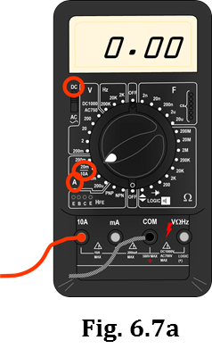
Let’s use the ammeter to measure some currents.

1. Obtain a multimeter, then adjust the settings so as to utilize it as an ammeter, as described next. Figure. 6.7a might be of help.

2. As with the voltmeter, when using the multimeter as an ammeter, the BLACK lead goes into the COM port. However, now the RED lead goes into the port labeled “10 A” (or maybe just “A”). This makes perfect sense because we measure current in the unit of amperes (A).

NOTE: As before, there is NO SUCH THING as a negative number; you need to report ALL values as POSITIVE. To ensure (+) values, connect the RED lead closest to the (+) (i.e., the “spring”) battery terminal and the BLACK lead closest to the (–) (i.e., the “nub”) battery terminal. The other option is to simply report the ABSOLUTE VALUE of whatever appears on the screen.

3. Somewhere/some way/somehow on the device, there is a way to set the device to AC or DC amps. Some way/somehow, choose DC AMPS.

4. When using our multimeters as ammeters, we need the dial to point at “20 m/10 A.” Do that now.

Okay, now we are ready to use the ammeter to quantify electric currents, i.e., to quantify arrowtails.

5. On the next page, you see Fig. 6.7b, which consists of three schematics showing several places where an ammeter can be inserted into a circuit. Below that, you see Fig. 6.7c, which shows specifically where the ammeter leads must be placed to make each of the measurements in Fig. 6.7b.
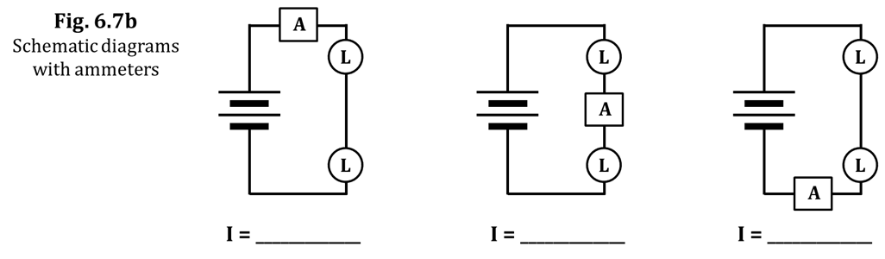

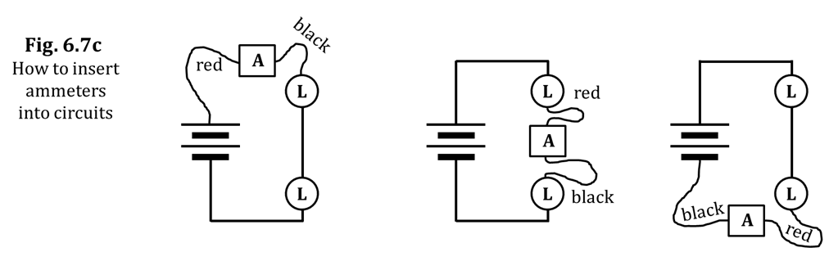

6. Construct the circuit shown above. Note that there are TWO D-cells and TWO long bulbs. Besides the ammeter with its RED and BLACK leads, you will also need TWO other connecting wires.

7. Properly set up and use the ammeter to measure the currents flowing through the various sections of the circuit. Record your three measurements in the three blanks that are provided in Fig. 6.7b.
DO NOT FORGET to put the unit “A” after each measurement.

8. How did your three readings compare to each other?

9. Explain why your answer to Q8 DOES NOT surprise you.

10. Now construct the circuit of Fig. 6.7d, measure the currents indicated, and record them in the figure.
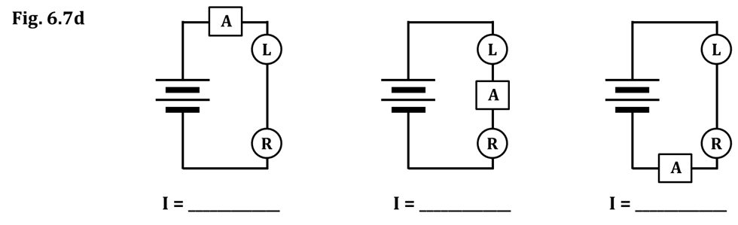

11. Again, how do your three measurements compare to each other?

12. Compare the currents from Figs. 6.7b and 6.7d. Which figure had the LARGER current?

13. What does your answer to Q12 indicate about the RESISTANCES of the circuits in Figs. 6.7b and 6.7d?
14. Explain your answer to Q13, referring specifically to the components making up the two circuits, as well as your prior knowledge about those components.

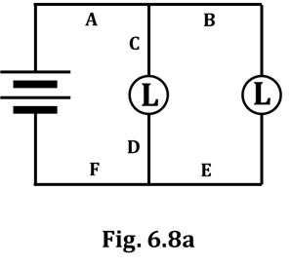
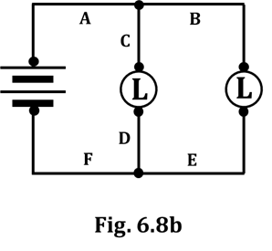
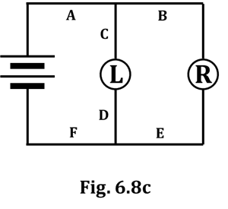
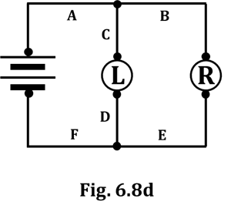
6.8 Activity: Measuring currents in a parallel circuit with an ammeter

Consider now the circuit of Fig. 6.8a.

1. Color-code Fig. 6.8a, and place appropriate starbursts on the bulbs.

2. Based on your prior knowledge, draw appropriate arrowtails at
locations A, B, C, D, E, and F, AS WELL AS through the battery.

Now construct this circuit, with reference to Fig. 6.8b. You will need
SIX wires, which have been labeled A-F. Note also that Wires A, B, and
C form a three-clip junction ABOVE the first long bulb and that Wires D,
E, and F form a three-clip junction BELOW the first long bulb.

3. Use your ammeter to measure the current going through each wire.
IN EACH CASE, you need to REMOVE a wire and INSERT the
ammeter IN ITS PLACE. If you have forgotten how to properly
set up the ammeter, see Steps 2-5 and Fig. 6.7c on pages 11
and 12. Record your measurements in the blanks below.
Be sure to write the unit (A) after each measurement.

Wire A: _________________ Wire D: _________________

Wire B: _________________ Wire E: _________________

Wire C: _________________ Wire F: _________________

4. Were your measurements from Q3 consistent with the arrowtails
you drew in Fig. 6.8a? If NOT, raise your hand and ask
your teacher for assistance.

You will now repeat what you did above except, as shown in Fig. 6.8c,
you will replace the rightmost long bulb with a round bulb.

5. Color-code Fig. 6.8c, and place appropriate starbursts on the bulbs.

6. Based on your prior knowledge, draw appropriate arrowtails at
locations A, B, C, D, E, and F, AS WELL AS through the battery.

7. Use your ammeter to measure the current going through each wire.
Record your measurements in the blanks below. Again, be sure
to write the unit (A) after each measurement.

Wire A: _________________ Wire D: _________________

Wire B: _________________ Wire E: _________________

Wire C: _________________ Wire F: _________________
INVESTIGATION FOUR: HOW DO WE MEASURE RESISTANCE?

We know that light bulb filaments hinder (or RESIST) the flow of charge, so a light bulb is an example of a resistor. Another type of resistor that we first met back in Section 2 is the carbon resistor which, instead of converting electrical energy to heat AND light (as light bulbs do), instead converts electrical energy into merely heat. In this investigation, you will learn how to determine the resistance of a resistor.

6.9 Commentary: Variables vs. units

It was mentioned in an earlier CASTLE section that the UNIT for resistance is the ohm, symbolized by a capital Greek letter omega, Ω. So, any time you are writing down a resistance that you’ve, say, measured or perhaps calculated, you write this character…Ω... after the number. On the other hand, the VARIABLE that indicates resistance – which is what you’d see on an equation from an equation sheet, or if you looked up an equation online – is a capital R. To help you understand the difference between a VARIABLE and a UNIT, below are some physical quantities, their variables, their units, and a common equation that contains each quantity.

QUANTITY VARIABLE UNIT EQUATION
speed of light c m/s c = f λ
frequency f Hz c = f λ
wavelength λ m c = f λ
electric pressure difference ΔV V ΔV = I R
current I A ΔV = I R
resistance R Ω ΔV = I R

Hopefully, you now understand the difference between variables and units. They are NOT the same thing.
The schematic symbol for ANY resistor in a circuit is a zig-zag, like this:

Look again at the equations listed in the table. In this next activity, in determining the resistance of a resistor, we will make use of this one: ΔV = I R. This equation is one of the most useful in all of physics, and is the “no denominators” form of Ohm’s law, named in honor of the German physicist Georg Ohm (1789-1854). We will make use of one form of Ohm’s law that DOES have a denominator:
$$R=\frac{∆V}{I}$$

You see that, in starting with ΔV = I R, if we divide both sides by I, we get the boxed equation above.

So, to determine the resistance of a resistor by use of the boxed-in version of Ohm’s law, we need to MEASURE the two quantities on the RIGHT and then use our calculator to compute what’s on the LEFT.

1. Look at the NUMERATOR on the right side of the boxed-in version of Ohm’s law.

(a) This QUANTITY is called…

(b) …its VARIABLE is…

(c) …its UNIT is (write BOTH the word AND the symbol)…

(d) …and the electrical instrument we will use to measure it is called a(n)…

2. Now look at the DENOMINATOR on the right side of the boxed-in version of Ohm’s law.

(a) This QUANTITY is called…

(b) …its VARIABLE is…

(c) …its UNIT is (write BOTH the word AND the symbol)…

(d) …and the electrical instrument we will use to measure it is called a(n)…

3. And finally, on the LEFT:

(a) This QUANTITY is called…

(b) …its VARIABLE is…

(c) …and its UNIT is (write BOTH the word AND the symbol)…

Incidentally – although we will NOT use them here – there ARE instruments that measure resistance directly; it perhaps will not surprise you to learn that they are called ohmmeters.

Here are the steps you will take to determine the resistance of a resistor:

A. Connect the resistor to a battery.
B. Use a voltmeter to measure the electric pressure difference across the resistor.
C. Use an ammeter to measure the current flowing through the resistor.
D. Use Ohm’s law, a calculator, and your measurements from Steps B and C to compute the resistance.

Piece of cake!

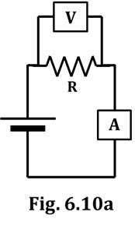
6.10 Activity: Determining the resistance of various resistors

1. Obtain two carbon resistors, R_{x} and R_{y}, from the available materials.

2. You will employ the circuit shown in Fig. 6.10a, where R represents the
carbon resistor. You will need to use a multimeter to fill in the
“pressure difference” and “current” columns in Figs. 6.10b and 6.10c.
NOTE that you will use, first, one D-cell, then two, and then three.
Look at these three figures now so you have an idea of what needs to
be done. HOW to do it is explained on the next page.

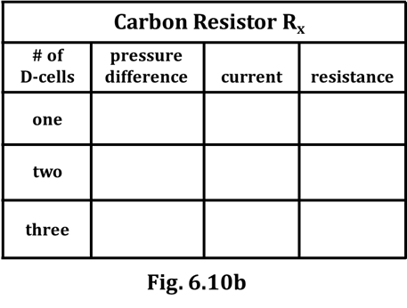
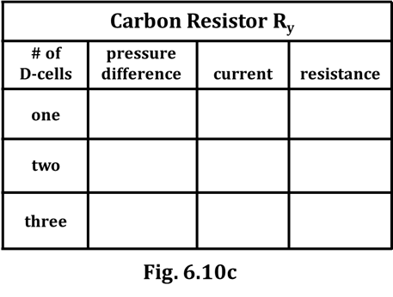

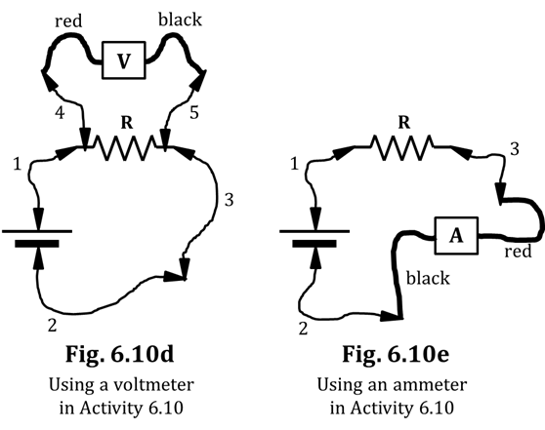
Most likely, there won’t be enough multimeters for you to use both an ammeter AND a voltmeter at the same time. If that’s the case, you will have to use ONE multimeter, first as a voltmeter and then as an ammeter.

The MOST EFFICIENT way to deal with this situation is to take ALL of your voltmeter measurements (there are a total of SIX of them), one after the other, changing the D-cells and resistors as needed as you fill in the “pressure difference” column in Figs. 6.10b and 6.10c. Then go back and take ALL of your ammeter readings to fill in the “current” columns, again changing out the D-cells and resistors as needed. You’ll be using a few extra wires to take advantage of their grippy-clip teeth; the multimeter leads and the carbon resistors don’t have clips and, if you don’t use extra wires, it is difficult to get good contact on those elements.

3. Use Fig. 6.10d to help you take the six pressure-difference readings. You can see that the extra wires have been numbered, and the alligator clips and the multimeter leads are visible. Fill in the measurements in Figs. 6.10b and 6.10c. Be sure to put the correct unit after your numbers.

4. Use Fig. 6.10e to take the six current readings. Again, put your measurements in Figs. 6.10b and 6.10c. Put the correct unit after your numbers.

5. Use your calculator and Ohm’s law (see p. 14) to calculate the resistance for each trial. Enter your calculated resistances into Figs. 6.10b and 6.10c. Put the correct unit after your numbers.

6. Now, compare your three calculated resistances for R_{x}. Are they approximately the same?

7. What about the three R_{y} resistances? Are THEY approximately the same?

NOTE: If a resistor has approximately the SAME resistance R when DIFFERENT values
of pressure difference ΔV are applied across it, we call it an ohmic resistor.

8. Based on your work here, are carbon resistors ohmic resistors?

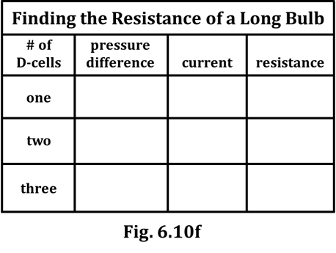
9. You will now repeat the process you’ve just completed, except with a long bulb (in a red socket, of course, you silly!). Use the same circuits of Figs. 6.10a, 6.10d, and 6.10e, except the resistor will be a long bulb instead of a carbon resistor. Make measurements and calculations as you did before and fill in Fig. 6.10f.

10. Based on your data, circle the correct answer.

“Lightbulbs are OHMIC NON-OHMIC resistors.”

6.11 Activity: Using the ammeter to investigate Ohm’s law and equivalent resistance

Already in this CASTLE curriculum, you’ve studied at length what happens to the total resistance of a circuit when you add ADDITIONAL resistors to the circuit. Let’s review that now: Circle your answers.

1. When we add an additional resistor in PARALLEL, the total resistance INCREASES DECREASES

2. When we add an additional resistor in SERIES, the total resistance INCREASES DECREASES

Often, instead of the term “total resistance,” we use the term equivalent resistance. The terms are essentially synonyms, with the only difference being that the term equivalent resistance can be applied to either THE ENTIRETY of a circuit’s resistors OR merely A PORTION of a circuit’s resistors; total resistance is applied only to the ENTIRETY. Here are some sentences that convey these meanings:

a. “The total resistance of this circuit (i.e., the resistance perceived by the battery) is 25.8 Ω.”

b. “The equivalent resistance of this entire circuit (i.e., the resistance felt by the battery) is 25.8 Ω.”

c. “In this circuit, the equivalent resistance of just-these-four-resistors-HERE is 53.7 Ω.”

When we use the term equivalent resistance, we mean something like: “If we removed all of THESE resistors and put, in their place, a SINGLE resistor such that the battery didn’t know that anything had happened, it would be a single resistor having a resistance equal to… the equivalent resistance.”

3. In Figure 6.11a, you see a single long bulb, L1. In Figure 6.11b, a second long bulb L2 has been added in PARALLEL with L1; in Fig. 6.11c, L2 has been placed in SERIES with L1. NOTE that there are TWO D-cells in each figure; this means that the pressure difference ΔV is EQUAL in all three cases; this is why the “ΔV” symbols below the three figures are printed to be exactly the SAME SIZE. We will discuss the “R” and “I” below Fig. 6.11a and the dashed ovals as we progress through this exercise.

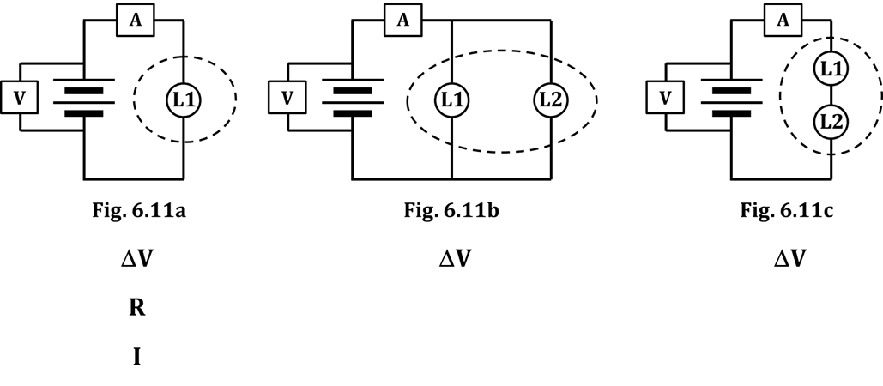

4. NOTE the normal-sized “R” below Fig. 6.11a. Based on what you already know about equivalent resistance, draw a BIGGER-R-than-that and a SMALLER-R-than-that below Figs. 6.11b and 6.11c, one symbol below each figure. In other words, determine which figure has a LARGER resistance than Fig. 6.11a and draw a larger “R” below that figure; draw a smaller “R” below the figure having LESS resistance than Fig. 6.11a. In effect, you are stating which circuit, 6.11b or 6.11c, has a larger equivalent resistance – and which has a smaller equivalent resistance – than Figure 6.11a.
5. You learned weeks ago, back in Section 2 of this program, how a circuit’s resistance affects the current (i.e., the flow rate) that passes through it. Since current is symbolized by I, there is a normal-sized “I” below Fig. 6.11a. Your next job is to draw a BIGGER-I-than-that and a SMALLER-I-than-that below Figs. 6.11b and 6.11c, based on the resistances of those circuits. Do that now.

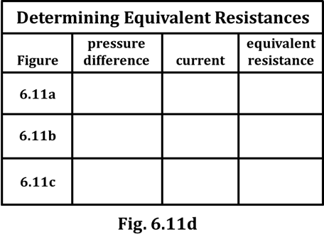
6. See if you can figure out the most efficient way to
build each circuit in Figs. 6.11a, 6.11b, and 6.11c.
HINT: Your AMMETER READINGS will require:

-- ONE wire for Fig. 6.11a
-- THREE wires for Fig. 6.11b, and
-- TWO wires for Fig. 6.11c

Your VOLTMETER readings will require…
TWO, FOUR, and THREE, respectively.

For each circuit, measure your voltmeter
and ammeter readings, then record them in the
appropriate columns of Fig. 6.11d. Note that, for each
case, you are measuring the ΔV across the battery terminals. Put correct units after each number.

7. Use Ohm’s law to calculate the equivalent resistance for each figure. Write these values – along with the correct unit – into the last column of Figure 6.11d.

8. Compare the magnitudes of the NUMBERS you wrote into Fig. 6.11d with the SIZES of the variables that you wrote BELOW Figs. 6.11a, 6.11b, and 6.11c on the previous page.
Is there any kind of correlation between the NUMBERS and the SIZES?

9. Summarize your results from this Activity by correctly filling in the blanks below.

Here, you have gathered experimental evidence that, as the equivalent resistance of a circuit INCREASES, the current through the circuit __________________. The configuration of resistors WITHIN THE DASHED OVAL in Figure _______ has a LARGER equivalent resistance than what’s within the oval of Fig. 6.11a.

On the other hand, as the equivalent resistance of a circuit DECREASES, the current through the circuit __________________. The configuration of resistors WITHIN THE DASHED OVAL in Figure _______ has a SMALLER equivalent resistance than what’s within the oval of Fig. 6.11a.

INVESTIGATION FIVE: HOW DO WE MEASURE THE RATE AT WHICH ENERGY IS TRANSFERRED?

6.12 Activity: What are the variables that determine the rate of energy transfer?

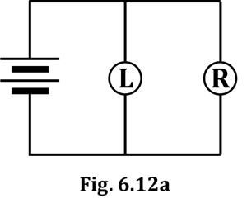
1. Set up and observe the circuit of Figure 6.12a.

2. Based on your past experience, correctly color-code Fig. 6.12a.
Also, draw appropriate starbursts around the bulbs and
appropriate arrowtails next to the bulbs and battery.

In any circuit, there is ALWAYS a transfer of energy. In Fig. 6.12a, chemical energy from the D-cells is changed into electrical energy, which is then transformed into heat and light by the bulbs. In Fig. 6.12a, the RATE at which energy is being transferred from the D-cells to the two bulbs is NOT EQUAL.

3. For WHICH bulb in Fig. 6.12a is energy being transferred at a greater rate?
(Relax; this is an easy question; your EYES will give you the answer.)

4. What is the (visual) evidence for your answer to Q3?

The RATE at which energy is transferred is called power. In electrical terms, the power consumed by a resistor depends on TWO variables: (1) the CURRENT through the resistor, AND
(2) the PRESSURE DIFFERENCE across the resistor.

The equation for electrical power is: P = I ΔV and the UNIT for power is the watt, symbolized W.

As you can see, power is the product of current and electric pressure difference.

5. Is your answer to Q3 due to THAT bulb having a larger PRESSURE
DIFFERENCE across it, or due to THAT bulb having a larger CURRENT
passing through it? HINT: Look at what you drew in Fig. 6.12a.

6. The variable you DIDN’T list in Q5…How does THAT compare, for the two bulbs in Fig. 6.12a?

Now, refer back to the big-, small-, and normal-sized variables (ΔV, I, and R) that you wrote below Figs. 6.11a, 6.11b, and 6.11c on page 17. What you need to do now is write “equations” using bigger- or smaller- or equal-sized variables P, I, and ΔV, that will DEMONSTRATE your answers to Q3, Q5, and Q6 above. Example “equations” that apply to Figs. 6.11a, 6.11b, and 6.11c are shown to help you understand what we’re after.

From… Fig. 6.11a: ΔV = I R Fig. 6.11b: ΔV = I R Fig. 6.11c: ΔV = I R

7. In the boxes, write similar P = I ΔV “equations” for Long: Round:
the bulbs in Fig. 6.12a, using letters of several sizes.

We’re going to repeat the exercise, but now with the two bulbs in SERIES.
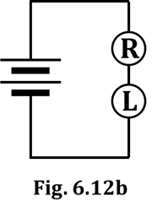
8. Set up and observe the circuit of Figure 6.12b.

9. Color-code Fig. 6.12b. Also, draw appropriate starbursts around the
bulbs and appropriate arrowtails next to the bulbs and battery.

10. For WHICH bulb in Fig. 6.12b is energy
being transferred at a greater rate?

11. What is the evidence for your answer to Q10?

12. Is your answer to Q10 due to THAT bulb having a larger PRESSURE
DIFFERENCE across it, or due to THAT bulb having a larger CURRENT
passing through it? HINT: Look at what you drew into Fig. 6.12b.

13. The variable that you DIDN’T list in Q12…How does THAT compare, for the two bulbs?

14. As you did above in Q7, write P = I ΔV “equations” using different-sized variables that demonstrate your answers to Q10, Q12, and Q13.

For the bulbs of Fig. 6.12b… Long: Round:

6.13 Activity: Experimentally verifying the variables that determine electrical power

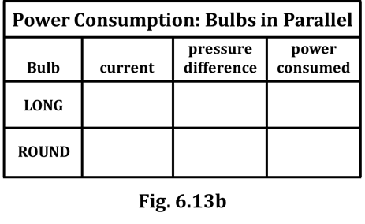
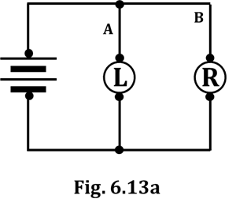
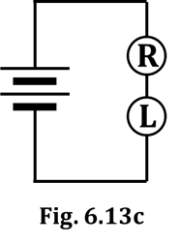
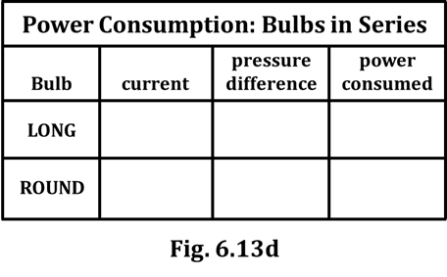
In this activity, you will MEASURE the pressure differences and currents through the round and long bulbs in the circuits of Activity 6.12, and then CALCULATE the power consumed by each bulb. Hopefully, this work will agree with all of your answers from Activity 6.12.

1. Set up the circuit of Figure 6.13a, which is essentially the same one you studied in Fig. 6.12a. We will set it up in a slightly different way to help you more easily measure things but, rest assured: It IS the same circuit. Set it up and verify that the bulb brightnesses are identical to what you observed in Activity 6.12.

2. The figure shows that you’ll need SIX wires. TWO of them (A and B) have been labeled because THOSE need to be removed – one at a time – and the AMMETER inserted in their place to measure the currents that flow through each bulb. You also need to measure the pressure difference across each bulb. As you make your measure-ments, fill in the appropriate columns in Fig. 6.13b, being sure to include units.

3. Now that you’ve measured your currents and pressure differences, use the
electric power equation (see Activity 6.12) to calculate the power consumed
by each bulb in Fig. 6.13a. Enter these into the last column in Figure 6.13b.

4. Comment here how the numbers you wrote into Fig. 6.13b compare with
your answers in Q7 of Activity 6.12.

5. Now build the circuit of Fig. 6.13c. Use the multimeter
to measure the currents and pressure differences
needed in Fig. 6.13d. Fill in those columns, then
calculate the last column, as you did previously.

6. Comment here on how the numbers you wrote in Fig.
6.13d compare with your answers in Q14 of
Activity 6.12. (See the top of this page.)

SUMMARY EXERCISE

1. State which electrical quantity each meter measures, the variable used to identify that quantity, and the unit used for that quantity.

ammeter:

voltmeter:

2a. Describe the measurements you made and the calculation you used to determine the resistance of a resistor. (See Activity 6.10.)

2b. What is the variable for resistance? What is the unit for resistance?

3. A good measuring instrument should interfere as little as possible with the system being investigated. State how much resistance the following instruments have.

a. ammeter

b. voltmeter

4. State how these instruments should be connected in a circuit, relative to other circuit elements.

a. ammeter

b. voltmeter

5a. Describe how the resistances of carbon resistors R_{x} and R_{y} were affected, if at all, by the different voltages you used across them. If the resistance increased (or decreased) considerably, state that. State also if carbon resistors are ohmic resistors or non-ohmic resistors.

5b. Describe how the resistance of a long bulb was affected, if at all, by the different voltages you used across it. If it increased (or decreased) considerably, state that. State also if the long bulb is an ohmic resistor or a non-ohmic resistor.

6. A circuit contains TWO D-cells, a capacitor, and a few bulbs. Sketch graphs showing how the electric pressure difference between the two capacitor plates changes with time.

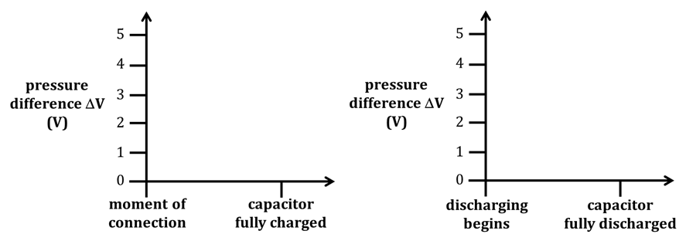

7. Consider the equivalent resistance of each of these four configurations of bulbs. List them in order from the least resistance to the greatest resistance.

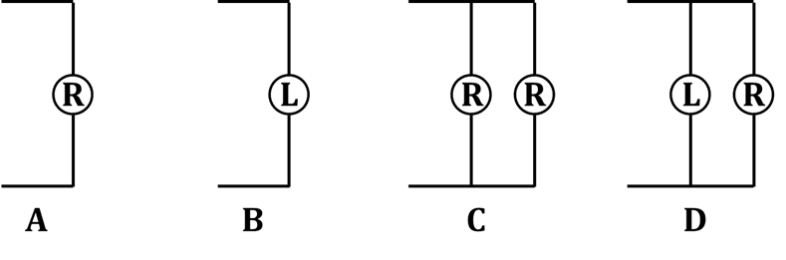

LEAST _______ < _______ < _______ < _______ GREATEST

8. As you know, power is the rate of energy transfer; the more the
power, the greater the rate at which energy is transferred.
Circle which household lightbulb would be brighter: 60 W 100 W

9. The electric pressure difference that exists across a lightbulb is 120 V. Use the equations P = I ΔV and ΔV = I R to calculate the resistance of a:

a. 60-W bulb

b. 100-W bulb

