Name _________________________________

**Section 3: WHERE DOES THE MOVING CHARGE ORIGINATE?**

**INTRODUCTION** “Where does the charge that flows through a light bulb filament come from?”

“Where was that charge located before it began to move?”

These questions will be investigated using a charge-storing device called a capacitor in the same kinds of circuits that we have used in previous sections.

**SCHEMATIC DIAGRAMS WITH WITH BULB LIGHTING AND CHARGE FLOW**

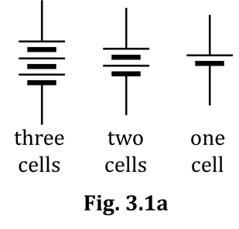**3.1 Commentary: Schematic diagrams with battery, wires, and bulbs**

Many of the circuit diagrams in earlier sections showed the visual

appearance of circuits: drawing batteries, bulbs, and wires as they

actually appear. From now on, we will draw schematic diagrams,

using symbols to represent the circuit components. The battery

symbols we will use from now on are shown in Figure 3.1a.

The LONG line represents the positive (+) battery terminal; the

SHORT line 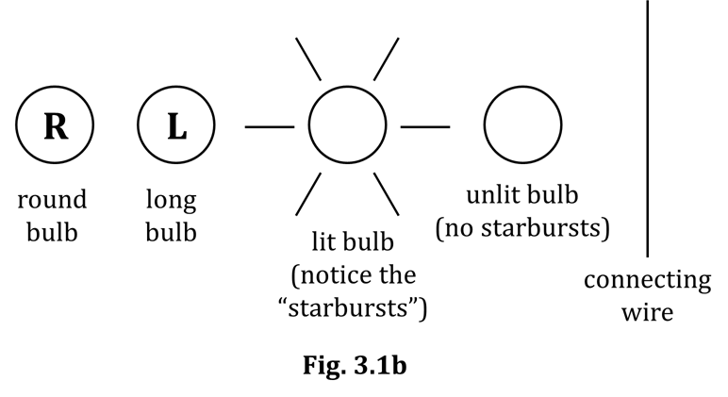represents the negative (–) battery terminal.

Other symbols we will use in

drawing schematic diagrams

are shown in Figure 3.1b.

Figure 3.1c shows three cells,

two lit bulbs, and the connecting

wires that form a closed,

conducting loop.

Figure 3.1d is a schematic

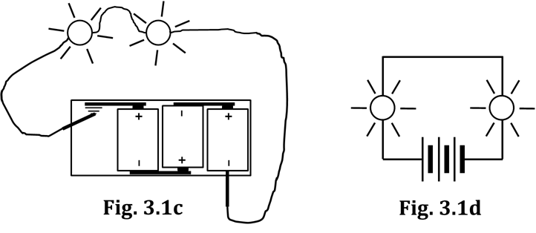diagram of the same circuit.

**3.2 Commentary: Representing conventional charge flow**

Recall from our studies in Section 1 that the deflection of a compass needle under a wire will reverse if the direction of charge flow in the wire reverses. But also recall that a compass CANNOT tell us which of the two possible directions of charge flow is the actual one. Said another way: The direction of movement in a simple circuit with lit bulbs is either clockwise or counter-clockwise, but a compass CANNOT tell us which of those is actually occurring.

To avoid confusion, the scientific and engineering professions

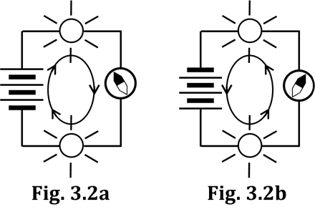agreed long ago to ASSUME the charge travels in a specific one

of the two possible directions in a wire. The direction chosen

is called the conventional flow direction.

The word *conventional* means “by agreement.” The

agreement (i.e., the convention) is that mobile charge

in a circuit is assumed to flow AWAY FROM the (+)

battery terminal and TOWARD the (–) battery terminal.

This conventional flow direction is illustrated by arrows

seen in the centers of Figures 3.2a and 3.2b. The arrows in

these schematic diagrams are drawn as a continuous

(i.e., unbroken) arrow, which represents the continual,

uninterrupted flow of charge through the bulbs and wires.

**3.3 Exercise: Drawing circuit diagrams**

1. In the space to the right of the visual representation, draw a schematic diagram of the circuit.

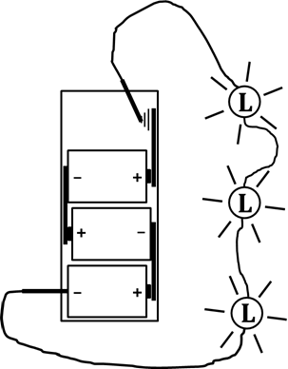

VISUAL APPEARANCE SCHEMATIC DIAGRAM

2. On the diagram you drew for Q1, draw a CONTINUOUS arrow to show the direction in which conventional charge is flowing. Refer to Figs. 3.2a and 3.2b to see what a continuous arrow should look like.

3. In the space to the right of the schematic diagram, draw a visual representation of the circuit.

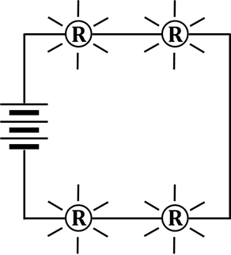

SCHEMATIC DIAGRAM VISUAL APPEARANCE

4. Draw a continuous arrow on the schematic diagram in Q3 to show the direction in which conventional charge is flowing.

**INVESTIGATION ONE: WHAT DOES A CAPACITOR DO IN A CIRCUIT?**

**3.4 Commentary: What is a capacitor?**

A capacitor is an electrical device consisting of two layers of conducting material separated by a layer of an insulator. The name comes from the *capacity* of this three-layer device to store charge. The conducting layers are called capacitor plates. The insulating layer prevents movement of charge inside the capacitor from one plate to the other. You can make a simple capacitor by placing a sheet of waxed paper between two sheets of aluminum foil.

In most capacitors, the plates have a VERY large surface area. The plates are also made very thin, so that the three layers can be rolled into a cylinder and placed inside a small can. Each plate has a screw or a wire attached to it, called a terminal. The terminals extend outside the can and allow the plate to be connected to a circuit, i.e., connecting wires (usually with alligator clips) can be attached to the terminals.

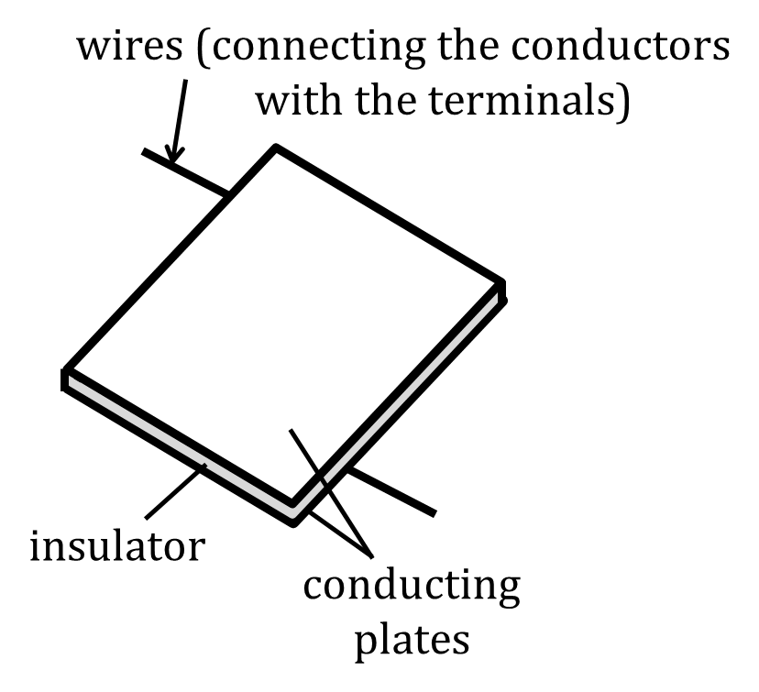

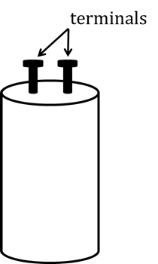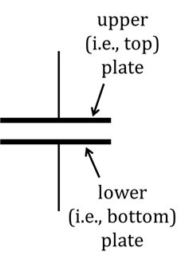

ACTUAL STRUCTURE VISUAL APPEARANCE SCHEMATIC SYMBOL

The charge-holding ability of a capacitor is called its capacitance. Capacitance is measured in a unit called the farad (F), named after the British scientist Michael Faraday (1791-1867). The capacitor in your CASTLE kit has a capacitance of 0.025 farads, or 25,000 microfarads (F).

Your classroom also has some larger capacitors, which you will borrow and use for various activities. These have a capacitance of 0.1 F, or 100,000 F – four times as much as the 25,000 F capacitors.

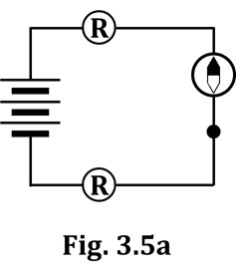NOTE: Sometimes capacitor plates may pick up stray charge that needs to be removed. So, before and after using a capacitor, you will want to neutralize it so you can start all over again. To do this, simply touch a wire simultaneously to both of the capacitor terminals.

**3.5 Activity: What happens to charge that flows into a capacitor plate?**

Assemble the circuit shown in Figure 3.5a. The black dot below the compass

indicates a location where two wires need to be joined; thus, you see that

the circuit requires that you use FOUR wires. As always, when using a

compass, align the wire so it is parallel to the needle, THEN make the connection.

1. Circle the direction the compass deflects: CLOCKWISE COUNTERCLOCKWISE

2. Draw a continuous arrow in Fig. 3.5a to show the direction of conventional charge flow. (See Fig. 3.2a.)

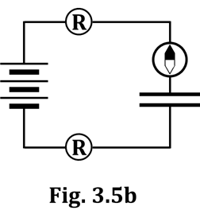

Now, disconnect one wire from one of the battery terminals; it doesn’t matter

which one. Leave this wire disconnected until directed to re-connect it. Now

disconnect the two wires at the dotted location. Take the blue 0.025 F capacitor

out of your CASTLE kit and insert it where the dot was; that is, make your

circuit look like Figure 3.5b, EXCEPT DON’T MAKE THE FINAL CONNECTION

AT THE BATTERY TERMINAL QUITE YET. Ensure that the compass is placed

under the wire connected to the top capacitor plate. Once you close this circuit

(DON’T DO IT, YET) you will be charging the capacitor.

** THIS NEXT PART IS CRITICAL: One partner MUST be looking AT the compass AT THE MOMENT the circuit is closed. The other partner MUST be looking AT one of the bulbs AT THE MOMENT the circuit is closed. You can compare notes afterward. What you need to see lasts, literally, about two seconds. So, decide who’s going to look where, and…now…carefully…GO!

3. What did you observe about the compass? Be very specific; quite a bit happened!

4. What did you observe about the light bulbs? Again, be specific.

5. Does inserting a capacitor into a circuit and charging it (as described after Q2 above) affect the DIRECTION of the flow of charge in the circuit? What is the evidence for your answer?

6. Draw a NEARLY-continuous arrow in Fig. 3.5b to show the direction of conventional charge flow; BUT, leave a SMALL GAP in the arrow at the capacitor, to show that there is an insulator between the plates. (Your arrow here should look similar to what’s in Fig. 3.5a, but with a gap at the capacitor.)

Here is how you discharge a capacitor that is in a circuit. DON’T do this yet; just read and learn.

-- Disconnect one of the wires that is connected to a battery terminal.

-- Touch and hold the alligator clip that you just disconnected…to the OTHER battery terminal.

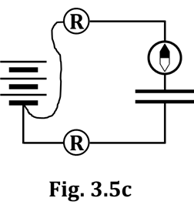

This process effectively takes the battery OUT of the discharging circuit.

In short, to discharge a capacitor, you will do

something like what is depicted in Figure 3.5c.

Again, have one partner watch the compass and the other partner watch one of

the bulbs. When both of you are ready, discharge the capacitor as described above.

7. What did you observe about the compass when discharging the capacitor?

Specifically, how did the compass behave here compared to how it

behaved as you mentioned in your answer to Q3 above?

8. What did you observe about the bulbs during discharge?

Charge (see Fig. 3.5b) and discharge (see Fig. 3.5c) the circuit at least three more times. Be sure to hold the wire over the compass and parallel to the needle while doing this. Observe carefully both the compass and the light bulbs. Revise or refine your answers to any of Q3-8, if needed.

9. What is the SAME about the compass deflection while charging and discharging a capacitor?

10. What is DIFFERENT about the compass deflection while charging and discharging?

11. State here your observations of the bulb behavior during charging and discharging.

12. Draw a nearly-continuous arrow in Figure 3.5c (again, with a GAP at the capacitor) to show the direction charge is flowing during discharge.

13. What is your evidence for why you drew what you did in Q12?

Acquire a large, 0.10 farad capacitor. (Some are silver in color, others are blue.) Replace the 0.025 F capacitor in the circuit of Figure 3.5b with the 0.10 F one. Charge and discharge this capacitor several times, observing the bulbs and compass needle.

14. Circle the answers to the following:

“With the 0.10 F capacitor, the bulbs stayed lit for MORE LESS time than for the 0.025 F

capacitor, and I would guess this occurred because MORE LESS charge flowed with the

0.10 F capacitor than with the 0.025 F capacitor.”

15. During capacitor charging, do you think the same thing is happening in every wire?

16. During discharging, do you think the same thing is happening within every wire?

17. What evidence COULD you gather that would give you more information about your answers to Q15 and Q16? (HINT: Think – or look – back to the very beginning of Section 1.)

At this time, feel free, if you wish, to gather the evidence you hinted at in Q18. (Or not; your choice.)

**3.6 Exercise: Where does the moving charge come from?**

1. Do you think the charge that flows into the capacitor gets USED UP in the capacitor, OR do you think it is simply STORED in the capacitor? (You HAVE to choose one of these.) Then explain your answer.

Now look back at the nearly-continuous arrow you drew in Figure 3.5b.

2. About the charge that lights the TOP bulb during charging:

FROM WHERE does that charge appear to originate?

3. About the charge that lights the BOTTOM bulb during charging:

FROM WHERE does that charge appear to originate?

Now look back at the nearly-continuous arrow you drew in Figure 3.5c.

4. About the charge that lights the TOP bulb during discharging:

FROM WHERE does that charge appear to originate?

5. About the charge that lights the BOTTOM bulb during discharging:

FROM WHERE does that charge appear to originate?

6. Based on your answers above, of the two choices below, circle the one that seems more reasonable:

the wires are sometimes full of charge OR the wires are never

and sometimes are empty of charge completely empty of charge

**INVESTIGATION TWO: HOW IS CHARGE DIFFERENT FROM ENERGY?**

**3.7 Activity: Using a Genecon**

**CAUTION: Do NOT turn the Genecon crank too quickly; you will burn out the bulbs.**

**Also, CAREFULLY UNPLUG the Genecon (“grab the chab”) before returning it.**

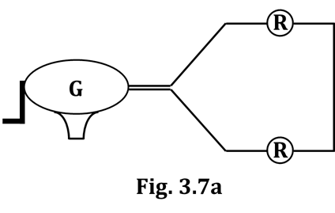

Acquire a Genecon from the available materials, then

construct the circuit shown in Figure 3.7a. Note that

there is NO battery; instead, there is a Genecon.

Unscrew one of the bulbs enough to break the circuit.

Then, turn the crank on the Genecon at the rate of one

or two revolutions per second for about ten seconds.

1. Is it EASY or DIFFICULT to turn the crank when the circuit is open?

Now, screw the bulb back in to complete the circuit. Turn the crank at the same rate as before, again for about ten seconds.

2. Is there any difference in the effort required to keep the Genecon crank turning at the same speed as before? If there IS a difference, state specifically what that difference is.

3. Circle the type of energy that is being demonstrated

anytime someone is turning a Genecon crank. KINETIC POTENTIAL

4. Circle the correct answer to this statement: *“Light is a form of energy.”* TRUE FALSE

5. Keep in mind your answers to Q3 and Q4 as you answer this question: Because the bulbs are lighting while YOU are turning the crank, WHAT does a Genecon do, in a complete circuit?

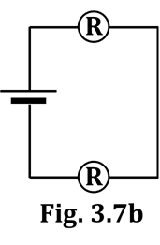Leaving the circuit in Figure 3.7a untouched, set up ANOTHER circuit:

the one in Figure 3.7b, which has ONLY A SINGLE D-cell in the battery holder.

Place this circuit so the bulbs are near to the bulbs in the Genecon circuit

of Figure 3.7a. Your next task will be to crank the Genecon at such a rate that

ALL bulbs in Figures 3.7a and 3.7b have approximately the same brightness.

6. During a ten-second time period, how many times must

you turn the crank so that the bulbs of Figures 3.7a

and 3.7b have the same brightness?

7. Now put TWO D-cells into the circuit of Figure 3.7b. Again, count the

number of times you turn the crank in a ten-second period to

match the brightness of the bulbs in the two-cell circuit.

8. Here, ESTIMATE the number of turns needed in ten seconds to match the

bulb brightness, assuming you put THREE cells in the circuit. Estimate = __________

9. Now, try it. How close was your estimate?

**3.8 Thinking Exercise**

1. Think about a hair dryer, or a fan, Is a hair dryer the SOURCE of the air that it moves?

and about WHERE the air that is

moved IS…before it is moved. Is a fan the SOURCE of the air that IT moves?

2. If you answered NO to both parts of Q1, where does the air come from? (i.e., Where does it originate?)

3. We’re now going to make a similar argument about batteries, the Genecon, and charge.

Make your best guess. Is a battery the SOURCE of the charge that moves in a circuit?

Ready?

Is a Genecon the SOURCE of the charge that moves in a circuit?

4. If you answered NO to both parts of Q3, where MUST the charge have come from?

(i.e., Where does it originate?)

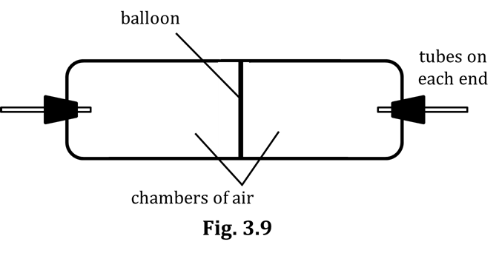**3.9 The Air Capacitor**

Here, your teacher will demonstrate an

air capacitor. You will learn about

similarities between an air capacitor

and the electrical capacitor you have

been working with in your activities.

The air capacitor consists of two chambers

of air separated by a flexible, balloon

membrane. See Figure 3.9.

Your teacher will exhale into the tube on the left side.

1. What happens to the balloon in the middle?

2. Draw a simple picture of what the air capacitor now looks like.

The exhalation process will be repeated, but this time while doing so, your teacher will hold a small piece of paper or other low-mass object near the open tube on the right side.

3. On the left side, some air went _______; on the right side, some air went _______.

4. State WHERE the two samples of air that you mentioned in Q3 originated, i.e., Where were they, before they “went”?

On the left, the air that “went” originated…

On the right, the air that “went” originated…

5. Must air flow through both tubes in order to “charge” the air capacitor?

6. Now your teacher will charge the air capacitor again, but afterward will place

a finger over the open tube on the right. What happens to the air capacitor?

7. At this point, to discharge the air capacitor, your teacher must ___________________________________, which causes air to flow _____ on the LEFT and _____ on the RIGHT.

8. Therefore, must air flow through both tubes in order to “discharge” the air capacitor?

9. Your teacher will now inhale air through the tube on the left, while keeping the other tube open.

The air that moves on the LEFT side started __________________________ and went __________________________.

The air that moves on the RIGHT side started __________________________ and went __________________________.

Draw a simple picture of what the air capacitor now looks like.

10. We have established now that when air is input through one tube, air MUST come out

the other tube. Is the air that comes out the SAME air as the air that goes in?

11. Explain your answer to Q10. Why is it IMPOSSIBLE

for the input and output air be the same?

**3.10 Relating an Air Capacitor to an Electrical Capacitor**

We will now go through some similarities between an air capacitor and an electrical capacitor.

1. The air capacitor’s two chambers correspond to an electrical capacitor’s two ________________.

2. Even before charging, the air capacitor’s two chambers already contain a good quantity of air.

Even before charging, the electrical capacitor’s two ________________ (🡨 this is your answer from Q1)

already contain a good quantity of ________________.

3. The air capacitor’s balloon prevents air from going directly between chambers.

An electrical capacitor’s _________________________ prevents the ________________ (🡨 answer from Q2)

from going directly between the ________________. (🡨 answer from Q1)

4. When we charge an air capacitor, air flows in one direction; during discharge, it flows opposite.

When we charge an electrical capacitor, ________________ (🡨 answer from Q2) flows in one direction;

during discharge, it flows…

5. After we charge an air capacitor, one chamber has more air than normal and the other chamber has

less air than normal.

WRITE YOUR ANSWERS TO Q5 HERE

After we charge an electrical capacitor, one

________________ (🡨 answer from Q1) has…

…and the other ________________ (🡨 answer from Q1) has…

6. It is a difference in AIR pressure between the two chambers that allows an air capacitor to be charged.

Since we are studying ELECTRICITY (hint, hint)...It is a difference in _____________________ pressure

between the two ________________ (🡨 answer from Q1) that allows an electrical capacitor to be charged.

**3.11 Commentary: Benjamin Franklin’s Notation of (+) and (–)**

Movable charge is normally present in all conducting matter, such as wires, bulb filaments, and – most notably – capacitor plates. ADDING some charge to a capacitor plate will result in there being MORE-than-the-normal-amount of charge on the plate; REMOVING some charge will result in there being LESS-than-the-normal-amount of charge on the plate.

Benjamin Franklin (1706-1790) came to this conclusion when he did he pioneering work in electricity a few years before the American Revolution. Franklin was the first person to use the (+) and (–) symbols in electricity. However, he did NOT mean for them to represent (+) and (–) as we understand them today (and as you are supposed to have learned in your chemistry class). He was definitely NOT referring to positive charge and negative charge. In Franklin’s mind, there were NOT two kinds of charge; only a SINGLE kind of charge, that objects sometimes had TOO MUCH of and sometimes NOT ENOUGH of. Franklin used the (+) and (–) symbols in the following sense:

(+) meant a MORE-THAN-NORMAL amount of charge (i.e., some charge has been added)

(–) meant a LESS-THAN-NORMAL amount of charge (i.e., some charge has been taken away)

We will find it very convenient and useful in the near future to use the (+) and (–) symbols to mean exactly what they meant to Benjamin Franklin. Keep this in mind as you answer the questions that follow.

1. In a charged electrical capacitor, the TOP plate has ________-than-the-normal-amount of charge and so is designated with a (___) sign. HINT: Look back at the flow-direction arrows you drew in Fig. 3.5b.

2. In a charged electrical capacitor, the BOTTOM plate has ________-than-the-normal-amount of charge and so is designated with a (___) sign. Again, Fig. 3.5 b should prove helpful.

3. Come up with a reasonable explanation as to WHY the charge in a charged capacitor spontaneously flows back in the opposite direction to how it flowed during charging.

**3.12 Commentary: Energy in Electrical Circuits**

Energy is best defined as some quantity that can be stored in matter and transferred to other matter. Energy is what gives matter the ability to make something happen. We have identified a number of things that happen in circuits; for example, charges move, and bulb filaments become hot and give off light. You might be wondering what is the source of the energy that makes it possible for these things to happen.

In most of the circuits we have observed, the source of the stored energy has been the battery. In some circuits, however, there was no battery present. We have seen that when a capacitor discharges, it can make the same things happen that a battery does, so it must also have been a source of energy after it had been charged.

In circuits where a Genecon was used, the source of energy was NOT the Genecon itself. The source of the energy was YOU, and the cranking action transferred energy that was stored in your muscles into the charges, causing them to move and light up the bulbs.

You know that batteries eventually wear down, and may become “dead.” This means that they no longer have sufficient energy stored in them to make something happen in a circuit. Some batteries are so-called “rechargeable” batteries; these can be used over and over again. You should be able to understand now, however, that the term “rechargeable” is incorrect, because a battery’s job is not to provide charge to a circuit. THE CHARGE IS ALREADY PRESENT IN THE CIRCUIT ELEMENTS, AND THE TOTAL AMOUNT NEVER CHANGES. “Rechargeable” batteries would be better called “re-energizable” batteries.

Once again: In a circuit, the charge originates in every single conductor and remains within the circuit while, at the same time, cycling through the circuit.

HOWEVER, energy always comes FROM someplace (like from a battery, or from you), and then at some point GOES TO someplace else (like a light bulb). Later, energy ALWAYS moves on to yet another place. In CASTLE, the energy that arrives at a light bulb soon LEAVES the circuit in the form of light and heat.

**INVESTIGATION THREE: MORE STUDIES WITH RESISTANCE**

**3.13 Activity: How much resistance does a connecting wire have?**

From previous investigations, you should already know the answer to the question posed directly above.

1. What IS the answer?

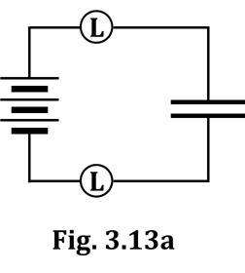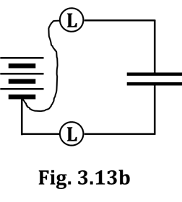

So far, so good.

Now, use LONG bulbs to build the circuit in Fig. 3.13a.

Repeat the charge/discharge sequence depicted

in Figures 3.13a and 3.13b several times to

(1) make sure you remember how to charge and

discharge a capacitor, and (2) so you can estimate

the amount of time the bulbs stay lit.

2. For how long do the bulbs stay lit during… a. charging? b. discharging?

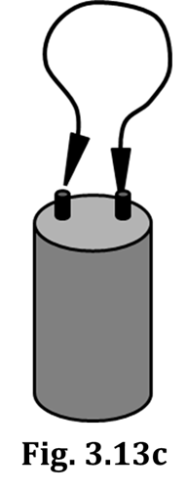Now, carefully follow this procedure:

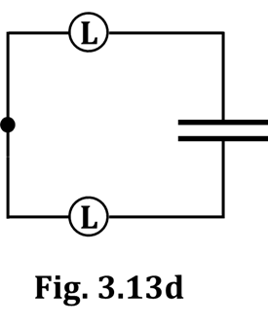 a. Charge your capacitor, as depicted in Figure 3.13a.

b. Completely remove the battery from the circuit by

disconnecting the wires at both terminals.

c. Completely remove the charged capacitor from the circuit.

d. Take a separate wire and attach ONE of the alligator clips

to ONE of the capacitor terminals.

e. Then, TAP that wire’s OTHER clip to the other capacitor

terminal ONCE, for as brief a time as possible. See Fig. 3.13c.

f. Remove the connecting wire from the terminals of the capacitor.

g. Discharge the capacitor through the bulbs, as depicted in Figure 3.13d.

3. Describe what happened to the bulbs. (If you are either surprised and/or underwhelmed, then you

saw what you were supposed to see.)

4. Explain how this investigation indicates that the resistance of a connecting wire is VERY LOW. In your explanation, you should mention the response you put for Q2b on the previous page.

**3.14 Exercise: Does a battery have internal resistance?**

Almost all of us have had the experience of needing a flashlight, only to realize when we try to turn it on that the batteries need to be changed.

1. When you notice that the beam from a flashlight has become dimmer, what MUST have happened to the flow rate of charge through the bulb filament, compared to when the beam was brighter?

______ increased ______ decreased ______ stayed the same

2. From your answer to Q1, you should be able to deduce that the total resistance in the flashlight has:

______ increased ______ decreased ______ stayed the same

3. Has the resistance of the bulb filament changed, do you think?

4. Has the resistance of the flashlight’s internal circuitry changed, do you think?

5. Therefore, the resistance of WHICH PART of the

circuit inside the flashlight MUST have increased?

6. When your flashlight is dim, WHAT ACTION do you take that completely and entirely supports your absolute confidence in your answers that you provided to Q3, Q4, and Q5?

7. Summarizing… Compared to new (i.e., fresh) batteries, old batteries have _______ resistance.

**SUMMARY EXERCISE**

1. To answer Q1, it will be helpful if you refer back to Figs. 3.5b and 3.5c. Write TOWARD or

AWAY FROM, as appropriate for each of the four parts.

What is the direction of charge flow, during capacitor CHARGING, with regard to the:

(a) TOP plate (b) BOTTOM plate

What is the direction of charge flow, during capacitor DISCHARGING, with regard to the:

(c) TOP plate (d) BOTTOM plate

2. With regard to AMOUNT OF CHARGE they have, describe:

(a) the plates of an uncharged capacitor

(b) the top of plate of a charged capacitor

(c) the bottom plate of a charged capacitor

3. From your answers to Q2b and Q2c above, it is thus logical that, during capacitor charging, the

batteries must FORCE charge _______________ the bottom plate and _______________ the top plate.

4. State a logical reason why, after you remove the battery from a circuit after having charged the capacitor, the charge would flow – on its own – in the opposite direction that the battery moved it.

5. A circuit has a capacitor, a battery, wires, and bulbs. What is the SOURCE OF CHARGE during capacitor:

(a) charging?

(b) discharging?

6. What is the SOURCE OF ENERGY for the circuit of Q5?

7. Now consider a circuit with a Genecon, wires, and bulbs. What is the SOURCE OF CHARGE while you are turning the Genecon crank to light the bulbs?

8. What is the SOURCE OF ENERGY for the circuit of Q7?

9. Q6 and Q8 refer to sources of energy. Once again – to review – the energy in the circuits we have been building is being used primarily to do WHAT?

10. With regard to WHAT THEY DO in a circuit, how are a Genecon and a battery similar?

11. With regard to WHAT THEY DO in a circuit, how are a Genecon and a battery different?

12. How would Benjamin Franklin (BF) have DESCRIBED the condition of a charged capacitor’s:

(a) top plate?

(b) bottom plate?

13. Next to your Q12 answers, put the symbols BF would have used to indicate the charged plates.

14. Back in Section 2, you identified two examples of evidence that a wire has essentially zero resistance. (Refer back to Figures 2.8 and 2.9.) Here in Section 3, you identified a third example. Describe and/or draw a diagram of all three of these.

15. Give the real-life example mentioned in this packet that

suggests that batteries have internal resistance.

16. What we have done through these first three CASTLE sections is begin to develop a MODEL of the behavior of electricity. Recall that a model is a simplified version of reality, i.e., it conforms to reality in many important respects, but also it might fail to adequately describe or explain other (hopefully minor) aspects of reality. List here the findings and assumptions we’ve covered so far that make up our CASTLE model of electricity. Also, describe the types of supporting evidence we have employed. IN SHORT, WRITE DOWN WHAT YOU’VE LEARNED SO FAR ABOUT ELECTRICITY.