Name _________________________________

Section 2: CURRENT AND RESISTANCE

INTRODUCTION

In this Section, we will learn how filaments offer resistance to the flow rate of charge. Any object with a HIGH resistance strongly opposes charge flow; any object with a LOW resistance only slightly opposes charge flow. Finally, we will learn that, in studies of electricity, “flow rate of charge” is more commonly termed current. You are responsible for knowing ALL of these terms.

INVESTIGATION ONE: HOW DO CARBON RESISTORS INFLUENCE CHARGE FLOW?
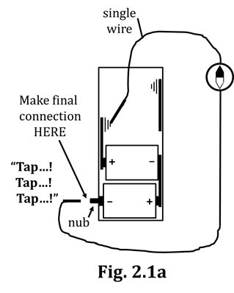
2.1 Activity: Carbon resistors, in series

BE VERY CAREFUL in doing this activity. DO NOT leave the circuit “running” (i.e., closed) while you read and answer questions in the packet. SEE WHAT YOU NEED TO SEE AND THEN BREAK THE CONNECTION. The carbon resistors and the plastic insulation on the wires get HOT and will melt
if the circuit remains closed too long.

1. Set up the circuit shown in Fig. 2.1a, but DO NOT make the final connection at the (–) battery terminal (i.e., the nub) quite yet. Besides the battery pack, you will need TWO D-cells, ONE wire, and the compass, which you should tape to the table, as you did before.

2. As with the Section 1 activities, before making the final connection, make sure the wire is placed directly on top and PARALLEL to the compass. Keeping your (“Tap!”) eye on the compass, make the final (“Tap!”) connection by – you guessed it – TAPPING the alligator clip to the (–) battery terminal (i.e., the nub). Do this a few times to be sure of your observations, then CIRCLE your answers below.
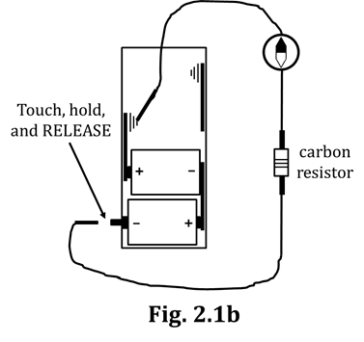
AMOUNT of compass deflection: LOTS! A FEW DEGREES

DIRECTION of compass deflection: CW CCW

3. Obtain three carbon resistors from the supplementary materials. Insert ONE resistor into the circuit by connecting alligator clips to the metal extensions on the resistor. (Obviously, you will need a second wire…) See Fig. 2.1b. Again, do NOT yet make the final connection.

4. As always, align the compass parallel to the wire BEFORE making the final connection. Have one partner watch the compass while the other touches the wire lead to the (–) terminal. You DON’T have to Tap! this time; just touch-and-hold the lead only until you are clear on your observations,
then OPEN the circuit as soon as you are sure of what you’ve seen.

What did the compass do, compared to what happened for Fig. 2.1a? CIRCLE your answers.

AMOUNT of deflection, compared to Fig. 2.1a: MORE LESS THE SAME

DIRECTION of deflection: CW CCW
5. Based on your observations, does a carbon resistor RESIST or ENHANCE the flow of charge?
CIRCLE your answer.

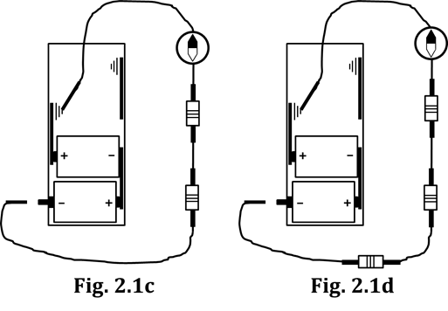
6. Use a third wire to add in a second carbon resistor. See Fig. 2.1c. Do NOT twist the metal extensions of the resistors; connect the new resistor into the circuit by having the wire’s alligator clips “bite down” on the metal extensions. When ready, TOUCH-HOLD-RELEASE, several times. Write down your observations, with regard to AMOUNT and DIRECTION of compass deflection.

Adding a resistor into a circuit as you did in Fig. 2.1c is
called adding a resistor in series. (You will need to
memorize this idea.) “Series” means one-after-another.
In baseball’s World Series, one game is played, then
another after that, and so on. In a lecture series or a
sermon series, a speaker gives one talk, then another one some time later, etc. So…SERIES means one-after-another, which is what you did with the second carbon resistor; you put in AFTER the first.

7. Based on your observations, what happens to the total resistance
of a circuit when an additional resistor is added in series?

8. Cite the evidence that supports your Q7 answer.

9. In just a minute, you will add your third and final carbon resistor, in
series (along with your fourth connecting wire). Refer to Fig. 2.1d.
Before doing so, however, MAKE A PREDICTION as to what you will
observe in the resulting circuit. Write your prediction at right.

10. Now, add the third resistor, in series, and close the circuit. (Remember: TOUCH-HOLD-RELEASE.) Did your observations agree with your prediction? ________ If they did, feel free to break into the refrain of Katrina and the Waves’ hit single, “Walking on Sunshine.”

2.2 Activity: Round bulbs (instead of carbon resistors) in series
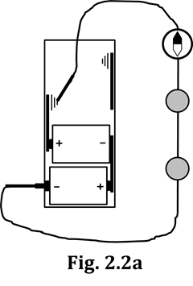
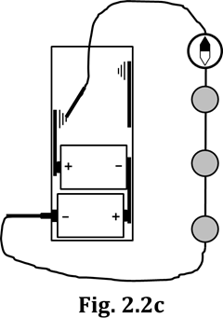
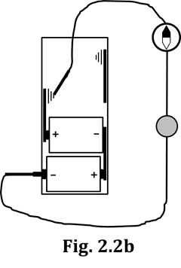
Now, re-do what you did in Activity 2.1, except use bulbs instead of carbon resistors. (See Figs. 2.2a-2.2c.) Start with Fig. 2.2a, which has TWO bulbs. Be sure you are holding the wire atop the compass and parallel to the needle BEFORE making the final connection. Summarize your findings by CIRCLING the correct answers IN THE BOTTOM
TWO ROWS (ONLY!) of Table 2.2d.
 | OBSERVATIONS |  | CONCLUSIONS
 | Bulb Brightness | Amount of Compass Deflection | Total Amount of Resistance in Circuit
Two bulbs in series | “SUMPm.”  (Now CIRCLE the right answer in the boxes below.) | “SUMPm.”  (Now CIRCLE the right answer in the boxes below.) | “SUMPm.”  (Now CIRCLE the right answer in the boxes below.)
One bulb | BRIGHTER DIMMER  than 2 bulbs than 2 bulbs  in series in series | MORE LESS  than 2 bulbs than 2 bulbs  in series in series | MORE LESS  than 2 bulbs than 2 bulbs  in series in series
Three bulbs in series | BRIGHTER DIMMER  than 2 bulbs than 2 bulbs  in series in series | MORE LESS  than 2 bulbs than 2 bulbs  in series in series | MORE LESS  than 2 bulbs than 2 bulbs  in series in series

Table 2.2d

Hopefully, you have gathered from this activity – and the previous one – that:

(1) Bulbs act like carbon resistors, obstructing the flow of electric charge.
One could, in fact, refer to bulbs as “resistors” instead of “bulbs.”

(2) Resistors placed one-after-the-other (i.e., placed in _____________) offer MORE
resistance than a single resistor alone. Furthermore, the more resistors that
are placed in this fashion, the greater the total resistance of the circuit.

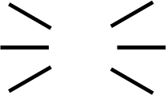
2.3 Commentary: Starbursts

Starbursts are symbols that we can put into circuit diagrams.
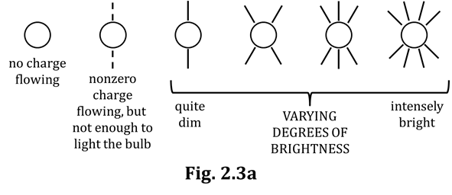
Starbursts are drawn around bulbs in order to indicate brightness. We met starbursts briefly at the end of the Section 1 Packet and also in the Section 1 Homework. Read through the descriptions of starbursts given in Fig. 2.3a. Pay particular attention to the starbursts having DASHED lines; we will meet this symbol later on.

There are no rules about HOW MANY starbursts to use. Starbursts are simply meant to show RELATIVE brightness. If you have several bulbs of equal brightness, it doesn’t matter how many starbursts you use; just use the SAME number for all of those bulbs. On the other hand, if you have several bulbs NOT having the same brightness, then the brighter bulbs should have more starbursts, the dimmer bulbs fewer.

2.4 Commentary: resistance and flow rate (i.e., current)

Previously, you classified objects as being conductors or insulators. As you recall, conductors are very good at allowing charge to flow, while insulators are NOT. (Another way to view this is that conductors are NOT very good at RESISTING the flow of charge, while insulators ARE very good at that. )

1. To review: Conductors are generally made out of WHAT KIND of materials?

and Insulators are generally made out of WHAT KIND of materials?

Many objects are NOT very good conductors, but neither are they super-great at insulating. These objects are resistors: they kind of allow charge to flow, but they also kind of obstruct the flow of charge. You have already met carbon resistors in this Packet, and you recall that they kind of allowed charge to flow, but also kind of resisted charge flow. Resistors have the property of resistance: a measure of their ability to RESIST the flow of charge.

Some resistors have a higher resistance – others have a lower resistance. The specific value of a resistor’s resistance depends on (1) what material it is made of, and (2) its physical configuration, i.e., its dimensions. We use resistors of particular resistances in circuits so we can CONTROL the flow of charge…to make it do the useful work we want it to do, such as properly power a television or a toaster.

Resistance, if you saw it in a Physics equation, is indicated by the variable R. This is exactly like, in an equation, mass would be indicated by the variable m. And, just like the unit for mass m is the kilogram (kg), the unit for resistance is the ohm, named after the German physicist Georg Ohm. The symbol for the ohm is the capital Greek letter omega (Ω), which looks like what’s on the football helmets of the Indianapolis Colts. The greater the resistance of a resistor, the more DIFFICULT it is for charge to flow through it; for instance, it is tougher to push charge through a 35-Ω resistor than it is a 5-Ω resistor.

Quantity | Variable | Unit
resistance
mass
velocity
wavelength
frequency
current
2. To practice distinguishing between VARIABLES and
UNITS, complete everything but the last row in
Table 2.4. We’ll get to the last row in just a minute.

Until now, we have used the term “flow rate” to describe
the amount of charge (per unit time) that flows through a
circuit. In electrical terminology, flow rate is more often
called current. The variable for current is the letter I,
from the French phrase intensité du courant (“current Table 2.4
intensity”). The unit for current is the ampere, symbolized with
a capital A, in honor of the French physicist André Ampere. Maybe you can now see why the term “current” is used to describe charge flow rate. The current of a river can have different strengths: LOTS of water passing a fixed point (like a certain tree on the river bank) in a given amount of time, or NOT VERY MUCH water passing the same point in the same amount of time. One thing you must NEVER do in electricity, however, is talk about HOW FAST charges are moving: we say “large/small current,” or “high/low flow rate,” but NEVER (EVER!) do we say “fast/slow current” or “fast/slow flow rate.”

3. You are ready now to complete Table 2.4, by correctly filling in the bottom row.

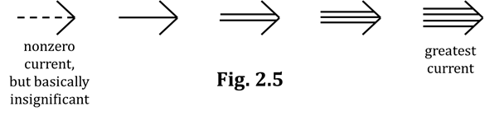
2.5 Commentary: Arrowtails

Arrowtails are another symbol we can put into circuit diagrams. Arrowtails indicate the current (i.e., the flow rate). (Current is in amps (A) = Arrowtails; get it?) Arrowtails can
be drawn next to ANY circuit element: wires, bulbs, batteries, etc, and they show the current flowing in that part of the circuit. Fig. 2.5 shows various arrowtail symbols and their approximate meanings.

As with starbursts, there are no rules about HOW MANY arrowtails to use. We simply use arrowtails to show RELATIVE amounts of current. For example, if you know that the current in several different places is equal, make sure to use the SAME number of arrowtails for all those locations. On the other hand, if you have regions that DON’T have the same current, use more arrowtails where there’s a higher current and fewer arrowtails where the current is lower. (Easy-peasy, mac ‘n’ cheesy…)

Let’s return now to the circuits you studied in Activity 2.1. Four figures in that section (Figs. 2.1a-d) have essentially been re-copied here as Figs. 2.5a-d. We will now be putting CORRECT arrowtails on these figures. (We have no use for INCORRECT arrowtails…or starbursts, for that matter.) Here we go…

1. Consider Figs. 2.5a-d, shown at the bottom of the page.
Why will we NOT be putting starbursts on these figures?

2. In which general direction around the circuit, CW or CCW, will your arrowtails point?

3. Justify your answer to Q2.

Look again at Fig. 2.5, at the top of this page. Do you see the leftmost, dashed arrowtail? It turns out here that NONE of the circuits at the bottom of this page have that dashed-arrowtail, insignificant current. Here, we will (happen to) use EACH of the other FOUR arrowtail symbols in Q4. Do that now.

4. Analyze Figs. 2.5a-d, THINK (!), and then draw the correct arrowtail symbol in each blank below.

Fig. 2.5a = ____________ Fig. 2.5b = ____________ Fig. 2.5c = ____________ Fig. 2.5d = ____________

5. What evidence did you gather (a LONG time ago!) that will cause you to draw
the SAME arrowtail symbol ALL THROUGHOUT a given circuit below?

6. Now, it’s time to put arrowtails into Figs. 2.5a-d. There is no rule about HOW MANY arrowtail symbols to draw. For now, put one symbol next to each resistor, and then at least one more next to a wire.
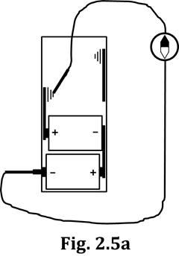
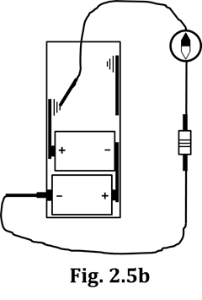
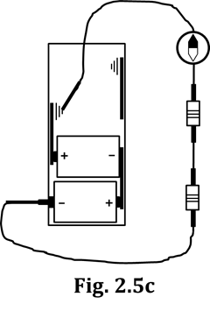
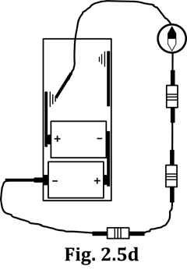

7. Have your teacher check your work at the bottom of the previous page.

Now, do the same kind of thing for the circuits of Activity 2.2. Three figures in that section (Figs. 2.2a-c) have been re-copied here as Figs. 2.5e-g.

8. Consider Figs. 2.5e-g. Why will we be putting
BOTH starbursts AND arrowtails on these?

9. Draw starbursts and arrowtails on the figures below, keeping in mind that:

- Starbursts must indicate relative bulb brightness.
- Arrowtails must indicate relative currents and must be equal throughout a given circuit.

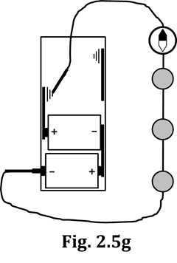
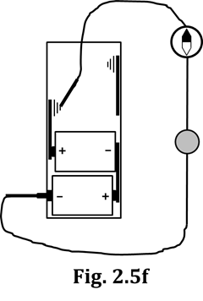
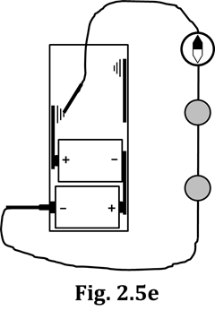

INVESTIGATION TWO: RESISTANCE OF VARIOUS CIRCUIT ELEMENTS

2.6 Activity: Comparing the effect of different bulbs

You might have noticed, in Figs. 2.5e-g above, that there appears to be a relationship (or pattern, or trend) between the relative number of starbursts and the relative number of arrowtails.

1. Is there some noticeable trend between the starbursts and arrowtails you drew above?

If your answer to Q1 was NO, raise your hand and ask your teacher for help.

2. Once your answer to Q1 is YES (), state what the trend is.

One of the key points of this activity is that the trend you identified in Q2 is true ONLY if ALL THE BULBS INVOLVED ARE OF THE SAME TYPE. So I’m sure you’ll guess what’s coming next…

Bingo: We’re going to build and analyze a circuit having two different types of bulbs.

3. Up until this point, we’ve worked exclusively with round bulbs. Now, from the cache of supplemental materials, obtain a long bulb. (You’ll see why the two bulbs have the names they do.)

4. Now, construct the circuit of Fig. 2.6a, which is at the top of the next page. (Don’t forget the compass.)
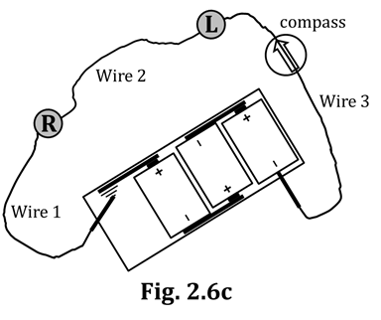
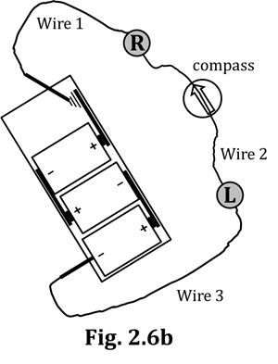
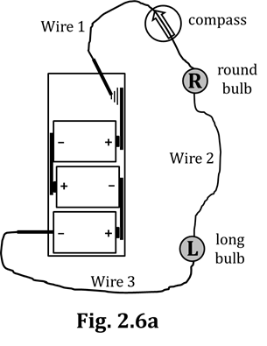

As always, set up the circuit, THEN hold the wire directly atop – and parallel to – the compass, and ONLY THEN make the final connection (at either terminal, it doesn’t matter). Record your observations below.

5. From Fig. 2.6a:

The compass deflected…. CW or CCW …at an angle of about _____ degrees.

Compared to the round bulb, the long bulb was: BRIGHTER DIMMER THE SAME BRIGHTNESS

Compared to the long bulb, the round bulb was: BRIGHTER DIMMER THE SAME BRIGHTNESS

You’ve done this next part before, but it is VERY important that it is done correctly. Leave the compass where it is and ROTATE the ENTIRE circuit CCW so that Wire 2 is over the compass. You have to physically MOVE the battery pack to a different location for this to work. Do NOT simply SLIDE the circuit straight across the table, NOR just leave everything in place and pull Wire 2 over enough so that it’s on the compass. ROTATE the ENTIRE CIRCUIT, like you’re turning a steering wheel. That’s the deal.

6a. From Fig. 2.6b, the compass deflected…. CW or CCW …at an angle of about _____ degrees.

6b. From Fig. 2.6b, how did the bulb brightnesses compare to Fig. 2.6a?

Now, ROTATE the circuit one more time, to achieve Fig. 2.6c.

7a. From Fig. 2.6c, the compass deflected…. CW or CCW …at an angle of about _____ degrees.

7b. From Fig. 2.6c, how did the bulb brightnesses compare to the first two circuits?

8. Okay, we’re going to put the bulb brightnesses aside for a moment and focus on the compass deflections from Figs. 2.6a-c. One more time: How did those three deflections compare?

9. From your Q8 answer, what therefore HAS to be true about
the flow rates (i.e., the currents) in Wires 1, 2, and 3?

10. Suppose we want to draw an arrowtail symbol, one on EACH EXACTLY THE SAME
of the Wires 1, 2, and 3. Based on your answer to Q9, you have
NO CHOICE but to conclude that all three symbols must be… DIFFERENT FROM EACH OTHER
11. Your answer to Q10 might seem a little strange; have your teacher check your answer to Q10.

12. Now, put arrowtails next to Wires 1-3 in all three figures on the previous page, Figs. 2.6a-c, in this way: Draw a total of nine (9) arrowtails (3 wires in each of 3 figures). Which arrowtail symbol you choose (refer back to Fig. 2.5) is NOT important; what is VERY important is that you draw arrowtails that are in absolute agreement with your answer to Q10 AND that they point in the correct direction.

Let’s use our imagination a bit now. First off, flow rate (current!) – which we symbolize with arrowtails, as you know – is a measure of the NUMBER of charges passing a certain point in a certain amount of time. In simple terms, a flow rate could be, say, “30 charges per second” or “50 charges per second” which pass a fixed point within a circuit.

Let’s say that the current in Wire 2 is 30 charges per second. If you were INSIDE Wire 2, this would mean, for one thing, that you are extremely tiny . More importantly for us here is that it would also mean that you would see 30 charges moving past you every second. (Besides being tiny, you would also have to be a pretty fast counter.) Now, continue this line of reasoning; refer back to your answer to Q10, if needed…

13. What would the current be in Wire 1? ______________________ How about Wire 3? ______________________

Your answer to Q13 means that if you’ve got two (very tiny) friends, one inside Wire 1 and the other inside Wire 3...ALL THREE of you will be seeing 30 charges flowing past you every second.

This 30-charges-per-second current is very SMOOTH: 30 charges, every second, second… after second… after second. Recall that, after you’ve had a circuit hooked up for NOT very long, the compass needle doesn’t erratically jump around anymore; it stays in one place, as long as you aren’t opening or closing the circuit or fiddling with the wire on top of the compass. Keep this smooth flow of current in mind now…
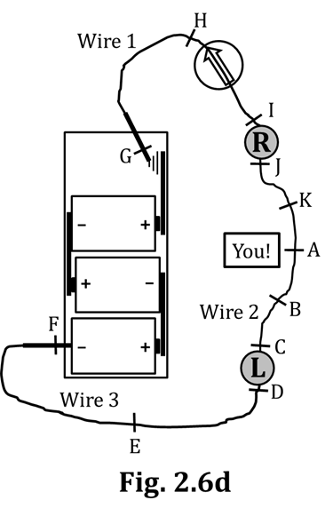
Let’s say you are WITHIN Wire 2, right in the middle of the wire, at Checkpoint A in Fig. 2.6d, at right. There you are, watching the 30 charges per second (let’s abbreviate it ch/s, shall we?) flow past. But yours isn’t the only checkpoint; there are a bunch of them, like what are set up for a long distance running or biking event, and there’s a “Checkpoint Checker-Person” at each one. From your vantage point at A, you can see Checkpoint B, a short distance away, in the same Wire 2.

14. a. What current does the Checker at B observe?
(Refer back to your Q10 answer, if needed.)

b. What current does the Checker at C observe?

c. What about D? H?

E? I?

F? J?

G? K?

15. Look back at your answer to Q10. Do ALL your answers to Q14 agree with your answer to Q10?
YES, your Q10 and Q14 answers should be in EXACT agreement.

So we’ve established that the current through the WIRES is the same for all wires in a series circuit. But what about the current through the BULBS in these circuits? What about the current through the D-cell batteries? Are these the same as the current in the wires? In other words, will the current through the bulbs be – for our example – 30 ch/s? (Don’t answer these questions now; you WILL, below.)

Look again at Fig. 2.6d, on the previous page.

16. a. Which TWO checkpoints are on either side of the long bulb?

b. And for our numerical example discussed earlier, HOW MANY charges
per second were being observed at each of those two checkpoints?

c. Suppose we put a new checkpoint, Checkpoint L, WITHIN the long bulb. (Checkpoint L, Long
bulb. Get it? Anyway…) What current do you suppose we would measure, at Checkpoint L?

17. a. Which TWO checkpoints are on either side of the round bulb?

b. How many ch/s were being observed at each of those checkpoints?

c. Therefore, what current would we measure, at “Checkpoint R”?

18. a. Which TWO checkpoints are on either side of the battery pack?

b. How many ch/s were being observed at each of those checkpoints?

c. Therefore, what current would we measure, at “Checkpoint Battery”?

19. By mentally combining your answers to Q13, Q16c, and Q17c, draw arrowtails
(NOT starbursts! we’ll do that next…) next to ALL of the bulbs in Figs. 2.6a-c.

Here, we have tried very hard to convince you that the current through ALL of the circuit elements (wires, bulbs, and batteries) is EVERYWHERE THE SAME for every circuit we’ve met up to this point (which are SERIES circuits). It is absolutely essential that you understand and accept this conclusion.

20. Now, choose some appropriate starbursts (from Fig. 2.3a) and draw them on the bulbs in Figs. 2.6a-c.

21. Summarize the biggest ideas of Activities 2.5 and 2.6 by CIRCLING the correct answers below.

For IDENTICAL types of bulbs, brightness For DIFFERENT types of bulbs, brightness

DOES DOESN’T DOES DOESN’T

correlate to the current flowing through the bulbs. correlate to the current flowing through the bulbs.

In a series circuit, the current is the SAME through WHICH circuit elements? CIRCLE all correct answers.

BATTERIES WIRES LONG BULBS ROUND BULBS

2.7 Activity: Examining circuit structures under magnification

Here, you will assess the THICKNESS (i.e., the diameter, the cross-sectional area…you get the idea) of four different structures: connecting wires, long bulb filaments, round bulb filaments, and support wires.

To review:

- Connecting wires are the wires that have alligator clips on the ends, and that you’ve been using when CONNECTING (Ha!) different parts of circuits together.

- Support wires are the two wires inside a light bulb that SUPPORT (Ha!) each end of the filament. Hopefully, you recall that one support wire is connected to the bulb’s threads; the other support wire is connected to the bulb’s tip.

NOTE: A connecting wire – as you will see – consists of several thinner wires bundled together. In ALL
your responses related to this topic, you are to consider the thickness of a connecting wire as
being the COMBINED thickness of ALL its constituent, thinner wires.

To help you understand why, imagine you have two unopened cans of soda. You open one can in the conventional fashion, using the pop-up tab. (“PFFT!”) On the other can, you poke many, many tiny holes through the top of the can…enough holes that – if you added them all up – they have the EXACT SAME area as the opening from the pop-up tab.

1. If you then turned the cans upside down, THE ONE WITH THE THE ONE WITH SAME TIME
which one would empty faster? POP-UP OPENING LOTS OF HOLES FOR BOTH CANS

So, you can see how several thinner wires can be envisioned as a single, thicker wire.

2. Okay, taking with you ONLY this packet AND a
pencil, make your way over to a microscope. connecting wire “Pretty thin, I guess.”

3. The four structures whose thickness you need to long bulb filament “Meh…kinda thick.”
observe can be found taped to a card by the
microscope. View each structure’s thickness, and round bulb filament “OMG thick!”
then record your observations by MATCHING the
structure with the most appropriate description. support wire “OMG thin!”

4. STEP AWAY from the microscope now and return MATCH STRUCTURE WITH DESCRIPTION
to your lab station, so others may use the scopes.

5. Report again the conclusions you made about thickness, but in a different way: by LISTING the names of the four structures below, IN ORDER from thickest to thinnest. Write the name of each structure out. As you write from left to right, put a “greater than” symbol (i.e., >) between the names. (As you have four structures, this means you will need THREE “greater than” symbols.)

THICKEST THINNEST
STRUCTURE STRUCTURE

6. Common-sense time: CIRCLE the type of hallway that it’s “pretty WIDE NARROW
easy” to get LOTS of people through, in NOT very much time. HALLWAY HALLWAY

7. Your task now is to write four statements, TWO below EACH of the Q6 choices, both the one you circled AND the one you didn’t. Here are the four statements:

resists the flow of people a LOT resists the flow of people a LITTLE

people flow through VERY EASILY people flow through, but WITH DIFFICULTY

Go.

8. The conductive elements of circuits are a lot like THICKEST THINNEST
hallways, except that these “hallways” allow for STRUCTURE: STRUCTURE:
the movement of electric charge, not for people.
(People are too big to fit into circuits.) Look again
at your answer to Q5 and re-write the names of
your thickest and thinnest structures at right.

9. Below your answers to Q8, you now need to re-
write the four statements from Q7, BUT with a
very important change: In each statement, change
the word “people” to “charges.” Then re-write those
four revised statements, TWO statements below
EACH structure you listed in Q8.

10. As you learned back in Act. 2.1, an object’s resistance is a measure of how well it RESISTS the flow of charge. THINK for a second, then list the names of the four structures, IN ORDER, one last time, but this time from LEAST to GREATEST RESISTANCE. This time, use three “less than” signs.

LEAST GREATEST
RESISTANCE RESISTANCE

11. Have your teacher check your answers to Q5 and Q10.

Before any assessment, you will want to have your CORRECT Q5 and Q10 responses memorized.

2.7 Activity: Making a connection between resistance to AIR flow and resistance to CHARGE flow

1. From the supplementary materials, obtain now a coffee stirrer AND a soda straw. These objects should be NEARLY the same length, but if they’re “off” by a little bit, it won’t matter here.

In just a minute, you will EXHALE a big breath through both of these objects, one at a time, but NOT YET. Read through Steps 2-4 so you understand what to do, and then you’ll actually do it in Step 5.

2. INHALE a big breath.
3. Exhale naturally. DON’T force the air out; just let it flow out
naturally. But it is very important that all of the air comes
out your mouth; if you need to use your fingers to plug your
nose so that no air escapes that way, do it.
4. Use the timer on your phone to time how COFFEE STIRRER EXHALATION TIME: ____________
long it takes for ONE complete exhalation.
SODA STRAW EXHALATION TIME: ____________

5. You exhaled a greater volume of air through the: STIRRER STRAW NOPE; SAME
VOLUME FOR BOTH
6. Based on your Q4 and Q5 answers...

Through which structure was there a HIGHER flow rate? STIRRER STRAW

Which structure offered MORE RESISTANCE to the flow of air? STIRRER STRAW

Through which structure was there a LOWER flow rate? STIRRER STRAW

Which structure offered LESS RESISTANCE to the flow of air? STIRRER STRAW

Recall now the difference between a direct relationship and an inverse relationship. A direct relationship exists between two quantities if, as one quantity changes, the other changes in the SAME direction. That is, a direct relationship exists if, as one quantity increases, so does the other…OR, as one quantity DECREASES, so does the other. An indirect relationship exists if, as one quantity changes, the other changes in the OPPOSITE direction: As one goes up, the other goes down, and vice-versa.

7. Fill in the blanks below. Your answers in Q6 should help.

The type of relationship that exists between RESISTANCE and FLOW RATE is a(n) _____________________ relationship. We know this because when the resistance was higher, the flow rate was _______________; when the resistance was lower, the flow rate was _______________. Connecting what we learned for circuit structures AND for straws/stirrers, as the thickness/diameter/cross-sectional area of something INCREASES, the resistance of the something ________________ and the flow rate through the something ________________. As the thickness/diameter/cross-sectional area of something DECREASES, the resistance of the something ________________ and the flow rate through the something ________________.

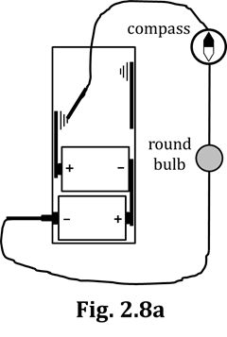
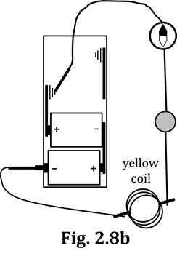
2.8 Activity: Investigating a wire’s resistance

1. Build the circuit of Fig. 2.8a. You will need two D-cells,
two connecting wires, a compass, and a round bulb.

2. As always, hold the wire over the compass and parallel
to the needle, then make the final connection.

3. Make a mental note of the bulb brightness
and compass deflection.

4. Obtain from the supplementary materials a
yellow coil of wire. Do NOT unravel the coil; LEAVE IT in its coiled form.

5. Build the circuit of Fig. 2.8b. You will need a third connecting wire to add in the yellow coil.
6. Repeat Steps 2 and 3.
WERE A LOT LOOKED THE
7. For the two cases, the brightnesses and compass deflections… DIFFERENT SAME, TO ME

8. Based on your Q7 answer, you conclude that the VIRTUALLY A LOT
RESISTANCES of the circuits of Figs. 2.8a and 2.8b are: THE SAME DIFFERENT

9. Thus, ABOUT HOW MUCH resistance did your yellow coil of wire contribute to the circuit?

10. And – by extension – ABOUT HOW MUCH resistance does ANY connecting wire have?

11. What is DIFFERENT about the structures of filaments and connecting wires that
will make us DEFINITELY NOT apply our Q9 and Q10 answers to filaments?

12. In Figs. 2.8a and 2.8b, draw arrowtails and starbursts
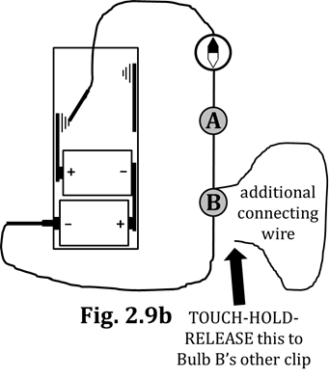
that support what you learned in this activity.
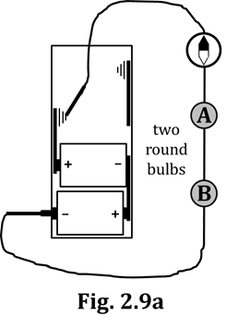
2.9 Activity: A wire’s resistance: More evidence

1. Build the circuit of Fig. 2.9a.

2. Make a mental note of the compass deflection.

3. Place CORRECT arrowtails
and starbursts into Fig. 2.9a.

4. Now, attach an additional
connecting wire to JUST ONE
of the clips of the socket of Bulb B. See Fig. 2.9b.

5. Now, TOUCH-HOLD-RELEASE the OTHER alligator clip of the connecting
wire to the OTHER clip of Bulb B’s socket. This is called “short-circuiting Bulb B.” Short-circuit Bulb B several times, to see the effects on the compass and both bulbs. Record your observations in Q6.

6. When you short-circuited Bulb B:

6a. the amount of compass deflection INCREASED DECREASED DROPPED TO ZERO

6b. the brightness of Bulb A INCREASED DECREASED DROPPED TO ZERO

6c. the brightness of Bulb B INCREASED DECREASED DROPPED TO ZERO

NOTE: When we say “the amount of current flowing through the circuit,” we mean also… “the amount of current flowing through the battery.” Seriously, do yourself a favor now and take a minute to look back at the arrowtails you drew in Figs. 2.5a-g. Note how the arrowtails point OUT OF the battery at the (+) terminal and point INTO the battery at the (–) terminal. Is it so hard to conjecture that those VERY SAME arrowtails MUST ALSO be flowing THROUGH the battery? Thus, we say that “the amount of current flowing through the circuit” exactly equals “the amount of current flowing through the battery.”
7. Now, use your pencil to DRAW a closed gap into Fig. 2.9b, to show the actual “shorted” circuit.

8. Based on your Q6a answer, what happened to the current in
the wire over the compass when you short-circuited Bulb B?

9. Based on your Q8 answer, draw ONE appropriate arrowtail symbol next to the compass in Fig. 2.9b.

10. Knowing what you know about current and arrowtails, now draw ONE appropriate arrowtail
symbol next to Bulb A. (This answer follows logically from your Q9 answer.)

11. Does your Q10 answer corroborate (i.e., does it support/
is it in agreement with) your Q6b answer?

12. Note now in Figs. 2.9a and 2.9b that the wire over the compass is ATTACHED to the (+)
battery terminal. With reference to your Q8 answer…What, therefore, can you conclude
happened to the current flowing through the battery when you short-circuited Bulb B?

13. By mentally combining your Q9, Q10, and Q12 answers, now draw ONE appropriate
arrowtail symbol on the wire connected to the battery’s (–) terminal.

14. Your Q6c answer now leads us to a few things. State what you’ll do about Bulb B with regard to…

a. starbursts b. arrowtails

Nearly done with this…

15. In Fig. 2.9b, look at the arrowtails you drew next to Bulb A (your Q10 answer) AND those you drew next to the wire connected to the (–) terminal (your Q13 answer). With these AND your Q14b answer in mind, discuss with your partner the ONLY POSSIBILITY for the arrowtails that MUST be drawn next to the “shorting wire” around Bulb B. Then, DRAW those arrowtails by the shorting wire in Fig. 2.9b.

16. Have your teacher check your drawings in Figs. 2.9a and 2.9b.

17. From this activity, WHAT do you conclude about the RESISTANCE
of the shorting wire of Fig. 2.9b and, by extension, all connecting wires?

18. How does your Q17 answer (above) compare to your answer to Q10 of the previous Activity 2.8?

19. THINK: You CAN answer this question… In Fig. 2.9b, WHY would charge flow the-way-it-does in the shorted portion of the circuit? (In other words, why do the arrowtails in the shorted region look the way they do? WHAT ABOUT the structures in the shorted region CAUSES this arrowtail-result?)

INVESTIGATION THREE: RESISTANCE OF BULB COMBINATIONS

IMPORTANT: Check the clock now. If you have at least 15 minutes left in the period, then continue.
If not, stop for today. The reason for this is that you MUST complete Activity 2.10 in one
day, so that you can use the SAME four coffee stirrers throughout. (Save the planet!)
2.10 Activity: Properties of series combinations vs. parallel combinations

1. From the supplementary materials, acquire four coffee stirrers AND a page-width length of tape.

Like you did in Act. 2.7, you will be exhaling through stirrers and TIMING yourself. As before, make sure NO air escapes out your nose NOR out the corners of your mouth; all air must exit through the stirrers. The main DIFFERENCE now is that – instead of just letting the air come out naturally – you should apply some amount of pressure to FORCE the air out, AND KEEP THE PRESSURE CONSTANT, THE WHOLE TIME. Don’t apply maximum pressure to force the air out, just some…and try to apply about the SAME amount of pressure for all of your trials.

# of stirrers and configuration | Time (s)
four stirrers, in series
two stirrers, in series
one stirrer (Hey! Start here…)
two stirrers, in parallel
four stirrers, in parallel
2. Get your timer ready. Take a full breath, then exhale through a single stirrer. Record the time it takes you in the CORRECT box in Table 2.10. BE CAREFUL: This is NOT the box at the top of the table!
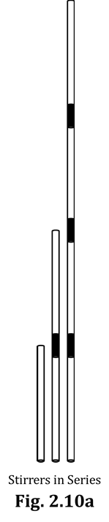
3. Tape another stirrer onto the end of the first one. Try to be sure there are NO leaks between the stirrers. Because the second stirrer is AFTER the first one, these two stirrers will therefore be connected in SERIES. See Fig. 2.10a. Table 2.10
(We have already met the term series,
back in Act. 2.1, when we connected carbon resistors to each other…in series.)
4. Repeat the “full breath/exhalation/timing” process with the two stirrers in series. Try to apply about the same pressure as before, and keep the pressure CONSTANT, in forcing the air out. Record your time in the CORRECT box of Table 2.10.

5. Construct all four stirrers in series. Enter your time for this trial into Table 2.10.

6. Show your partially-completed Table 2.10 to your teacher.

7. Describe the ease/difficulty (however slight) of exhaling through four stirrers in series, compared to exhaling through a single stirrer. (Hopefully, your timing data support a correct conclusion…)

Starting again from one stirrer, you can easily see that there is another way to add additional stirrers (other than adding them in series). This way is called adding them in parallel; that is, adding them in a side-by-side fashion (so they’re PARALLEL to each other, get it?) rather than adding them one-after-the-other, as in series. See Fig. 2.10b.
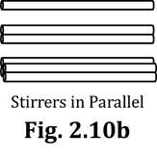
8. Remove the tape from the stirrers. With reference to Fig. 2.1b, repeat the “full breath/exhalation/timing” process with, first, two stirrers in parallel and then FOUR stirrers in parallel. Apply the same amount of CONSTANT exhalation pressure as before. Enter your times into Table 2.10.

9. Describe the ease/difficulty of exhaling through four stirrers
in PARALLEL, compared to exhaling through a single stirrer.
We will now relate what you did with multiple coffee stirrers to what we can do with multiple resistors.

10. Whenever you added stirrers in SERIES, resistance to air flow… INCREASED DECREASED

11. Whenever you added stirrers in PARALLEL, resistance to air flow… INCREASED DECREASED

Therefore, by extension…

12. Whenever we add RESISTORS in SERIES, resistance to CHARGE flow will… INCREASE DECREASE

13. Whenever we add resistors in PARALLEL, resistance to CHARGE flow will… INCREASE DECREASE

14. Quickly turn all the way back to Q7 in Activity 2.1. How did your
answer to THAT Q7 compare to your answer to Q12 above?

Fill in the blanks below.

15. ANY TIME we add a resistor into a circuit so that it is in SERIES with the stuff it is directly connected to…the total RESISTANCE of the circuit will INCREASE, and therefore the total CURRENT flowing through the circuit (also the battery) will _____________________.

16. ANY TIME we add a resistor (or a wire) into a circuit so that it is in PARALLEL with the stuff it is directly connected to…the total RESISTANCE of the circuit will DECREASE and – therefore – the total CURRENT flowing through the circuit (also the battery) will _____________________.

17. Show your answers to Q15 and Q16 to your teacher.

I don’t expect you to fully grasp the magnitude and importance of the statements made in Q15 and Q16 at this time but, make no mistake, you WILL (you MUST!) know/memorize/
understand those two statements eventually…and the sooner, the better.

18. Here is an easy way to remember the effective resistance of
resistors in series vs. parallel…Suppose you have to go for a
whole day breathing ONLY through four coffee stirrers. How
will you orient the stirrers, in series or in parallel, and…WHY?

2.11 Activity: A circuit with a parallel combination of bulbs
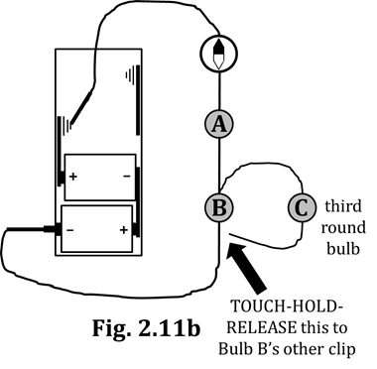
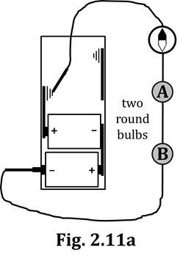
1. Build the circuit of Fig. 2.11a.

2. Draw arrowtails and starbursts on BOTH bulbs
of Fig. 2.11a. Normally it doesn’t matter,
but PLEASE USE the three-
arrowtail symbol this time.

3. Now build the circuit of Fig. 2.11b.
You will need a THIRD round bulb
and TWO more connecting wires
(i.e., leads). As it shows in Fig. 2.11b,
you will leave one end of a lead as a
place where you will TOUCH-HOLD-RELEASE.
4. Now, TOUCH-HOLD-RELEASE several times, to be sure of what you see.

5. Use your pencil to DRAW a closed gap into Fig. 2.11b, so Bulb C is shown to be in parallel with Bulb B.

6. When you TOUCHED-HELD-RELEASED, what did you observe?

6a. the amount of compass deflection INCREASED DECREASED

6b. the brightness of Bulb A INCREASED DECREASED

6c. the brightness of Bulb B INCREASED DECREASED

6d. the brightness of Bulb C INCREASED DECREASED

7. Based on your Q6a answer, what happened to the current in the
wire over the compass when you TOUCHED-HELD-RELEASED?

8. In Fig. 2.11b, draw ONE appropriate arrowtail symbol next to the compass. Be careful:
Look back at what you drew in Step 2 above; then choose this new arrowtail wisely.

9. Now draw ONE appropriate arrowtail symbol next to Bulb A.

10. Is your Q9 answer in agreement with your Q6b answer?

11. In Figs. 2.11a-b, the wire over the compass is connected to the (+) terminal. Therefore, what happened to the current flowing through the battery when you TOUCHED-HELD-RELEASED?

12. Now, draw ONE appropriate arrowtail symbol on the wire connected to the battery’s (–) terminal.

13. Step 9 and Step 12 above asked you to draw arrowtails into Fig. 2.11b. Please re-draw them here…

Step 9: next to Bulb A (i.e., BEFORE Bulbs B and C)

Step 12: by the wire touching the (–) terminal (i.e., AFTER Bulbs B and C)

14. Okay, follow the logic here: Bulbs B and C are in _________________ (you fill it in!) with each other. This means that the current flowing INTO that portion of the circuit DIVIDES: some of it goes through Bulb B, and the rest goes through Bulb C. In our circuit, Bulbs B and C are the SAME type of bulbs (i.e., round bulbs), and therefore they have EQUAL RESISTANCES. So, take a guess: WHICH arrowtail symbol MUST be drawn on…? (The word “DIVIDES”
might be important here…) Bulb B Bulb C

15. Have your teacher check your answer to Q14, and then DRAW the correct arrowtails into Fig. 2.11b.

16. Last thing: In this activity, we added Bulb C into the circuit IN PARALLEL. Compare now your answer from Q11 above with your answer to Q16 from the previous activity,
Activity 2.10. How did those answers compare to each other?

17. To review:

Any time we add a resistor into a circuit IN PARALLEL, the total resistance of the circuit _______________.
SUMMARY EXERCISE

1. Which has the thicker filament: a relatively high-resistance bulb, or a relatively low-resistance bulb?

2. Which type of bulb HAS the thicker filament?

3. What are the two observations we might make that could possibly give us information about the current in a circuit?

4. About your answer to Q3…List the conditions for which each of the observations mentioned in Q3 can
be applied.

5. When more bulbs are added into a circuit, is there ALWAYS more total resistance, as a result? Explain.

6. Which two experiments from this Section 2 Packet suggest that wires have essentially zero resistance?
Draw a diagram or sketch showing each of these experiments.

