Name _________________________________

**Section 1: WHAT IS HAPPENING INSIDE WIRES?**

**INTRODUCTION**

Electricity is usually invisible; except for lightning and sparks, one never sees it in daily life. However, light bulbs and a compass (the needle of which IS a tiny magnet) can give us evidence that something electrical is happening. By observing the behavior of the bulbs and the compass – and by making a few reasonable assumptions – you will begin forming correct ideas about electricity. In your mind, you will be creating a scientific model.

These learning activities are called the CASTLE program. CASTLE is an acronym for **C**apacitor-**A**ided **S**ystem for **T**eaching and **L**earning **E**lectricity. Throughout this program, you will work through a series of activities, thought experiments, and lines-of-questioning that are designed to get you to THINK, and ultimately to lead you to a solid understanding of electrical components and electrical circuits.

GOOD NEWS, for most of you: You do NOT need to have any prior knowledge about electricity in order to succeed at a very high level in this CASTLE program. You will learn from your observations of electrical phenomena and by reasoning logically about these phenomena. It is VERY important that you read and follow directions carefully. You are to perform ONLY the activities that are prescribed in these handouts; do NOT conduct unauthorized experiments. If you are curious about something for which there is no prescribed activity, ask your teacher; he or she will respond appropriately to your inquiry.

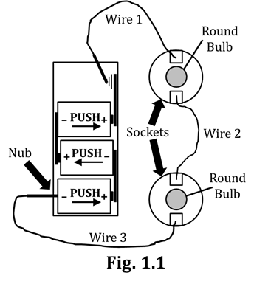

**INVESTIGATION ONE: WHAT IS NEEDED TO LIGHT A BULB?**

**1.1 Activity: Lighting bulbs in a loop**

Set up the circuit shown in Fig. 1.1, in the following way:

1. Locate the plastic battery pack, which has space for four D-cells

(i.e., four batteries). Insert the first D-cell into the slot that has

the nub, such that the (–) end of the D-cell is touching the spring

closest to the nub. Then, give that battery a little push so that its

(+) end makes firm contact with the non-spring end of the slot

(i.e., make sure that the (+) end of the D-cell touches the non-spring end).

2. Repeat this process with the next two D-cells, being sure that the (–) end of the battery touches the

spring, as well as that you HELP the spring by PUSHING the D-cell so its (+) end touches the non-spring end of the slot.

3. Screw two round bulbs into two plastic sockets. Make sure the bulbs are seated firmly, but do NOT overtighten them.

4. Obtain three connecting wires; note the alligator clips (also called leads – pronounced “LEEDS”) at the ends of the wire. Clip one end of Wire 1 to the spring of the fourth (empty) slot of the battery pack. (Note that this spring IS the (+) terminal.) Clip the other end of Wire 1 to one of the socket clips (they are metal). Use Wire 2 to connect the two sockets to each other (socket clip to socket clip), and use Wire 3 to connect the last socket clip to the nub (i.e., the (–) terminal) of the battery pack.

Verify that the bulbs light and that they have approximately the same brightness. (If this is NOT the case, raise your hand and ask your teacher for assistance.) You have just created what is called, in electrical terms, a closed loop or a closed circuit.

5. “Break” or “open” the loop by disconnecting Wire 1 from the (+) battery terminal (i.e., the spring end); then re-connect Wire 1, “closing” the loop. Repeat this process several times. Below, base your answers on what you observed.

5a. When you close the circuit, do the bulbs appear to light immediately? YES NO

5b. Do the bulbs appear to light at exactly the same time as each other? YES NO

5c. Do you BELIEVE that your answer to Q5b is REALLY what is happening? YES, I DO NO, I DON’T

5d. When the loop is broken, do the bulbs appear to go out immediately? YES NO

5e. Do the bulbs appear to go out at exactly the same time as each other? YES NO

5f. Do you BELIEVE that your answer to Q5e is REALLY what is happening? YES, I DO NO, I DON’T

6. A key tenet (i.e., a key idea, a key principle) of science is that we draw conclusions based NOT on what we BELIEVE, but rather on what we OBSERVE. Even so, scientists always keep an open mind that new observations might change our current understanding of things. Circle the letter of the one statement below that best expresses the mentality of a scientist.

A. “Even though the bulbs appear to light at the same time, they probably do not.”

B. “The bulbs definitely light at the same time.”

C. “The bulbs appear to light at the same time, so I’m going to assume that that REALLY is true,

until some other evidence is found that suggests otherwise.”

7. Now, be sure Wire 1 is re-attached to the (+) battery terminal (i.e., the spring), so that the loop is again closed. Because there are three wires, with each having two ends, there are a total of SIX places where the loop can be broken (and re-closed, obviously). You have tested ONE of these places already (where Wire 1 attaches to the (+) battery terminal). Now, open and close the loop at EACH of the other five locations. Be sure that you have only one break in the loop at a time.

Once you have tested a break at the other five locations…Does the

location of the break give you DIFFERENT results than what you

reported in your answers to Q5a, 5b, 5d, and 5e above?

**INVESTIGATION TWO: IS ANYTHING HAPPENING IN THE WIRES?**

**1.2 Activity: Investigating the loop with a compass**

You will now use the compass (and its magnetic needle) as a detector for what is happening in the wires.

1. Stick the compass to the tabletop (face up, obviously) with a rolled piece of masking tape.

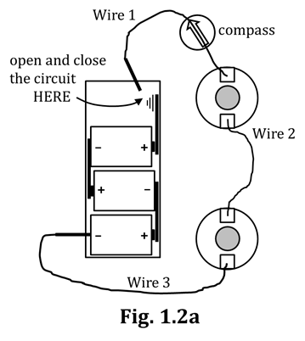2. Open the loop by disconnecting Wire 1 at the (+) battery terminal.

Leave the loop open as you assemble the circuit as shown in

Fig. 1.2a; do NOT close the loop again until instructed to do so.

***This next part is extremely important, so follow directions EXACTLY.***

3. With the loop still OPEN, manipulate the circuit such that part of Wire 1

can be pressed directly on top of the clear cover of the compass. ALSO, make

sure that that portion of Wire 1 is PARALLEL to the needle. Hold Wire 1

down with your fingers to make sure it stays parallel to the needle.

*You will need to BE WATCHING the compass when you perform the*

*next sequence of steps. If working with a partner, decide now which*

*partner will be watching the compass and which will be handling Wire 1.*

4. When ready, touch Wire 1 to the (+) battery terminal (the spring). Which way

does the compass needle deflect: clockwise (CW) or counterclockwise (CCW)? CW CCW

5. Disconnect Wire 1 from the (+) terminal. What does the compass needle do?

6. Connect and disconnect Wire 1 again several times, until you are confident of your Q4 and Q5 answers.

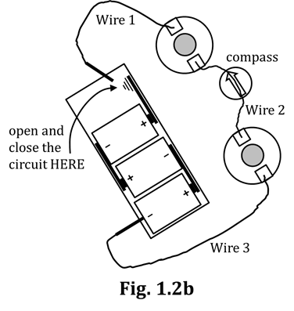

7. Break the loop again at the (+) battery terminal. Leaving the compass

where it is, ROTATE the ENTIRE circuit CCW so that Wire 2 is now

directly atop the compass. See Fig. 1.2b. DO NOT SIMPLY SLIDE THE

CIRCUIT STRAIGHT ACROSS THE TABLE. IT MUST BE ROTATED.

8. Holding Wire 2 parallel to the needle, touch Wire 1 to the

(+) terminal to close the loop, as you did before.

Which way does the compass needle deflect? CW CCW

9. How does the AMOUNT of compass deflection compare

to the AMOUNT you observed in Step 4 above?

10. Disconnect Wire 1 from the (+) terminal. What happens to the needle?

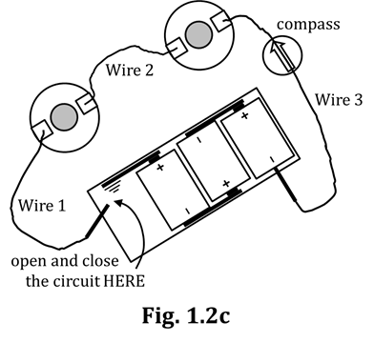

Repeat Steps 8 and 10 until you are confident of your Q8-Q10 answers.

11. With the loop broken, again ROTATE the ENTIRE circuit so

that – now – Wire 3 is atop the compass. (See Fig. 1.2c.)

BUT – before closing the loop – make a prediction: What, do

you think, the needle will do when you close the loop?

12. Holding Wire 3 parallel to the needle, touch

Wire 1 to the (+) terminal to close the loop.

Which way does the compass needle deflect? CW CCW

13. How does the AMOUNT of deflection compare to what you have previously observed?

14. Disconnect Wire 1 from the (+) terminal. What happens to the needle?

Repeat Steps 12 and 14 until you are confident of your Q12-Q14 answers.

15. Before going further, raise your hand and show your teacher your answers to Q4-Q14.

Next, you will essentially repeat the sequence you performed above, but first…

16. Disconnect Wires 1 and 3 from the battery pack, then turn the pack around so that Wire 1 is now connected to the nub (the (–) terminal) and Wire 3 is closest to the “fourth spring” (the (+) terminal). (See Fig. 1.2d.) This technique is called “reversing the battery orientation.”

17. Now, essentially repeat Steps 4-14, now that the battery orientation has been reversed. This time, you will connect and disconnect Wire 3 (instead of Wire 1) at the (+) battery terminal. Each time you test a wire, you ROTATE the entire circuit (like turning the steering wheel in your car). For every wire, be sure to hold the wire PARALLEL to the compass needle BEFORE closing the loop at the (+) battery terminal. Refer to Figs. 1.2d-f for visual guidance. NOTE that the compass STAYS IN PLACE; the circuit is merely rotated around the compass.

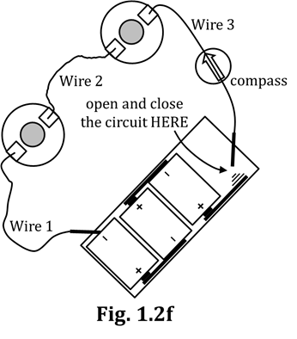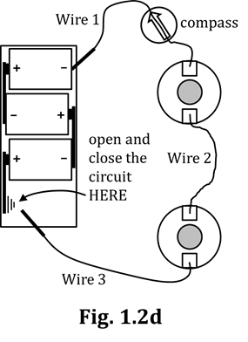

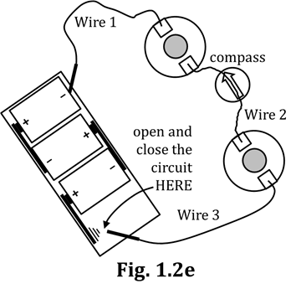

18. Summarize all of your results in Table 1.2g.

|  |  |  |  |  |  |  |
| --- | --- | --- | --- | --- | --- | --- |
|  | **Initial Battery Orientation** | | | **Reversed Battery Orientation** | | |
| **Wire** | **1** | **2** | **3** | **1** | **2** | **3** |
| **DIRECTION of compass deflection (CW or CCW)** |  |  |  |  |  |  |
| **AMOUNT of compass deflection**  **(approx. # of degrees)** |  |  |  |  |  |  |

**Table 1.2g**

19. Have your teacher check your Table 1.2g…because there is a VERY important idea in that data.

20. Easy question: When your circuit is closed, WHY is it that we conclude that the SAME thing is happening in every wire? Hint: Look at Table 1.2g.

**1.3 Commentary: What is a Circuit?**

As you have seen, a closed circuit (or a complete circuit) is an unbroken loop of electrical components that forms a CONTINUOUS conducting path. An open circuit (or broken circuit) has a GAP somewhere. The term *circuit* is from a Latin word that means “to go around,” as in planets *going around* the Sun.

This CASTLE curriculum is centered on model-building from evidence. There are two types of evidence that concern us: direct evidence and indirect evidence. Direct evidence is evidence we can gather with our senses and from which we draw inescapable conclusions. If we fill up the dog’s bowl and watch the dog eat the food, we have gathered DIRECT evidence that the dog has eaten. Indirect evidence involves us INFERRING something. If we fill up the dog’s bowl, then go for a 30-minute run (leaving the dog at home), and when we come back, the dog’s bowl is empty…we now have some INDIRECT evidence that the dog has eaten. A helpful hint for you: In these activities, whenever you are asked to cite evidence, at least 90% of the time we are looking for you to mention WHAT HAPPENED WITH THE COMPASS.

**1.4 Building Our First Mental-Model**

1. Let us begin with the assumption that there is something within the connecting wires. We will call this something charge. Furthermore, we will assume that charge can be made to move around a circuit in a circular path, like a bunch of runners going in a particular direction

around a track. Do we have any DIRECT evidence for this claim?

We do, however, have INDIRECT evidence that charge can move in the wires, and also that doesn’t have to be moving. Use your common sense to figure out – and then CIRCLE – the correct answers below.

2a. When the bulbs are lit, we have seen the compass on top

of the wire deflect. This is indirect evidence that charge: IS moving ISN’T moving

2b. When the bulbs are NOT lit, we saw that the compass goes back

to its natural orientation. This is indirect evidence that charge: IS moving ISN’T moving

3. Assuming charge IS able to move in a “going-around-the-track” path in the circuit, do

both the DIRECTION and AMOUNT of charge flow appear to be the SAME in every wire?

4. Cite evidence for your Q3 claim.

5. Predict what the compass would do if suddenly there was

MORE charge flowing in a circuit than there was before.

6. Be very critical, here…If a compass deflects, say, clockwise (CW): Are we absolutely

positive that the charges traveling around the loop are ALSO going in a CW direction?

7a. To review: When the battery orientation was reversed, state again what the compass needle did.

7b. Therefore, it is logical to suppose that the charges did WHAT when you reversed the battery?

8. And – piggy-backing on your Q7 answers – WHAT does a battery determine, in a circuit?

9. A compass can tell us a lot about charge flow in a circuit. Below, CIRCLE the letters of the three TRUE statements; put an X over the letter of the one FALSE statement. **“A compass CAN tell us**…”:

A. whether or not there is charge flowing in a circuit

B. which specific direction (CW or CCW) the charge is flowing around a circuit

C. whether the charge flow has increased or decreased, compared to what it was before

D. whether the charge flow has changed direction, compared to what it was before

**1.5 Commentary: In which direction is charge moving?**

In case you missed the entire gist of what you were supposed to get out of Activity 1.4:

**A compass gives NO information about the direction (CW or CCW) of charge flow around a circuit loop. When the battery orientation is reversed, the reversal of the compass deflection shows that the direction of charge flow has ALSO reversed, but the compass doesn’t tell us which way the charge is now going…nor which way it was going before we flipped the battery.**

When scientists began studying electric circuits, they were unable to determine the exact direction of charge flow around a loop. So they settled upon a convention, an agreed-upon assumption that is useful, but not necessarily right or wrong. Their charge-flow convention – which we still abide by today – is this:

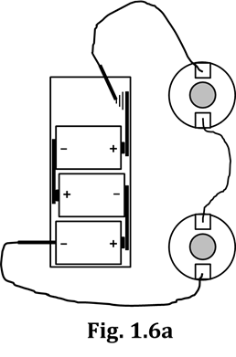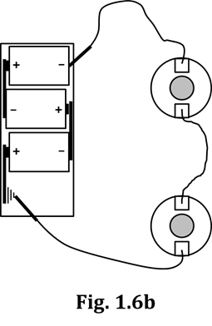

Charge flows AWAY from the (+) battery

terminal, through the wires and bulbs of the

circuit, and TOWARD the (–) battery terminal.

**1.6 Exercise: Practice with**

**Conventional Charge Flow**

Figures 1.6a and 1.6b show the circuits you

constructed in Section 1.2. Draw arrows

next to each of the three wires to properly

indicate the direction of conventional

charge flow through the circuit.

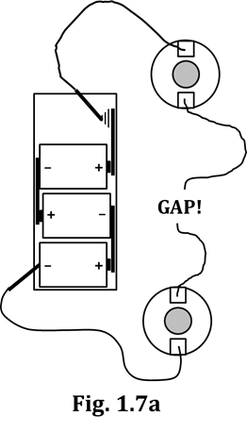**INVESTIGATION THREE: TESTING CONDUCTORS AND INSULATORS**

**1.7 Activity: Identifying conductors and insulators**

1. Modify the circuit of Fig. 1.6a by adding a fourth connecting wire,

as shown in Fig. 1.7a. This figure is called the testing circuit. You

will be inserting various materials into the GAP! in the two wires

between the bulbs and testing whether each material is a conductor

or an insulator. A conductor will ALLOW the bulbs of the test circuit

to light; an insulator will PREVENT the bulbs from lighting.

2. Using the testing circuit of Fig. 1.7a, complete Table 1.7b by circling

your choices. In the two rows at the bottom of the table, find two

other objects (your choice!) and test them for conductivity, too.

|  |  |  |  |
| --- | --- | --- | --- |
| **Test object** | **Prediction**  **(before testing)** | **Observation of Circuit** | **Classification**  **(after testing)** |
| **aluminum foil** | insulator conductor | bulbs lit no light | insulator conductor |
| **Popsicle stick** | insulator conductor | bulbs lit no light | insulator conductor |
| **string** | insulator conductor | bulbs lit no light | insulator conductor |
| **nail** | insulator conductor | bulbs lit no light | insulator conductor |
| **paperclip** | insulator conductor | bulbs lit no light | insulator conductor |
| **cardboard** | insulator conductor | bulbs lit no light | insulator conductor |
| **waxed paper** | insulator conductor | bulbs lit no light | insulator conductor |
|  | insulator conductor | bulbs lit no light | insulator conductor |
|  | insulator conductor | bulbs lit no light | insulator conductor |

**Table 1.7b**

3. State here what… …all/most of the conductors have in common 🡪

…all/most of the insulators have in common 🡪

Based on the patterns you saw in Table 1.7b AND your answers to Q3, you should – from this point onward – immediately be able to identify essentially any material as likely to be either a conductor or an insulator.

**1.8 Activity: Determining the Conducting Path in a Bulb**

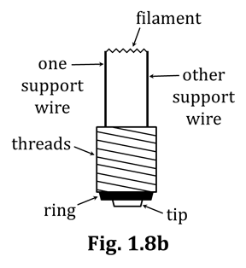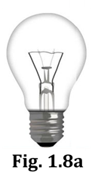The purpose of this activity is for you to learn the precise conducting pathway by which charge flows through a light bulb. You will also learn WHY bulbs and bulb sockets are constructed the way they are. To do this, you will begin by using a full size, household screw-in type incandescent bulb. This “dissected” bulb is missing two of its original structures: (1) the metal (usually made of tungsten, FYI…) filament, which glows white-hot when charge flows through it, and (2) the outer glass bulb. You can see all structures of a bulb in Fig. 1.8a, which is a photograph of an

incandescent bulb. Fig. 1.8b is a diagram showing the essential

structures of such a bulb. From this point onward, you are

responsible for knowing all of the structures specified in Fig. 1.8b.

1. Obtain a dissected bulb from among the supplementary materials available.

2. Examine the dissected bulb and locate the structures identified in Fig. 1.8b. Point to each structure and say aloud the name of each structure. You will note that the filament is unfortunately missing.

3. Of the structures you just identified and named, only ONE of them is an insulator.

Examine the bulb again, decide which structure is the insulator, and write its name here.

4. Now examine one of your round bulbs and verify that it contains the same structures.

Now that you are familiar with bulbs, your next task is to determine the precise path of charge flow through a bulb. But first, let’s start you thinking about putting things in a logical sequence…

Suppose you intend to visit Wellington, New Zealand. (You’ll need a passport, and it’s close to Australia, so you’ll have to cross an ocean, FYI…). Anyway, you’re flying out of Chicago, and there are no direct flights between Chicago and Wellington. There ARE, however, direct flights between THESE cities…

Auckland, NZ 🡨🡪 Wellington, NZ Los Angeles 🡨🡪 Chicago Los Angeles 🡨🡪 Auckland, NZ

5. List here, in correct sequential order, the four cities AND one ocean you would encounter as you travel to NZ. Also, draw a BOX around the name of the OCEAN .

6. Now list the four cities AND one OCEAN in the order you would encounter them on the way home.

You can see that, to go between Chicago and Wellington, there is a specific sequence of things that you HAVE to encounter, in a particular order. What you will do next is to try to determine the correct sequence of “things” that MUST be encountered – NOT when someone is traveling around the world – but rather when CHARGE is traveling through a light bulb.

7. Look closely now at one of the sockets in your circuit. Each socket is designed to make contact with TWO structures on a bulb. Choosing from among the structures shown in Fig. 1.8b, list the names of the TWO bulb structures that make physical contact with a socket.

8. Raise your hand so your teacher can verify your answer to Q7.

9. In Q5 and Q6 above, the two cities Chicago and Wellington were the endpoints for your traveling adventure. Similarly, the two structures you listed in Q7 are the endpoints for the pathway that CHARGE takes as it travels through a bulb.

10. You will now do something like what you did in Q5 and Q6. This time, however, instead of listing

(IN ORDER!) four cities and one OCEAN , you will list (IN ORDER!) four BULB STRUCTURES and

one FILAMENT . You have to THINK and use a tiny bit of logic, but this is NOT very hard. Here are some hints to help you:

* All of the bulb structures you will list are shown in Fig. 1.8b.
* In Q5 and Q6, you listed two cities, then an OCEAN , and then two more cities. Here, you will list two bulb structures, the FILAMENT , and then two more bulb structures. BOX in the FILAMENT .
* Your answers to Q5 and Q6 were flip-flops of each other. Here, do that flip-flopping again (i.e., write down TWO properly-ordered lists, each of which is the other…run backwards).

GO. ☺

11. Show your two lists above to your teacher, to make sure you are on the right track.

NOTE: It is CRUCIAL that you memorize your answers to Q10.

**1.9 Commentary: Why do we need the insulating ring on a light bulb?**

Perhaps you can now understand why there is a black, insulating ring separating the bulb threads from the bulb tip. Charge must be FORCED to flow through the filament; if there were no ring between the threads and tip (i.e., if threads and tip were DIRECTLY connected), the charge would take the easiest path and flow straight from one to the other, without bothering to flow through the filament. And flowing through the filament is what it’s all about; we’re talking about a light bulb, after all. Without charge flowing through the filament, the filament CANNOT be made to glow white-hot, and…NO LIGHT!

**1.10 Activity: Lighting a bulb with a minimum of materials**

For this activity, you are allowed to use ONLY three items: one round bulb, one D-cell, and one wire.

That’s it. Nothing else.

Your task is to use those three items to make ONE of them (the bulb, duh…) light up. Here are two hints:

* Refer back to your answers to Q10 in Section 1.8.
* There are FOUR possible ways to orient the three items to complete this task. You must figure out ALL FOUR, and then DRAW a sketch of each of them.

GO. ☺

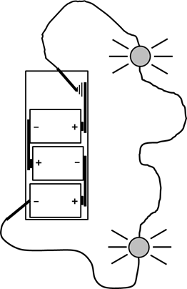**SUMMARY EXERCISE**

Refer to figure in order to answer Q1-Q4.

1. Are there any breaks or insulators in this circuit?

2. Is this circuit a continuous conducting path?

3. Cite evidence from the figure that supports your

answers to Q1 and Q2.

4. On the figure, draw arrows next to the wires and

bulbs to show the direction in which conventional charge is flowing through the circuit elements.

5. What evidence have you observed in your activities that suggests that something is happening in the wires (NOT the bulbs!) when the bulbs are lit?

6. State our present hypothesis about what is happening in the wires while the bulbs are lit.

7. State our present hypothesis about what happens in the wires when the battery connections are reversed. Also, state the evidence for this claim.

8. It appears that the battery is doing WHAT whenever bulbs are lit?

9. Based on the assumption that charge flows through wires when bulbs in a circuit are lit…

A. Is the direction of the charge flow (we’re talking CW or CCW, here)

the same through all parts of the circuit, or does it vary?

B. What is the evidence for your answer to Q9A?

10. On this diagram of a bulb in a socket, draw a heavy line to show a continuous conducting path that starts at one wire (which is attached to a socket clip), goes through the bulb, and leaves at the other wire (attached to the other socket clip). You can see that part of the supporting wires have been left out of the diagram; YOU need to draw in the rest of the supporting wires, connecting them to the proper places (as best you can). Refer back to your work in Section 1.8, if necessary.

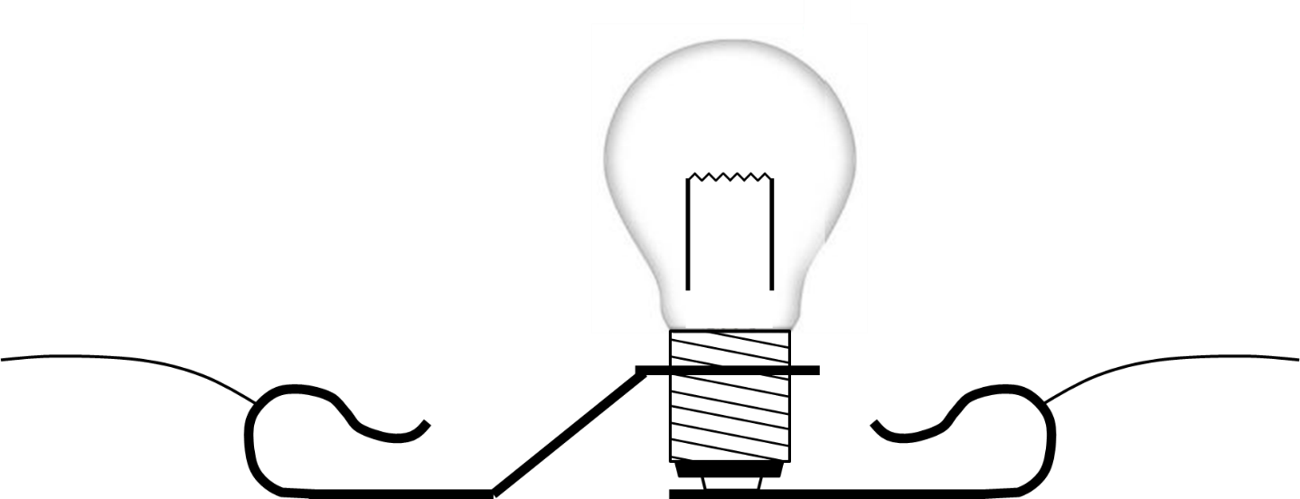

11. In a directional device, the direction in which the charge is flowing makes a difference; in a non-directional device, charge can easily flow in either direction. Look back for a moment at your work in Section 1.10 and then answer the following question: Would you classify light bulbs as directional devices or non-directional devices? Your answer to Q10 above might also give you some insight.