**Homework Questions: Section 5** Name _________________________________

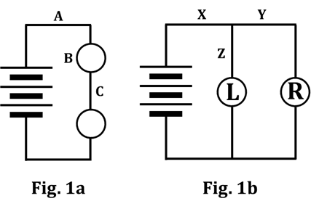

1. Consider the circuits shown in Figures 1a and 1b.

a. Write an equation or inequality that expresses how the

flow rates at A, B, and C compare to each other.

Call the variables Aflow, Bflow, and Cflow.

b. WHAT ABOUT the layout of the circuit in Figure 1a

REQUIRES that your answer to Q1a be what it is?

c. Write an equation or inequality that expresses how the electric pressures

at A and C compare to each other. Call the variables Apres and Cpres.

d. Write an equation or inequality that expresses how the electric pressures at

X, Y, and Z compare to each other. Call the variables Xpres, Ypres, and Zpres.

e. Write an EQUATION (NOT an inequality) to show how the flow rates at X, Y,

and Z compare to each other. Call the variables Xflow, Yflow, and Zflow.

f. WHAT ABOUT the layout of the circuit in Figure 1b REQUIRES that your answer to Q1e be what it is?

g. Write an INEQUALITY (NOT an equation) to show how the MAGNITUDES of the flow

rates at X, Y, and Z compare to each other. Call the variables Xflow, Yflow, and Zflow.

h. WHAT IS IT about the circuit components in Figure 1b that justifies your answer to Q1g?

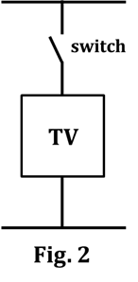2. Circuits in homes or businesses are designed so that the appliances or devices are

wired in parallel. Of course, each device also has a SWITCH of some kind that

allows the user to turn the device ON and OFF. A simple schematic of an

appliance might look like what is shown in Figure 2. You can see the switch,

which you can imagine can be pushed closed to turn the device on.

In the space here, show a simple

schematic of a house circuit. Start

by drawing the schematic for a

battery; this will indicate the

electric pressure provided by

the household circuit. Then draw,

in parallel to each other, a toaster,

microwave, and coffee maker,

showing the switch for each,

similar to what’s shown in Fig. 2.

3. The wires that an electric company connects to your house can be pictured as being attached to a very big battery having an electric pressure of 120 volts. The electric lights and appliances in your house are designed to operate properly only when there is a 120-volt pressure difference across them AND they are all connected in PARALLEL. List two advantages of parallel wiring, rather than series. To help you understand why parallel is preferable, it might help to look back at the schematic you drew in Q2.

4. A home or business has many separate circuits, each of which has multiple parallel branches. In each circuit, a fuse or – more commonly today – a circuit breaker is inserted into the wire that leads from the power source to the parallel branches. A fuse melts or a circuit breaker opens if the current through it becomes greater than a certain value (often, 20 amperes). The purpose of a fuse or circuit breaker is to prevent the wires from overheating and possibly starting a fire when too many appliances are connected in parallel. In the space here, re-draw your circuit from Q2, but this time draw in ONE circuit breaker (or fuse) whose purpose is to protect the circuit (i.e., “shut everything down”) if the current through the “battery” gets too large. You can represent the circuit breaker or fuse as .

5. What does a circuit breaker or fuse do that enables it to potentially save appliances (and wires, and homes, and people, and pets!) from harm?

6. In a home or business, the main electrical “trunk” that enters the building diverges into several “branches.” Draw a diagram showing how the main trunk wire diverges into the following branches: “kitchen,” “family room,” “bathroom,” “garage,” and “bedrooms 2 and 3.”

HINT: This will NOT be a complete circuit; just show one thing branching out into several.

7. The branch wires, of course, are attached to many different devices and lights having various resistances. Write an equation expressing the relationship between the flow rates in the trunk and in the various branches. Use the variables trunkflow, kitchenflow, family roomflow, bathroomflow, garageflow, and BR 2 and 3flow.”

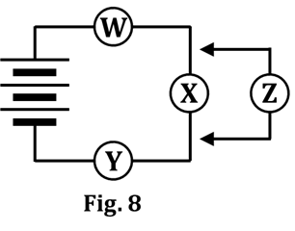8. A battery is connected to three identical bulbs – W, X, and Y – in

series, as shown in Figure 8. After a steady state condition

is reached, a fourth identical bulb – bulb Z – is connected

in parallel to bulb X. Identify the effect the adding of

bulb Z has on the:

|  |  |  |  |  |  |
| --- | --- | --- | --- | --- | --- |
|  |  | increases  a bit | decreases  a bit | remains  the same | drops to  ZERO |
| a. | total resistance of the circuit |  |  |  |  |
| b. | flow rate through the battery |  |  |  |  |
| c. | flow rate through W |  |  |  |  |
| d. | flow rate through Y |  |  |  |  |
| e. | electric pressure difference across W |  |  |  |  |
| f. | electric pressure difference across Y |  |  |  |  |
| g. | electric pressure difference across X |  |  |  |  |
| h. | flow rate through X |  |  |  |  |

9. To answer this question, refer back to Figure 8. Suppose you put a WIRE where bulb Z is, instead of bulb Z. Identify the effect the adding of this wire would have on the:

|  |  |  |  |  |  |
| --- | --- | --- | --- | --- | --- |
|  |  | increases  a bit | decreases  a bit | remains  the same | drops to  ZERO |
| a. | total resistance of the circuit |  |  |  |  |
| b. | flow rate through the battery |  |  |  |  |
| c. | flow rate through W |  |  |  |  |
| d. | flow rate through Y |  |  |  |  |
| e. | electric pressure difference across W |  |  |  |  |
| f. | electric pressure difference across Y |  |  |  |  |
| g. | electric pressure difference across X |  |  |  |  |
| h. | flow rate through X |  |  |  |  |

10. Circle the correct answer.

In a circuit, a battery is a device that supplies a constant… CURRENT ELECTRIC PRESSURE

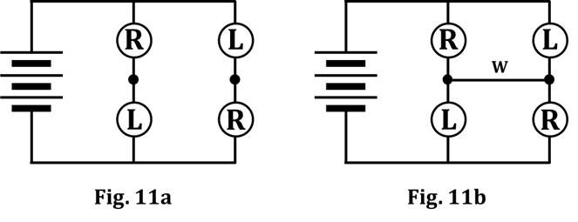11. Refer to the figures at right.

Fig. 11a is how the circuit

starts out. Somewhat later,

wire W is added across the

branches; the result is what

you see in Fig. 11b.

a. Color-code both figures.

HINT on color-coding Fig. 11b:

Note that Fig. 11b is symmetrical, in the up-down sense. Although the left-right configuration of the bulbs is different, THAT doesn’t change the fact that there is UP-DOWN SYMMETRY.

b. Which way will conventional charge flow in wire W at the

moment wire W is connected? Circle your answer. TO THE LEFT TO THE RIGHT

c. Use your color-coding of Figure 11a to justify your answer to Q11b.

d. Which way will conventional charge flow in wire W when a final

steady state condition is reached? Circle your answer. TO THE LEFT TO THE RIGHT

e. Use your color-coding of Figure 11b AND your knowledge of the resistances of the different types of bulbs to justify your answer to Q11d.

f. State how the brightness of each bulb compares, in going from Fig. 11a to Fig. 11b.

g. Use your color-coding of BOTH figures to justify your answer to Q11f.

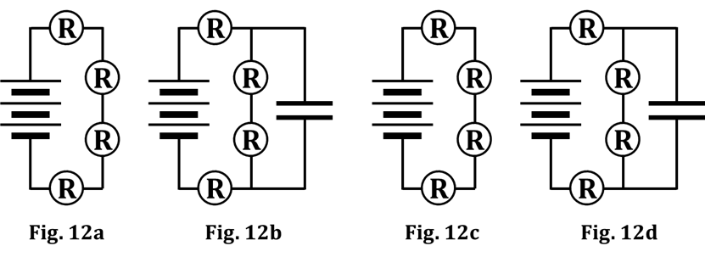12. Refer to the figures.

a. Color-code Figures 12a

and 12b at the MOMENT

OF CONNECTION.

b. Color-code Figures 12c

and 12d at STEADY-

STATE CONDITIONS.

c. Explain WHY it takes so much longer for Fig. 12b to become Fig. 12d than it does for Fig. 12a to become Fig. 12c.