Homework Questions: Section 4 Name _________________________________

1. The table at right indicates the electric
 | Wire on one side of bulb | Wire on other side of bulb | How bright is the bulb?
a. | red | green
b. | yellow | blue
c. | red | yellow
d. | blue | orange
e. | orange | green
f. | orange | red
g. | green | blue
h. | red | blue
i. | orange | yellow
j. | green | yellow
pressures in the wires on each side
of a bulb. Fill in the last column. Your
choices are…. very bright
bright
medium-bright
dim
not lit

NOTE: Assume all bulbs are identical.

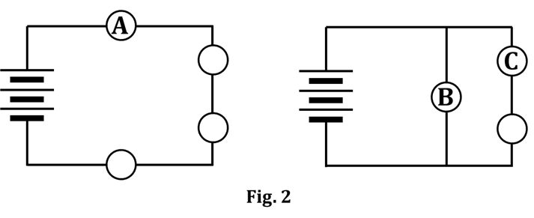
2. Use color-coding to determine
the order of brightness of
bulbs A, B, and C, shown
in Figure 2.

BRIGHTEST ______ ______ ______ DIMMEST

3. In a circuit, CONVENTIONAL charge _____ A. low pressure to high pressure

is always considered to flow from: _____ B. negative to positive

_____ C. high pressure to low pressure

4. Color-code (or just label with the letters R/O/Y/G/B, if you want) the figures shown. The colors should indicate the electric pressure existing in each wire at the time indicated. Remember that we NEVER color-code bulbs, but that we ALWAYS color-code capacitor plates. Also, draw appropriate starbursts around any bulb that is lit, indicating the brightness of the bulb at that particular time.
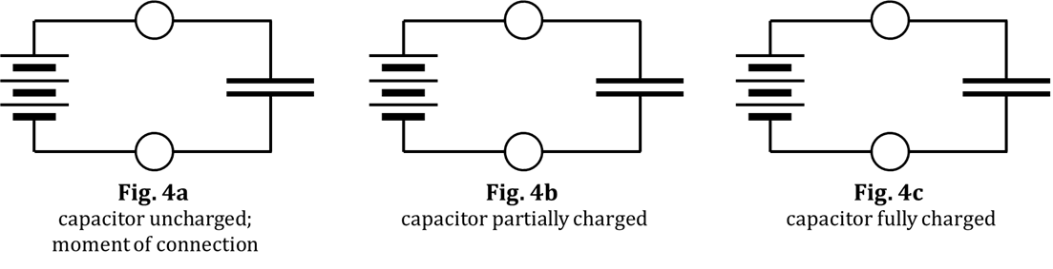

5. A capacitor and a battery are in a circuit during charging; then the battery is removed. Using the term ELECTRIC PRESSURE, describe a charged capacitor. It might help to look at the color-coding you did in Q4.

6. Use the figures shown and answer the questions.

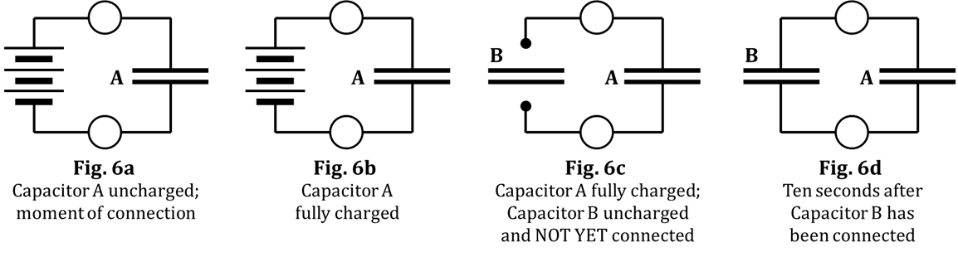

a. Color-code Figure 6a, at the moment of connection. NOTE the presence of Capacitor A in Fig. 6a.

b. Color-code Figure 6b, in which Capacitor A is fully charged.

c. In Fig. 6c, the circuit shown in Fig. 6b has been modified, in this way: The battery has been removed and a second capacitor – Capacitor B, which is initially uncharged – is brought out but has NOT YET been connected into the circuit. Capacitor A has not been touched or discharged. In Fig. 6c, color-code the circuit that remains in place AS WELL AS the plates of the uncharged Capacitor B.

d. In Fig. 6d, Capacitor B has been inserted into the circuit where the battery used to be. Given that capacitor plates can donate or accept way, WAY, WAY! more charge than wires can, color-code Fig. 6d to show the state of affairs, say, ten seconds after connecting Capacitor B into the circuit.

e. What is true about the capacitors in Fig. 6d? A. they are both uncharged

B. they are both fully charged

C. one is fully charged; the other is uncharged

D. they are both partially charged

E. one is fully charged; the other is partially charged

f. How did the bulbs behave when going from Fig. 6c to Fig. 6d, compared to how they behaved when going from Fig. 6a to Fig. 6b?

g. Use the idea of electric pressure difference to explain your answer to Q6f.

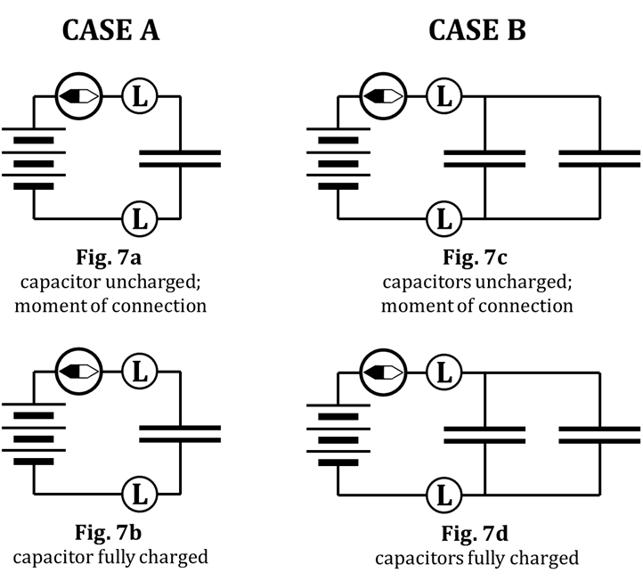
7. Consider Case A (Fig. 7a and 7b)
and Case B (Fig. 7c and 7d).

a. Color-code all four figures.

Now, compare Case A (which starts with Fig. 7a and ends with Fig. 7b)
with Case B (which starts with Fig. 7c and ends with Fig. 7d).

b. The initial bulb brightness will be greater for: ____ A ____ B ____ neither; it’s a tie

c. The initial (i.e., the max.) compass deflection will be greater for: ____ A ____ B ____ neither; it’s a tie

d. The bulbs will stay lit longer for: ____ A ____ B ____ neither; it’s a tie

e. The compass will stay deflected longer for: ____ A ____ B ____ neither; it’s a tie

f. The direction of compass deflection will be: ____ same dir. ____ opposite dir.

Now, we’ll DISCHARGE the circuits, i.e., discharge Fig. 7b for Case A and discharge Fig. 7d for Case B.

When discharging:

g. The initial bulb brightness will be greater for: ____ A ____ B ____ neither; it’s a tie

h. The initial (i.e., the max.) compass deflection will be greater for: ____ A ____ B ____ neither; it’s a tie

i. The bulbs will stay lit longer for: ____ A ____ B ____ neither; it’s a tie

j. The compass will stay deflected longer for: ____ A ____ B ____ neither; it’s a tie

k. The direction of compass deflection will be: ____ same dir. ____ opposite dir.

8. Suppose you begin a sequence of experiments involving two long bulbs, a discharged capacitor, and three SEPARATE three-cell battery packs.

a. You build the circuit shown in Fig. 8a. Over the first, say, five-seconds after
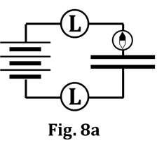
connection, describe the behavior of the:

i. compass

ii. bulbs

b. At the start of the scenario in Fig. 8a, the capacitor acts like ____ batteries.

c. At the end of the scenario in Fig. 8a, the capacitor acts like ____ batteries.

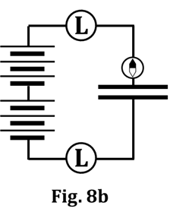
d. Now, WITHOUT DISCHARGING the capacitor, you add a second three-cell
battery pack, as shown in Fig. 8b. Again, over the first five seconds
after connection, describe the behavior of the:

i. compass

ii. bulbs

e. At the start of the scenario in Fig. 8b, the capacitor acts like ____ batteries.

f. At the end of the scenario in Fig. 8b, the capacitor acts like ____ batteries.

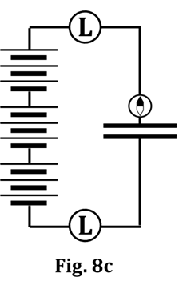
g. Now, again WITHOUT DISCHARGING the capacitor, you add a third three-
cell battery pack, as shown in Fig. 8c. Again, over the first five seconds
after connection, describe the behavior of the:

i. compass

ii. bulbs

h. At the start of the scenario in Fig. 8c, the capacitor acts like ____ batteries.

i. At the end of the scenario in Fig. 8c, the capacitor acts like ____ batteries.

j. Finally, you REMOVE all three three-cell battery packs, as shown in Fig. 8d.
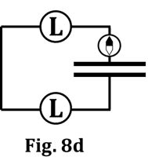
You connect the free ends of the wires together. Over the first five
seconds after connection, describe the behavior of the:

i. compass

ii. bulbs

h. At the start of the scenario in Fig. 8d, the capacitor acts like ____ batteries.

i. At the end of the scenario in Fig. 8d, the capacitor acts like ____ batteries.

