**Homework Questions: Section 3** Name _________________________________

1. The drawing of a circuit is shown below. In the space to the right, redraw it as a schematic diagram.

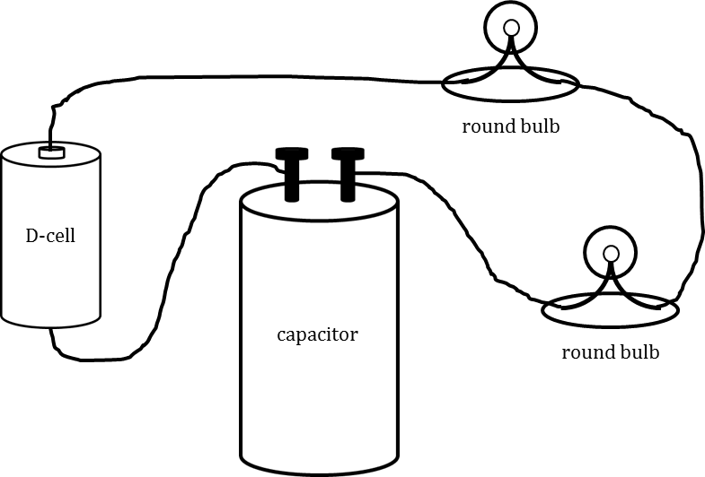

2. Figure 2 represents what the compass and bulbs look like at the moment the battery is connected.

a. On Fig. 2, draw a nearly-continuous arrow to show conventional charge flow.

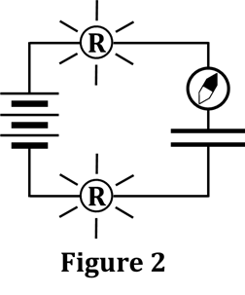b. Describe what happens to the bulbs in the next five seconds.

c. Describe what happens to the compass in the next five seconds.

3. Now that the capacitor in Figure 2 is fully charged, the battery is

effectively removed, which yields Figure 3. On Figure 3, draw:

a. what the compass will look like at the moment the wires are

re-connected at the single battery terminal

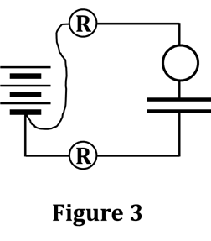

b. starbursts to indicate how bright the bulbs will be at the moment

the wires are re-connected at the single battery terminal

c. draw a nearly-continuous arrow to show conventional charge flow.

d. Describe what happens to the bulbs in the next five seconds.

e. Describe what happens to the compass in the next five seconds.

4. Bulbs A and B light temporarily when the circuit in Figure 4a is connected. They will also light temporarily if they are connected as shown in Figure 4b.

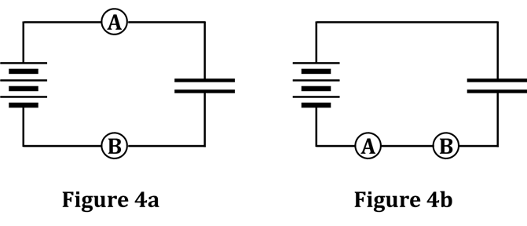

a. Draw arrowtails on both diagrams to show the movement of charge during charging, AT THE FIRST MOMENT WHEN THE CIRCUIT IS CONNECTED. Also, draw starbursts on each bulb.

b. State where, primarily, the charge ORIGINATES that moves through the bulbs in Figure 4b.

5. In Figure 5, what causes the charge to move through the bulbs?

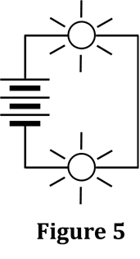 Be specific.

6. In Figure 6, what causes the charge to move through the bulbs?

Be specific.

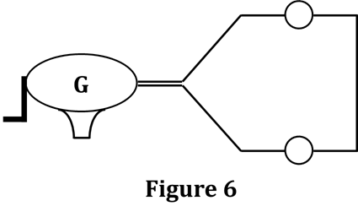

7. A capacitor is charged through two bulbs (Figure 7a) and then discharged through a single bulb (Figure 7b). FIRST, show starbursts and arrowtails for ALL bulbs in the figures below.

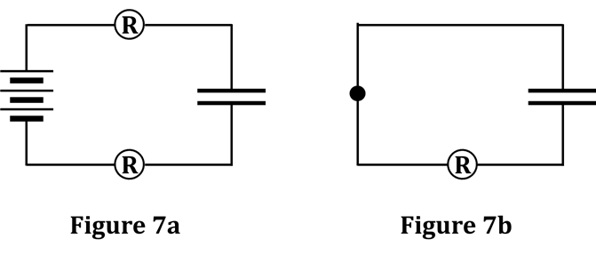

Now, mark each of the following statements TRUE or FALSE. If a statement is FALSE, then underneath it, change one or more of the words to make it a correct statement.

a. _________ The same total amount of charge flows during charging and discharging.

b. _________ More charge flows through the single bulb than through the two bulbs.

c. _________ Charge flows at a greater rate through the single bulb than through the two bulbs.

d. _________ The single bulb shines brighter than either bulb in the two-bulb circuit.

e. _________ The total resistance of the two bulbs is greater than that of the single bulb.

f. _________ A compass would show a larger deflection for the two-bulb circuit than for the one-bulb circuit.

g. _________ When the bulbs are brighter, that means that charge is flowing the fastest.

h. _________ Charge flows in the same direction in both circuits.

i. _________ Conventional charge flows counterclockwise in Fig. 7a and clockwise in Fig. 7b.

8. Below are three proposed patterns of charge flow while a capacitor is charging, and then discharging. Fig. 8a is charging, with 8b discharging; 8c is charging, with 8d discharging, and 8e charging, with 8f discharging. In the open space next to each figure, CIRCLE whether or not the charge flow arrows shown are correct or incorrect. Support each of your answers with an explanation. Where possible, state EVIDENCE rather than just theory.

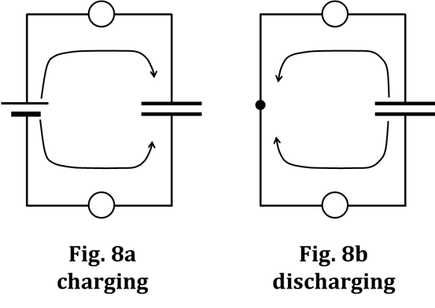

Fig. 8a Fig. 8b

correct incorrect correct incorrect

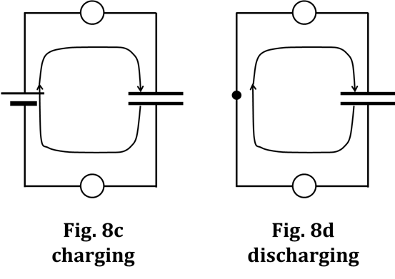

Fig. 8c Fig. 8d

correct incorrect correct incorrect

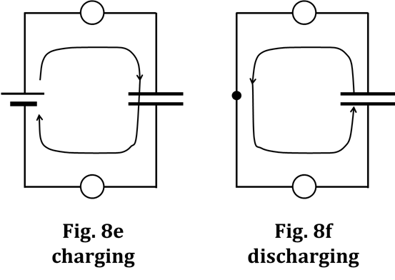

Fig. 8e Fig. 8f

correct incorrect correct incorrect