**Homework Questions: Section 2** Name _________________________________

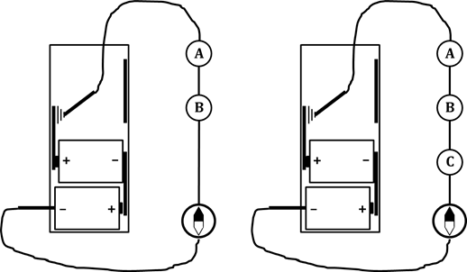1. In the circuits shown, all bulbs are identical.

At the start, the circuit contains only

bulbs A and B. At a later

time, bulb C is added, as shown.

a. Draw arrowtails and starbursts on the bulbs in both figures.

b. When bulb C is added:

i. Bulb A will… _____ become brighter _____ become dimmer _____ stay the same brightness

ii. Bulb B will… _____ become brighter _____ become dimmer _____ stay the same brightness

iii. the amount of compass

deflection will be _____ more than before _____ less than before _____ the same as before

iv. the direction of compass

deflection will be _____ opposite to before _____ the same as before

2. Suppose you are given two new bulbs (Brand X), which are different from the round and long bulbs you have been using. You need to determine how the resistance of Brand X bulbs compares to that of both round and long bulbs. Describe an experiment you could conduct to solve this problem, AND state how the results of the experiment will provide you with the answer.

3. List the following materials, in order from lowest to highest resistance: **round bulbs**

**long bulbs**

**connecting wires**

__________________________ < ___________________________ < __________________________

LOWEST RESISTANCE < “MIDDLE” RESISTANCE < HIGHEST RESISTANCE

4. Describe one or more experimental observations that support your answer to Q3.

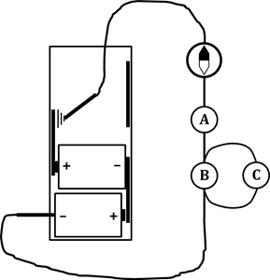5. Refer to the circuit at right. Originally, it contained ONLY bulbs A and B.

When bulb C is added:

a. the total resistance of the circuit

_____ increases _____ decreases _____ stays the same

b. the flow rate of charge through the battery

_____ increases _____ decreases _____ stays the same

c. the flow rate of charge through bulb A

_____ increases _____ decreases _____ stays the same

d. the brightness of bulb A

_____ increases _____ decreases _____ stays the same

e. the AMOUNT of compass needle deflection

_____ increases _____ decreases _____ stays the same

f. the DIRECTION of compass needle deflection

_____ changes _____ stays the same