**Homework Questions: Section 1** Name _________________________________

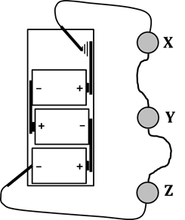Answer the following questions. As much as possible, base your answers

NOT on what you THINK, but what you OBSERVED in your CASTLE activities.

1. In the circuit shown, which bulb(s) light(s) first?

A. Bulb X D. All bulbs light at the same time.

B. Bulb Y E. Bulbs X and Z light first, then Bulb Y lights.

C. Bulb Z

2. For each loop shown, CIRCLE the bulbs that will light and put an X through the ones that don’t.

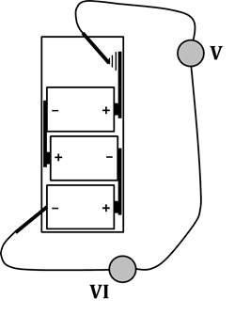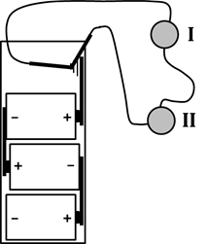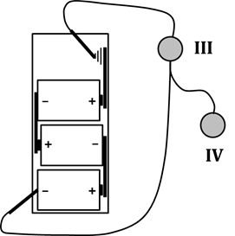

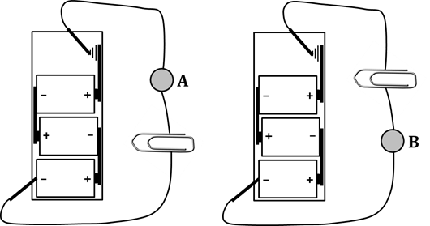3. In each of the circuits shown, a paperclip

has been inserted into the gap between

two wires. Which statement is true?

A. Bulb A will be brighter.

B. Bulb B will be brighter.

C. Both bulbs will light and have the same brightness.

D. Neither bulb will light.

4. Support your answer to Q3 by correctly using the terms “insulator” and “conductor.”

5. WHAT ABOUT the paperclips shown above could be changed that would cause you to give a different answer to Q3?

6. We have observed that as soon as even the slightest gap is produced

anywhere in a circuit, the bulbs go out. Based on this observation,

would you classify air as an insulator or conductor?

7. CIRCLE whether each statement that follows is TRUE or FALSE. Then, provide evidence.

TRUE FALSE A. Charge flows out of both battery terminals and into a circuit.

Evidence:

TRUE FALSE B. Light bulbs are non-directional devices.

Evidence:

TRUE FALSE C. The battery determines the direction of flow of charge in a circuit.

Evidence:

TRUE FALSE D. A compass can be used to determine the exact direction (e.g., CW or CCW)

in which charge flows in a circuit.

Evidence:

TRUE FALSE E. Metal substances are generally conductors.

Evidence:

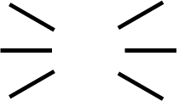

8. For each circuit shown, decide which bulbs will light and then draw starbursts on those bulbs. ALSO, draw a heavy line showing the continuous conducting path.

You will have to add to the support wires to show where they connect to the rest of the bulb.

