Chromatography

Chromatography is a useful method for separating the substances in some mixtures. As you recall, the substances in a mixture are NOT chemically combined, so they can be separated from one another. Chromatography can be used to separate some substances because each substance dissolves at a different rate.

Many mixtures, such as inks and food colorings, consist of 2 or more different dyes. To separate the different dyes, a small portion of the mixture is put on an absorbent material such as filter paper, also called chromatography paper. A liquid solvent is put into contact with one end of the filter paper. The solvent is soaked up by the filter paper and is drawn upward, where it meets the mixture of dyes. If a dye is easily dissolved in the solvent, it moves rapidly up the paper. If another dye dissolves less easily, it creeps along very slowly.

Soon, a pattern of colors will appear on the filter paper. Each color will be that of a single dye that was in the ink. The distance that one dye travels is a property of that dye. This property can be used to identify dyes that are found in other inks.

Procedure

- Tape a 2.5 cm-wide strip of chromatography paper to your pen or pencil so that the bottom of the paper hangs inside the beaker and just above the bottom of the beaker.

- Measure 2.5 cm up from the bottom edge of the strip and use an overhead marker to place a line across the strip.

- Add enough tap water to your beaker so that the bottom of the strip is under water, but the ink line is above the water.

- Wait a few minutes until the ink has separated into its component dyes. Remove the chromatography paper and place it on a paper towel to dry.

- Repeat the above procedure with 2 more strips of paper, each with a different color.

6. With a stapler, attach at least one paper strip to each lab that is turned in.
Data

- A. Color of ink line on strip #1: ______________
- List the colors that the ink line separated into, in order, from “moved the farthest distance” to “moved the shortest distance.” Where possible, measure and record an approximate distance that each color traveled.

- A. Color of ink line on strip #2: ______________
- List the colors that the ink line separated into, in order, from “moved the farthest distance” to “moved the shortest distance.” Where possible, measure and record an approximate distance that each color traveled.

- A. Color of ink line on strip #3: ______________
- List the colors that the ink line separated into, in order, from “moved the farthest distance” to “moved the shortest distance.” Where possible, measure and record an approximate distance that each color traveled.

Questions

- Use a textbook to define the following terms:

- physical change

- chemical change

c. mixture

- Which took place, a physical change or a chemical change, when you separated the inks into their component dyes? Explain your answer.

- How would you know if a particular ink is made of only a single dye?

- The term chromatography comes from the Greek root words chroma- (color) and graphos- (chart). Explain how the chromatography you performed on the different dyes reflects the meanings of these two root words. Is each chromatograph unique?

Teacher’s Notes:

- Use overhead markers.
- Good inks: black, brown, green, orange.
- Bad inks: blue, purple, red.
- Include a picture of the set-up, either on the board or on the handout.

Useful Website

Chromatography of Mr. Sketch Pen Colors
Light and color make our surroundings more pleasing and stimulating. Color selection in paintings, theater lighting and commercial displays are three applications where lighting is very important.
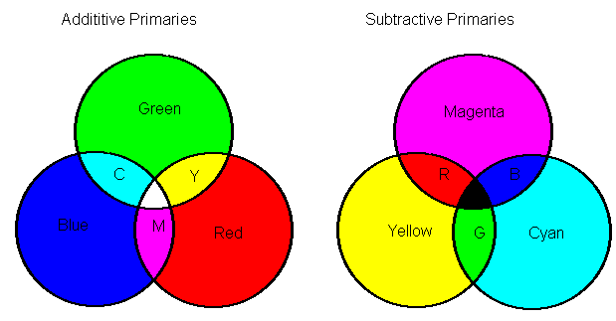

Application of three colored light sources, red, blue and green, on a white background illustrates the additive properties of light. When a red and a green light are super-imposed on the same area, the color observed is yellow. The diagram on the left may be used to predict the color seen when these three primary additive colors combine. Variation of the intensity of each source produces different shades of color. (What additive primary colors would you select to produce a white light?)

A second approach to color production is use of a white light with filters to subtract specific colors from the white light. This process is illustrated on the left above. Cyan, yellow and magenta filters can filter out red, green and blue to produce various colors. Color variations can be adjusted by the amount of each dye in an ink.

A white light source with a cyan filter results in a cyan colored image. Combinations of filters absorb light to produce other desired colors. White light with a magenta filter results in a magenta colored spot (can also be produced by radiation with red and blue light sources). A magenta light source with a yellow filter results in a red color. The diagram below illustrates this subtraction of light with a white light source and a yellow filter. Note that the blue light is absorbed and removed by the dye. The same color could be produced with red and green additive primaries as light sources.
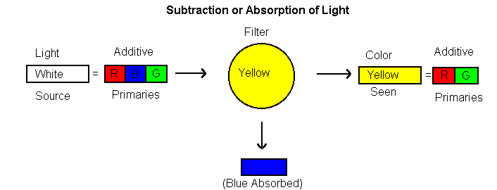
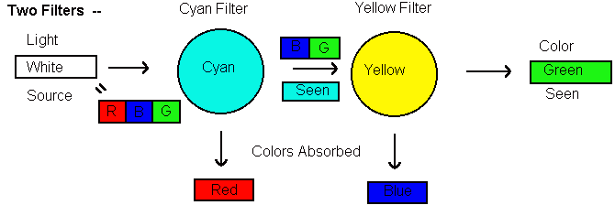
Two filters in succession, cyan and yellow with a white light source produce green. After the light passes through the cyan filter, the first filter, the light is cyan. The two primary colors that remain are red and green. The chart below may be used to predict the color with a combination of one or two filters.
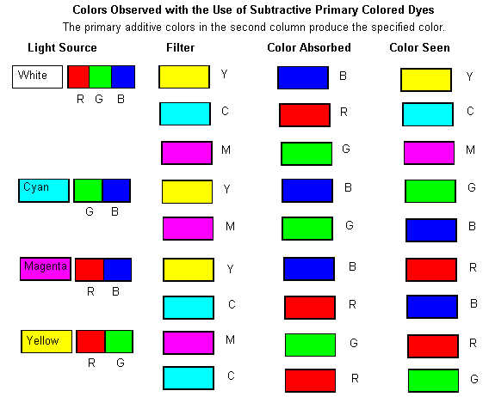

What color would an ink be that is made of a mixture of cyan and magenta dyes? What color primary subtractive dyes would you select to produce a black image?
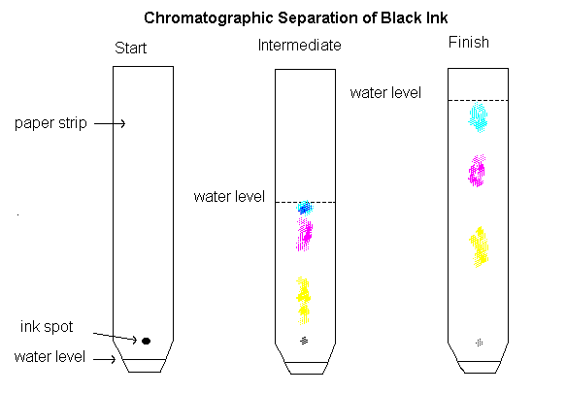

This diagram illustrates the separation of a black ink formed from the three dyes cyan, yellow and magenta. Water is the solvent. What would you expect to observe if you were to separate a green ink? A red ink?

