**KEY**

# Chemistry: *Visualizing the Limiting Reactant*

*Use the balanced chemical equation 2 H2(g) + O2(g) 2 H2O(g) for all the problems on this sheet.*

*Directions: Assuming that each molecule shown in the first two containers represents one mole of that*

*substance, write the correct number of moles of substance s below the containers. Then, assume*

*that the contents of the first two containers are combined in the third container. In the third*

*container, draw the correct number of moles of water produced.*

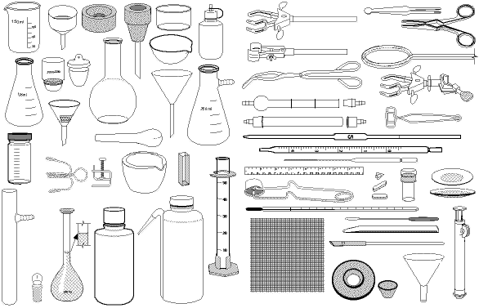

1.

_____ mol H2(g) _____ mol O2(g) _____ mol H2O(g)

2.

_____ mol H2(g) _____ mol O2(g) _____ mol H2O(g)

*In the questions above, all the H2 and O2 reacted. In most reactions, though, the reactants DO NOT combine perfectly; one reactant will be used up before the other; there is too much of one and not enough of the other. The reactant used up first is called the* ***limiting reactant****,**the other(s) is/are called the* ***excess reactant(s)****.*

Directions cont: *For each question below, write the number of moles of substances beneath the corresponding*

*containers. In the third container, draw in the correct number of moles of water produced* ***and*** *any unreacted,*

*excess reactant that is left over. To the right of each question, write the limiting and excess reactant.*

limiting reactant = **H2**

excess reactant = **O2**

3.

**6** mol H2(g) **4** mol O2(g) **6**  mol H2O(g) + **1** mol **O2** left over

limiting reactant = **H2**

excess reactant = **O2**

4.

**2** mol H2(g) **3** mol O2(g) **2** mol H2O(g) + **2** mol **O2** left over

limiting reactant = **O2**



excess reactant = **H2**

5.

**12** mol H2(g) **3** mol O2(g) **6** mol H2O(g) + **6** mol **H2** left over

limiting reactant = **O2**

excess reactant = **H2**

6.

**10** mol H2(g) **4** mol O2(g) **8** mol H2O(g) + **2** mol **H2** left over

limiting reactant = **H2**

excess reactant = **O2**

7.

**2** mol H2(g) **4** mol O2(g) **2** mol H2O(g) + **3** mol **O2** left over

limiting reactant = **O2**

excess reactant = **H2**

8.

**12** mol H2(g) **4** mol O2(g) **8** mol H2O(g) + **4** mol **H2** left over

limiting reactant = **O2**

excess reactant = **H2**

9.

**10** mol H2(g) **3** mol O2(g) **6** mol H2O(g) + **4** mol **H2** left over

limiting reactant = **O2**

excess reactant = **H2**

10.

**8** mol H2(g) **3** mol O2(g) **6** mol H2O(g) + **2** mol **H2** left over