**KEY**

# Chemistry: *Moles and Mass Relationships*

The mass of a mole of a substance expressed in grams is equal to its molecular mass.

1. Each of the following bottles contains a different number of moles of oxygen gas (O2).

For jars B and C, draw molecules in the circles. The number of molecules in each circle

is proportional to the number of moles of O2 *per unit of volume*.

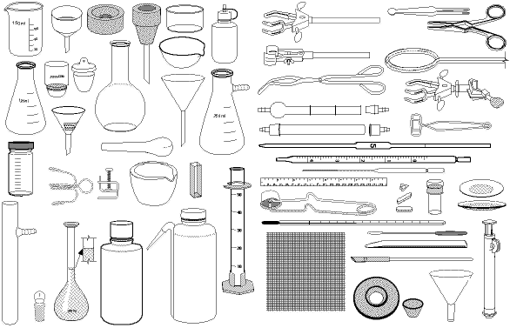

A B C

1 mol O2 0.5 mol O2 0.1 mol O2

Molecular mass = 32 amu Molecular mass = **16 amu** Molecular mass = **3.2 amu**

Mass = 32 g Mass = **16 g** Mass = **3.2 g**

2. For jars D, E, F, use the number of molecules in the circle to determine the number of moles of O2

in the jar. Then calculate the mass of the gas in the jar.



D E F

**12** mol O2 **2** mol O2 **6** mol O2

Mass = **384 g** Mass = **64 g** Mass = **192 g**

3. Jars G, H, and I contain ammonia gas (NH3). For jars H and I, draw the molecules in the circles

and calculate the mass of the gas.



G H I

1 mol NH3 2 mol NH3 0.4 mol NH3

Mass = **17 g** Mass = **34 g** Mass = 6.8 g