**KEY**

# Chemistry: *Balancing Equations*

The information in a chemical equation can be looked at in several ways.

On this worksheet you will represent particles of the substances involved in a chemical

reaction before and after it takes place.

The unbalanced equation for the reaction of chlorine gas with hydrogen gas is

Cl2(g) + H2(g) HCl(g)

Each picture shows the same bottle after something happened. The circles show a unit

volume of the gas in the jar. Draw the particles for the third picture.

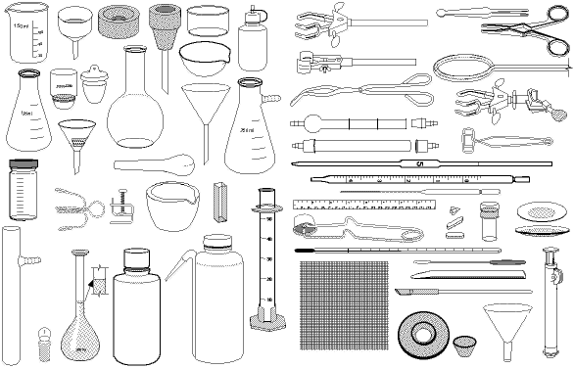

A certain number of The same number of The mixture is ignited.

Cl2 molecules are H2 molecules are Assume that all the

put into the jar. added to the jar. Cl2 and H2 are used up.

2. Show the same reaction using the fewest possible molecules. Draw the molecules in these circles.



**

+

Cl2 H2 HCl

3. Balance the equation using the smallest possible whole number coefficients.

**1** Cl2(g) + **1** H2(g) **2** HCl(g)

4. Suppose you start with different amounts of the reactants. In the empty circle, show the

particles after the reaction. (Be sure you account for all the particles.) On the line below

the circle, describe what is in the circle.



**

+

Cl2(g) + H2(g) **4** HCl (*with 2 Cl2 left over*)