# Name: ________________________

Hour: ____ Date: ___________

# Chemistry: *Review Problems for the Gas Laws*

Do the following problems, showing your work and including all proper units.

# Graham’s Law

1. At 350oC, nitrogen has a velocity of 800 m/s. Find the velocity of helium at the same temperature.

2. At room temperature, acetylene (C2H2) has a velocity of 480 m/s. At the same temperature, an unknown noble gas has a velocity of 267 m/s. What is the unknown gas?

## Gas Laws with One Term Constant

3. A sample of gas has an initial volume of 25 L and an initial pressure of 3.5 atm. If the pressure changes to 1.3 atm, find the new volume, assuming that the temperature remains constant.

4. A sample of neon is at 89oC and 123 kPa. If the pressure changes to 145 kPa and the volume remains constant, find the new temperature, in oC.

## Combined Gas Law

5. A gas at STP occupies 28 cm3 of space. If the pressure changes to 3.8 atm and the temperature increases to 203oC, find the new volume.

6. A sample of sulfur dioxide (SO2) is initially at a temperature of 133oC, a volume of 20 L, and a pressure of 850 mm Hg. If the volume changes to 25 L and the temperature increases to 181oC, find the new pressure.

## Ideal Gas Law

7. 25 g of methane (CH4) has a pressure of 4.44 atm at 250oC. Find the volume occupied by the gas.

8. A sample of gas has a volume of 5.0 L when at a temperature of 310 K and a pressure of 220 kPa.

1. Find the number of moles of gas.
2. If there are 56 g of the gas in the sample, which noble gas is it?

## Manometers: For each manometer, find the pressure of the confined gas, in kPa.

9. atmospheric pressure 10. atmospheric pressure

= 101.3 kPa = 100.4 kPa

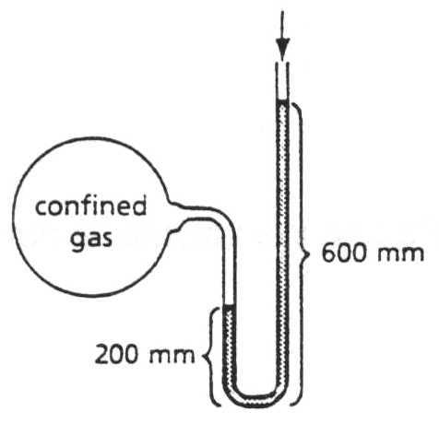 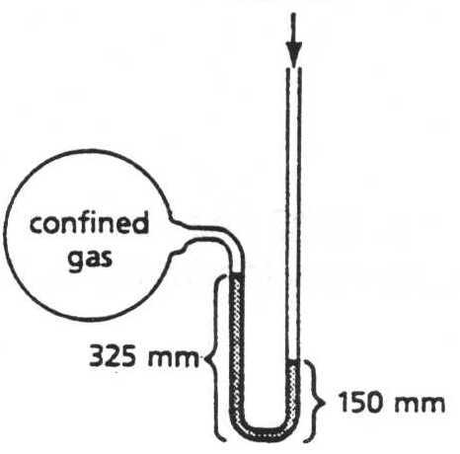

## Gas Stoichiometry

11. a) Write a balanced chemical equation for the combustion of methane to form carbon dioxide and water.

b) If the methane has a volume of 0.65 L when under 100 kPa of pressure and at a temperature of 305 K, find the mass of oxygen that is needed to use up all of the methane.

Answers: 1. 2117 m/s 5. 12.8 cm3 8b. mm ~ 130 g, Xe

2. mm ~ 84 g, Kr 6. 760 mm Hg 9. 154.6 kPa

3. 67 L 7. 15.1 L 10. 77.1 kPa

4. 154oC 8a. 0.43 moles 11b. 1.64 g O2

# KEY

# Chemistry: *Review Problems for the Gas Laws*

Do the following problems, showing your work and including all proper units.

# Graham’s Law

1. At 350oC, nitrogen has a velocity of 800 m/s. Find the velocity of helium at the same temperature.

  

2. At room temperature, acetylene (C2H2) has a velocity of 480 m/s. At the same temperature, an unknown noble gas has a velocity of 267 m/s. What is the unknown gas?

  

## Gas Laws with One Term Constant

3. A sample of gas has an initial volume of 25 L and an initial pressure of 3.5 atm. If the pressure changes

to 1.3 atm, find the new volume, assuming that the temperature remains constant.

 

4. A sample of neon is at 89oC and 123 kPa. If the pressure changes to 145 kPa and the volume remains constant, find the new temperature, in oC.

  

# KEY – page 2

# Chemistry: *Review Problems for the Gas Laws*

## Combined Gas Law

5. A gas at STP occupies 28 cm3 of space. If the pressure changes to 3.8 atm and the temperature increases to 203oC, find the new volume.

 

6. A sample of sulfur dioxide (SO2) is initially at a temperature of 133oC, a volume of 20 L, and a pressure of 850 mm Hg. If the volume changes to 25 L and the temperature increases to 181oC, find the new pressure.

 

## Ideal Gas Law

7. 25 g of methane (CH4) has a pressure of 4.44 atm at 250oC. Find the volume occupied by the gas.



# KEY – page 3

# Chemistry: *Review Problems for the Gas Laws*

8. A sample of gas has a volume of 5.0 L when at a temperature of 310 K and a pressure of 220 kPa.

1. Find the number of moles of gas.

 

1. If there are 56 g of the gas in the sample, which noble gas is it?



## Manometers: For each manometer, find the pressure of the confined gas, in kPa.

9. atmospheric pressure 10. atmospheric pressure

= 101.3 kPa = 100.4 kPa

 

150 mm mmmm

200 mm mm

600 mm mmmm

 

 

# KEY – page 4

# Chemistry: *Review Problems for the Gas Laws*

## Gas Stoichiometry

11. a) Write a balanced chemical equation for the combustion of methane to form carbon dioxide and water.

**CH4(g) + 2 O2 (g) 🡪 CO2 (g) + 2 H2O (g)**

b) If the methane has a volume of 0.65 L when under 100 kPa of pressure and at a temperature of 305 K, find the mass of oxygen that is needed to use up all of the methane.

 

Substitute volume of methane gas @STP and solve ideal stoichiometry problem.

**CH4(g) + 2 O2 (g) 🡪 CO2 (g) + 2 H2O (g)**

**0.574 L x g**



Answers: 1. 2117 m/s 5. 12.8 cm3 8b. mm ~ 131 g, Xe

2. mm ~ 84 g, Kr 6. 760 mm Hg 9. 154.6 kPa

3. 67 L 7. 15.1 L 10. 77.1 kPa

4. 154oC 8a. 0.43 moles 11b. 1.64 g O2