# KEY

# Chemistry: *Mixed Review*

Solve each of the following problems, being sure to show your work and include all proper units.

1. Use the ideal gas law PV = nRT, to derive Boyle’s law and Charles’s law.

If n, R and T are constant: PV = nRT If n, R and P are constant: V/T = nRP

PV = constant V/T = constant

P1V1 = P2V2 (Boyle’s Law) V1/T1 = V2/T2 (Charles’s Law)

2. A container holds 265 mL of chlorine gas, Cl2. Assuming that the gas sample is at STP, what is its mass?



V = 265 mL (0.265 L) PV = nRT

T = 273 K

P = 1 atm

n = ? mol



R = 0.0821 L.atm / mol.K



3. Suppose that 3.11 mol of carbon dioxide is at a pressure of 0.820 atm and a temperature of 39oC. What is the volume of the sample, in liters?



n = 3.11 mol CO2 PV = nRT

P = 0.820 atm

T = 39oC + 273 = 312 K



V = ? L

R = 0.0821 L.atm / mol.K



4. Compare the rates of diffusion of carbon monoxide, CO, and sulfur trioxide, SO3.



CO = carbon monoxide SO3 = sulfur trioxide

m1 = 28 g m2 = 80 g

*v*1 = ? *v*2 = ?



CO diffuses 1.69x faster than SO3 (or SO3 is 0.59x slower)

5. A gas sample that has a mass of 0.993 g occupies 0.570 L. Given the temperature is 281 K and the pressure is 1.44 atm, what is the molar mass of the gas?



P = 1.44 atm PV = nRT

V = 0.570 L

n = ? mol

R = 0.0821 L.atm / mol.K

T = 281 K



Answers: 1. 2. **0.84 g Cl2** 3. **97.1L** 4. **CO is 1.69x faster** 5. **28 g/mol**

6. The density of a gas is 3.07 g/L at STP. Calculate the gas’s molar mass.



P = 1 atm

V = ? L

T = 273 K



n = ? mol

R = 0.0821



D = 3.07 g/L

Density is an intensive property.



Assume mass = 1.0 g



7. How many moles of helium gas would it take to fill a gas balloon with a volume of 1000. cm3 when the temperature is 32oC and the atmospheric pressure is 752 mm Hg?



P = 752 mm Hg PV = nRT

V = 1 L

n = ? mol



R = 0.0821 L.atm / mol.K



T = 32oC + 273 = 305 K

8. A gas sample is collected at 16oC and 0.982 atm. If the sample has a mass of 7.40 g and a volume of 3.96 L, find the volume of the gas at STP and the molar mass.



P1 = 0.982 atm



V1 = 3.96 L

T1 = 16oC + 273 = 289 K

P2 = 1 atm



V2 = ? L PV = nRT

T2 = 273 K



9. An unknown gas effuses at 0.850 times the effusion rate of nitrogen dioxide, NO2. Estimate the molar mass of the unknown gas.

Unknown Gas Nitrogen dioxide, NO2



m1 = ? g m2 = 46 g

*v*1 = 0.850 *v*2 = 1



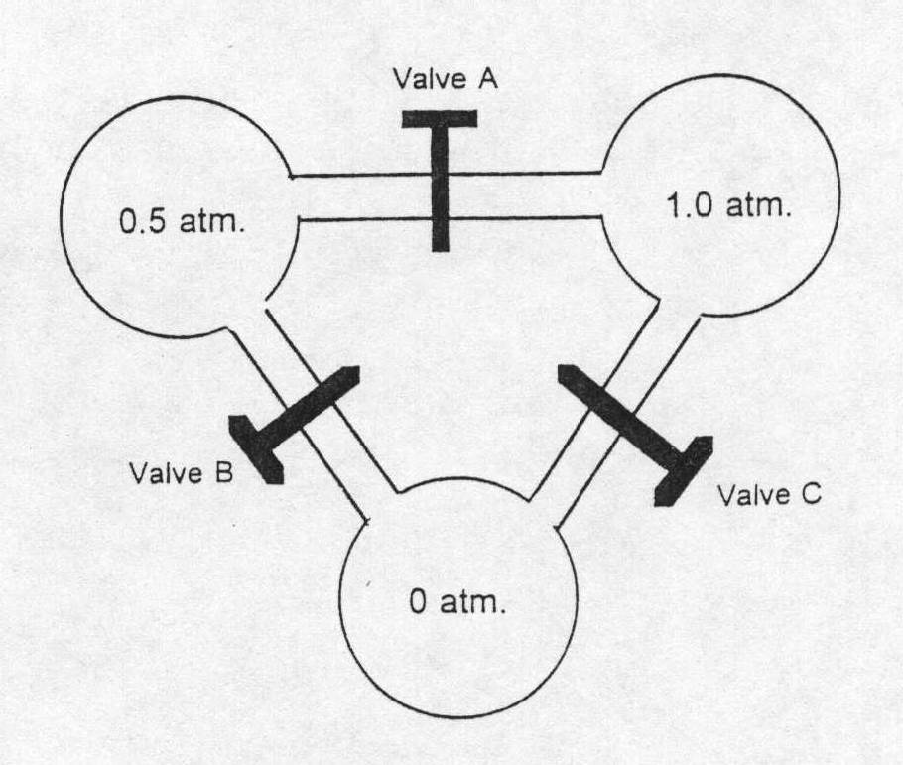

10. What will be the pressure if we open:

* 1. just valve A? **0.75 atm**
  2. just valve C? **0.5 atm**
  3. any two valves? **0.5 atm**

Use Boyle’s law:

(a) 1.5 atm of gas divided in 2 spheres = 0.75 atm

(b) 1.0 atm of gas divided in 2 spheres = 0.5 atm

(c) 1.5 atm of gas divided in 3 spheres = 0.5 atm

Answers: 6. **68.8 g/mol** 7. **0.0395 mol** 8. **3.67 L & 45 g/mol** 9. **63.7 g/mol**