Name: ________________________

Hour: ____ Date: ___________

**Chemistry: *Activity – Observation of a Burning Candle***

***Introduction***

Everyone thinks of himself as a good observer, but being a good observer is not necessarily easy. Good observation skills include concentration, attention to detail, ingenuity, and patience. In addition, observation takes practice.

There are two types of observations: ***qualitative*** and ***quantitative***. ***Qualitative*** observations describe the object or event in words, without using numbers. For example: “The car is red” is a qualitative observation. ***Quantitative*** observations, as the name implies, describe the object or event using measurable quantities; that is, numbers. For instance, “The car is traveling at 100 kilometers per hour” is a quantitative observation.

## Materials

The following materials are needed for this activity:

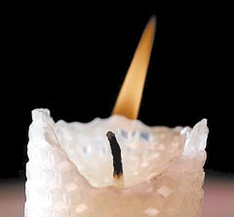 candle, drip paper, matches, ruler

## Activity

**Part A.** Observe an unlit candle and record your observations

in the space provided. Use complete sentences. Circle

the Observation Number in front of each observation you

make that is *quantitative*.

**Part B.** Now, light the candle and record your observations in

complete sentences. Again, circle the Observation Number

in front of each observation you make that is *quantitative*.

***You will need to make at least 20 observations;***

***at least 5 of them must be quantitative.***

### Observation

**Number**

1.

2.

3.

4.

5.

6.

7.

8.

9.

10.

11.

12.

13.

14.

15.

16.

17.

18.

19.

20.

_________________________________________________________________________________________

21.

22.

23.

24.

25.