**Honor’s Chemistry: *Fall Semester Final* Name____________________**

1. Explain what is wrong with the statement “My friend burned a piece of paper (a hydrocarbon) that had the final exam on it and it *disappeared*”. (Be sure to use a chemical equation, identify reactants and product(s) and include energy).

ANSWER: *The paper (CxHy) was burned with oxygen and the atoms in the paper*

*are broken apart and rearranged into new combinations. The new combinations*

*are the products: CO2 + H2O. Carbon dioxide and water are always the products*

*of a combustion reaction of a hydrocarbon.*  *The paper didn’t disappear, but its atoms*

*are rearranged into gases.*

**Law of conservation of mass** – mass is not created nor destroyed...atoms are only rearranged in chemical reactions. [Reactants = Products]

CxHy + O2 --> CO2 + H2O + energy

REACTANTS PRODUCTS

Reaction is EXOTHERMIC

match was activation energy (EA) to start reaction

R

Energy

P

1. Write a balanced chemical equation for the reaction forming magnesium chloride precipitate from its elements. Draw a picture to help me visualize what is happening.

Mg (*s*) + Cl2 (*g*) --> MgCl2 (*s*)

1. Identify three specific errors made during experiments that would disobey the scientific method.

* have bias in conclusion
* do not use a control for comparison
* make measurements a single time or multiple times (with poor precision)
* change two or more variables at a time
* exclude data because it doesn’t fit with the rest
* not make careful observations
* make-up data

SCIENTIFIC METHOD

* + Observation
  + Hypothesis
  + Collect Data
  + Analysis
  + Conclusions
  + Repeat / Modify

1. Describe the difference between a natural law and a theory.

**Natural law** – *describes* events in nature

laws do not change

laws of nature will always occur and are not man-made

**Theory** – an *explanation* of an event

theories can change as new evidence is discovered.

theories are man-made

A theory does not turn into a law after a long time or lots of experiments!

1. Suppose that you attempt to turn on a lamp, but the bulb does not light. Using the scientific method, describe how you might solve this problem. Be as complete as you can, and identify the elements of the scientific method in your explanation.

### Variables *Observations*

* bulb burned out *Hypothesis*
* bulb not screwed in tightly If...then...
* no power to circuit *Variables*
* lamp has a broken wire in it controlled experiment

change 1 variable at a time

*Data*

1. The substance looked *pale yellow* and had a *density of 3.6 g/mL*. It *burned readily in air*, and *produced bubbles when reacted with acid*. When heated, it *changed from solid to liquid at 79oC*, and from *liquid to gas at 143oC*.

# Identify the following properties as either chemical or physical

1. pale yellow **physical**
2. density of 3.6 g/mL **physical**
3. burned readily in air **chemical**
4. produced bubbles when reacted with acid **chemical**
5. Is there any difference between the properties of pure water that has been boiled and condensed and the properties of pure water that has been frozen and then melted? Explain

**No**, pure water is always H2O. Boiling or freezing are physical changes in state and are reversible. No chemical reaction has taken place.

H2O(*s*) H2O(*l*) H2O(*g*)

1. You are given a flask that contains sea water that has been contaminated with oil. Some sand is also present in the flask. Describe how you would separate the sand, oil, sea salt, and water from each other.

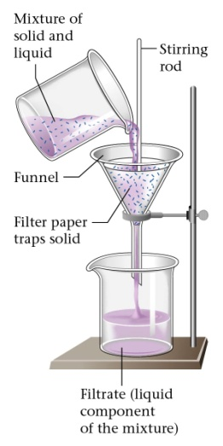

Step 1) Decant off oil / water from sand or use a filter.

Step 2) use a separatory funnel to separate oil from water.

Oil is less dense and immiscible with water

and will be the top layer.

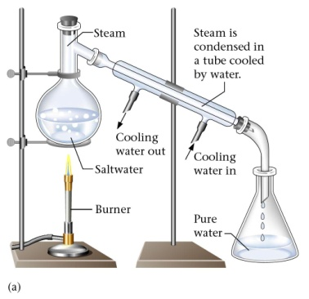Step 3) Distill water to remove salt.

1. Complete the following table:

|  |  |  |  |  |  |  |  |
| --- | --- | --- | --- | --- | --- | --- | --- |
| Element  (atom/ion) | Symbol | Atomic Number | No. of protons | No. of Neutrons | Mass Number | No. of electrons | Charge |
| chloride ion | 35Cl  17 | 17 | 17 | 18 | 35 | 18 | -1 |
| hydrogen ion | 1H  1 | 1 | 1 | 0 | 1 | 0 | +1 |
| sodium atom | 23Na  11 | 11 | 11 | 12 | 23 | 11 | 0 |

1. Write the formula for the compounds that would be formed from the following ions:

Na+ and Cl- ___________________ **NaCl**

Al3+ and Br- ___________________ **AlBr3**

K+ and S2- ___________________ **K2S**

Mg2+ and Cl- ___________________ **MgCl2**

1. Compare Rutherford’s model of the atom to Thomson’s model. Explain Rutherford’s reasoning in developing his model

**Thomson’s model** - protons and electron evenly distributed. No nucleus.

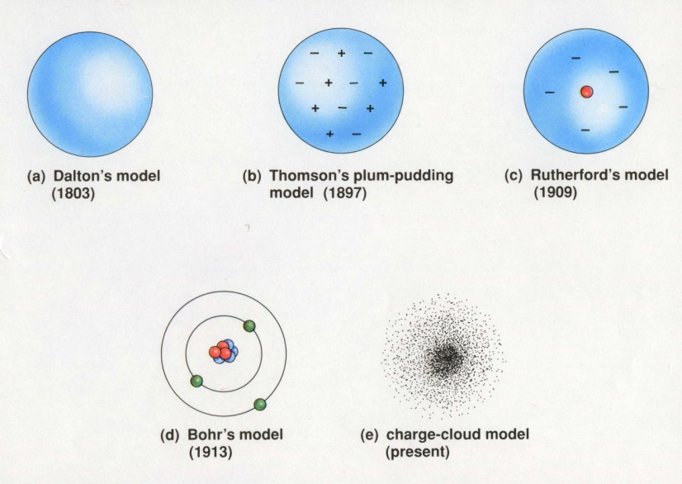

Cathode Ray tube experiment.

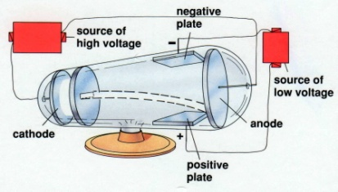 The cathode rays were attracted

to a negatively charged plate. The

atom must have negative charges (electrons). Atoms are electrically neutral and must possess positively charged particles (protons) also.

**Rutherford’s model** – Nucleus with atom being mostly empty space.

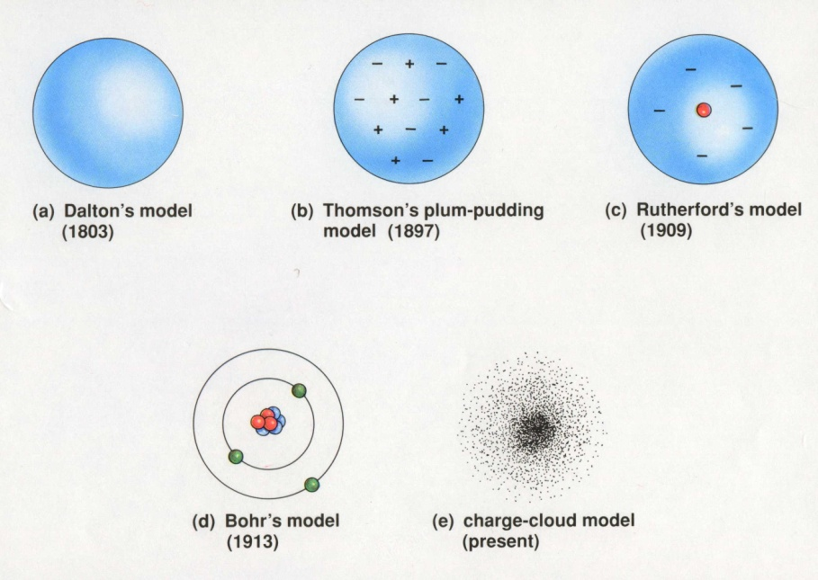

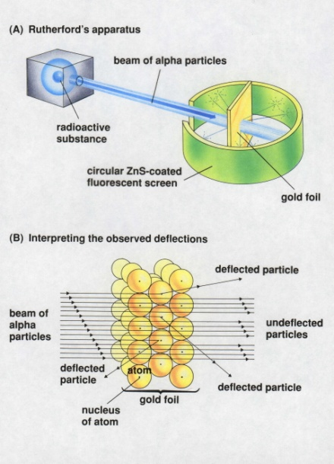 Gold foil experiment.

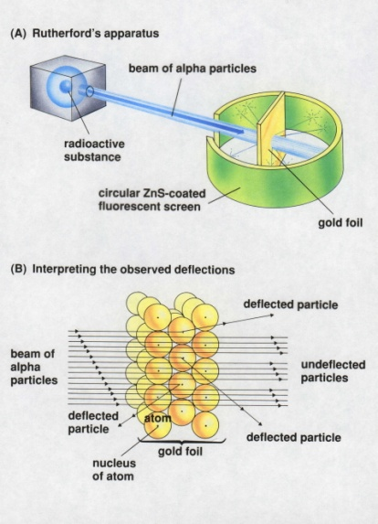

1. How might the results of Rutherford’s experiment have been different if he had used aluminum foil (atomic number 13) rather than gold foil (atomic number 79)?

**Aluminum** foil has *fewer protons* in its nucleus. You would expect more () alpha particles to pass through the Al foil (fewer deflections)

Gold has a larger (more massive) nucleus and will give more deflection of alpha particles.

13. a aluminum sulfide _______________ **Al2S3**

b. SF2 _______________ **sulfur difluoride**

c. phosphorus trichloride _______________ **PCl3**

d. Zn(NO3)2 _______________ **zinc nitrate**

e. iron(III) oxide _______________ **Fe2O3**

f. CuI _______________ **copper (I) iodide or**

**cupr*ous* iodide**

g. HNO3 _______________ **nitric acid or**

**hydrogen nitrate**

h. aluminum hydroxide _______________ **Al(OH)3**

i. CaBr2 _______________ **calcium bromide**

j. hydrochloric acid _______________ **HCl(aq)**

k. Ba3(PO4)2 _______________ **barium phosphate**

l. magnesium sulfite _______________ **MgSO3**

m. LiC2H3O2 _______________ **lithium acetate**

n. nitrogen trichloride _______________ **NCl3**

o. CuSO3 _______________ **copper (II) sulfite or**

**cupr*ic* sulfite**

p. sodium carbonate _______________ **Na2CO3**

14. Round each number to the indicated number of significant figures and express it in scientific notation:

a. 2501 (2 S.F) ___________ **2.5 x 103**

b. 0.030490 (3 S.F) ___________ **3.05 x 10-2**

c. 172590 (1 S.F.) ___________ **2 x 105**

d. 40035.2 (2 S.F) ___________ **4.0 x 104**

1. Round each number to the indicated number of significant figures and express it in scientific notation:

a 12.6 m x 2.0 m x 13.84 m = ___________ **3.5 x 102** **m3**

b. 13 cm + 10.4 cm + 1.25 cm = ___________ **25 cm**

c. (1.360 x 105 cm) x (6.05 x 10-2 cm) = ___________ **8.23 x 103** **cm2**

d. 11.63 mL – 8.8 mL = ___________ **2.8 mL**

e. (12.36 g – 11.25 g) = ___________ **0.1077 g/mL**

10.31 mL

f. 18.5 m = ___________ **5.3 x 102** **m/s**

0.035 s

When adding and subtracting - use fewest decimal places in answer

When multiplying and dividing – use fewest significant figures.

1. If 4 quarts = 1 gallon, and 1.06 quarts = 1 liter, how many liters are there in a 55.0 gallon container?



1. To three significant figures how many seconds are there in exactly 1 “microyear”?



1. Describe to a General Chemistry student how to make a measurement correctly

A MEASUREMENT consists of two parts a NUMBER + UNIT.

Record number as precisely as the instrument you are using and estimate one digit of uncertainty.

If a liquid, read from bottom of meniscus.

1. Your friend tells you that the number 1.2000 is more accurate than 1.2 x 100.

Is your friend correct? Explain.

No, both numbers are identical. 1.2000 is more precise than 1.2

1. Your friend says that smoking a mercury-laced cigarette is cool. You aren’t convinced

and decide to look up the LD50 value of mercury. It is 0.4 mg/kg. Assuming you

weigh 150 lbs and that 2.2 lb = 1 kg. How much mercury can you safely smoke?

No calculations required here! The answer is no amount of mercury is safe to smoke.

Mercury is toxic as expressed by its LD50 value.

1. List 3 intensive properties and 3 extensive properties of a BabyRuth candy bar.

INTENSIVE EXTENSIVE

a) brown color a) 300 calories

b) density less than 1 g/mL (floats) b) 220 mL volume

c) melting point ~95oF c) weighs ~170 grams

1. Classify the following materials as elements, compounds, or mixtures:
   1. Lead (II) chloride b. ozone c. vinegar d. heavy water e. tin foil

compound element mixture compound element

(allotrope of O2)

(5% acetic acid + 95% water)

1. Draw and label a phase diagram for a *non-pure* substance that has a melting point of ~22oC and a boiling point of ~89oF.

PHASE DIAGRAM for a NONPURE SUBSTANCE

(Note broad melting point and boiling point range)

Temp (oC)

GAS

Boiling point ~32oC

LIQUID

Melting point ~22oC

SOLID

 

1. Which has more kinetic energy a 400 mg bullet moving at 250 m/s or a lead ball, moving at 0.01 m/s. The radius of the lead ball is 30 dm and the density of lead is 11.2 g/cm3.

Given: [V = 4/3  r3]



1. Justify why or why not we should pursue an energy program of nuclear fusion in the United States. You need to explain the differences in fission and fusion, site advantages and disadvantages of each.

Fossil fuels pollute and generate CO2 (responsible for global warming) and are diminishing in amount.

FISSION – splitting large atoms to smaller

Produce long-lived radioactive isotopes

FUSION – small atoms combined at high temperatures (T ~10,000,000 oC)

No waste product.

Another option would be to invest in wind power, solar power or hydrogen fuel cells.

These technologies have fewer risks.

1. How much heat will be absorbed by a 20 g piece of ice (at 254 K) that is warmed to 150oF?

Latent heat of vaporization (H2O) = 2256 J/g

Latent heat of fusion (H2O) = 333 J/g

65.5oC

Specific heat of water (liquid) = 4.184 J/goC

Specific heat of water (solid) = 2.077 J/goC

q2

q3

Specific heat of water (gas) = 2.042 J/goC

-19oC

q1



1. What is the final temperature of a 20 g block of ice (at 273 K) that is placed in 300 g of water (T = 50oC)



1. Explain how Archimedes principle would be used to determine if a gold crown was “pure” gold. What other information would you need to know to be certain?

The gold crowns volume was determined by the water-displacement method.

|  |  |
| --- | --- |
|  | Vcrown = Vfinal – Vinitial  Density = mass / volume.  Density of pure gold in constant  (an intensive property).  By knowing the weight of the crown,  you can figure what volume pure gold  should displace. |

1. Given the following: U-235
   1. Write the longhand and shorthand electron configuration for U-235

U-235 = 1s22s22p63s23p64s23d104p65s24d105p66s24f145d106p67s24f35d1

* 1. How many protons **92**, neutrons **143**, and electrons **92**  does the element have?
  2. Write the formula for an isotope of this element. **U-238**

1. Given that light has a wavelength of 412 nm. What is its energy?





Substitute the calculated frequency into the next equation:



1. Draw an energy level diagram for an Al3- anion. Be sure to explain how the Aufbau principle, Pauli exclusion principle and Hund’s rule have been obeyed.

Correct Wrong

Correct Wrong

n=3

Pauli-Exclusion Principle Hund’s Rule

n=2 electrons spin in opposite maximum filled orbitals

direction

n=1 Aufbau Principle – build from bottom to top with electron filling

1. Compare and contrast the terms ions, atoms, and isotopes in subatomic structure

**ION** – charged particle

CATION = metal that loses electron(s) to have a POSITIVE charge

ANION = non-metal that gains electron(s) to have a NEGATIVE charge

Ions all have the same number of protons and neutrons but different # of electrons.

**ATOM** – all atoms of different elements have a different # of protons.

**ISOTOPE** – same element (# protons) but a different # of neutrons.

1. Calculate % a mass of an isotope “X”: given that the average atomic mass of “X” is 54.3 g/mol and the element has only two isotopes (X-50 comprises 38% abundance).



1. Why do metals generally have lower ionizations energies than nonmetals?

Metals have loosely held valence electrons. Metals want to lose electrons to have a stable octet. It is easier for a metal to lose 1,2, 3, or 4 electrons than gain that number. Metals have low electronegativities and are not good at attracting electrons.

Non-metals tend to be smaller due to greater coulombic attraction and hold electrons tightly. Non-metals want to gain electrons to achieve a stable octet.

Ionization energy – energy required to remove the most loosely held valence electron (in the gas phase).

M (*g*) + ionization energy --> M+(*g*) + e-

1. What differences in atomic structure (microscopic) explain the observable (macroscopic) differences in salts and compounds made from two non-metals?

SALT – metal bonded to non-metal (an ionic bond)

Ionic bond is a very strong bond with a high melting point;

compound is brittle (if atoms are moved (ions repel each other and cleavage occurs))

The bond is formed when *electron(s) are transferred* from the metal to the non-metal.

Ions are formed which attract very strongly. This is called an ionic bond.

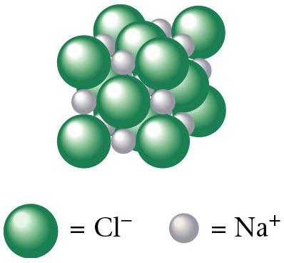

Two non-metals share electrons and form covalent bonds. Covalent bonds are weak and have low melting points.

An ionic compound.

..

P

O O

O

1. a) Draw the Lewis structure for the phosphite ion. 3-

Phosph*ate* = [PO4]3-

Therefore, Phosph*ite* = [PO3]3-

“*ite*” has one less oxygen than “*ate*”

* + - 1. What is the apparent charge on the P atom in the phosphate ion?

[PO4]3- where 4 O @ 2- = 8- P5+

and 1 P @ P5+= 5- yields a 3- overall

* + - 1. What is the percentage composition in ammonium nitrite?

NH4NO3 = ammonium nitrate 2 N @ 14 g = 28 g

4 H @ 1 g = 4 g

3 O @ 16 g = 48 g

NH4NO3 = 80 g



1. Which has more atoms: 396 g titanium (II) sulfate;



2.3 x 1022 molecules trichloro nonaoxide or



4.5 x 103 dm3 of methane (CH4) gas @ STP? Show work for credit.



Methane, CH4 has the most atoms.

1. Find the mass, in grams, of 2.65 x 1024 molecules of Cl2.



1. How many grams of sulfur are present in 83.2 g of sulfur dioxide?



40. How many hydrogen *atoms* are in 52.0 g of water?



41. Determine the empirical formula for a compound that contains 14.7 g of nickel and 40.0 g

of bromine.

 NiBr2

What is its molecular formula if its molecular mass is 657 g**.**



42. Balance the following chemical equations:

a. PbI2 + **2** AgNO3 🡪 Pb(NO3)2 + **2** AgI

b. **2** Mg + TiCl4 🡪 **2** MgCl2 + Ti

c. C3H8 + **5** O2 🡪 **3** CO2 + **4** H2O

d. P4 + **5** O2 🡪 P4O10

e. Na2CO3 + **2** HCl 🡪 **2** NaCl + CO2 + H2O

43. Write balanced equations for the following reactions:

a. zinc + hydrochloric acid 🡪 zinc chloride + hydrogen (gas)

## Zn + 2 HCl --> ZnCl2 + H2

b. barium chloride + ammonium sulfate 🡪 barium sulfate + ammonium chloride

## BaCl2 + (NH4) 2SO 4 --> BaSO4 + 2 NH4Cl

c. calcium hydroxide + nitric acid 🡪 calcium nitrate + water

## Ca(OH)2 + 2 HNO3 (*aq*) --> Ca(NO3) 2 + 2 H2O

d. calcium carbonate + hydrochloric acid 🡪 calcium chloride + carbon dioxide + water

## CaCO3 + 2 HCl (*aq*) --> CaCl2 + CO2 + H2O

e. bromine + sodium iodide 🡪 sodium bromide + iodine

Br2 + 2 NaI --> 2 NaBr + I2

f. magnesium + iron(III) chloride 🡪 magnesium chloride + iron

3 Mg + 2 FeCl3 --> 3 MgCl2 + 2 Fe

1. Write a balanced chemical equation for the reaction, including abbreviations for the physical states.
   1. Lithium metal reacts with water to form aqueous lithium hydroxide and hydrogen gas.

2 Li (*s*) + 2 H2O (*l*) --> 2 LiOH (*aq*) + H2 (*g*)

* 1. Iron (III) nitrate in water solution reacts with potassium sulfide in water solution to form aqueous potassium nitrate and solid iron (III) sulfide. Write a balanced chemical equation for the reaction, including abbreviations for the physical states.

2 Fe(NO3) 3 (*aq*) + 3 K2S (*aq*) --> 6 KNO3 (*aq*) + Fe2S3 (*s*)

1. Potassium chlorate (KClO3) decomposes to form potassium chloride and oxygen gas. If 5.4 moles of potassium chlorate decompose, how many moles of oxygen could be produced?

2 KClO3 --> 2 KCl + 3 O2

5.4 mol x mol



1. What mass of FeCl2 could be produced from 35.0 g of Fe and excess HCl if the balanced reaction is

**Fe + 2 HCl 🡪 FeCl2 + H2**

35 g excess x g



1. When ammonia burns in pure oxygen, the reaction is:

4 NH3 + 3 O2 🡪 2 N2 + 6 H2O

45 g x g x g

What masses of nitrogen and water could be produced from 45.0 g of ammonia?



1. Copper metal reacts with a solution of silver nitrate, AgNO3, to produce copper (II) nitrate and silver metal. In carrying out this reaction, a piece of copper wire was immersed in a solution of silver nitrate until the reaction stopped. The original mass of the copper wire was 2.36 grams. After the reaction stopped, the mass of the wire was 1.03 grams. What mass of silver was produced?

Cu + 2 AgNO3 🡪 Cu(NO3)2 + 2 Ag

1.33 g excess x g



1. If a piece of aluminum of mass 4.50 g and temperature 99.5oC is dropped into 12.0 g of water at 21.0oC, what will be the final temperature of the water-aluminum mixture? The specific heat capacity of aluminum is 0.902 J/(g. oC).

99.5oC

21oC



1. Write electron configurations for each of the following. DO NOT use noble gas shorthand.
2. Al 1*s*22*s*22*p*63*s*23*p*1
3. Fe 1*s*22*s*22*p*63*s*23*p*64*s*23*d*6
4. Sn 1*s*22*s*22*p*63*s*23*p*64*s*23*d*104*p*65*s*24*d*105*p*2
5. Identify the elements that have the following electron configurations. If the configuration shows the atom in an excited state, write the ground state configuration for the atom.
6. 1s22s22p63s23p2 **Silicon (Si)**
7. 1s22s22p63s23p64s23d104p4 **Selenium (Se)**

c) 1s22s22p33p1 **Oxygen (O)** it is in an *excited state*

1. Using atomic structure in your explanation, account for the general trend in

atomic size as you go from left to right across a period and from top to bottom

down a group on the periodic table.

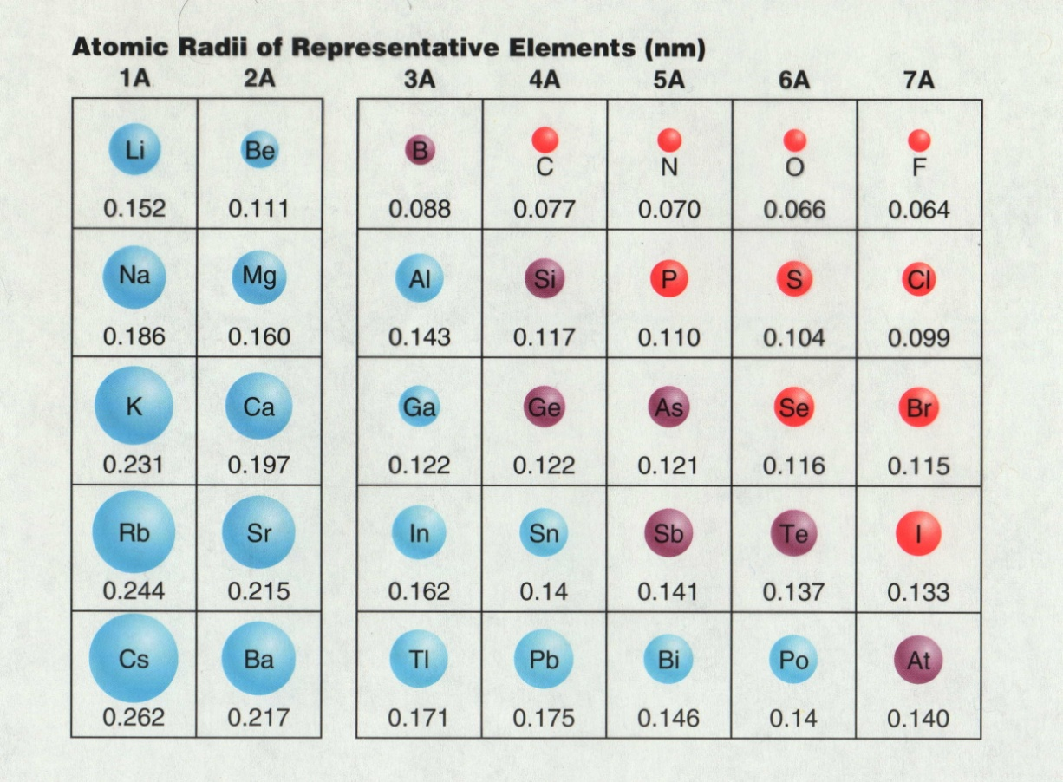

As you move from top to bottom of a family or group size of atom increases.

Increase is due to kernel electron repelling (screening) valence electrons.

This is called the shielding effect.

As you move from left to right across a period the size of the atom decreases.

Increase in coulombic attraction (more protons and electrons).

That’s All Folks!