###### Electronic Structure of Atoms Name: __________________________

Video

603

(7:35)

*AP Chemistry Lecture Outline*

electronic structure: the arrangement of electrons in an atom

quantum mechanics: the physics that correctly describes atoms

**electromagnetic radiation (i.e., light)**  **Characteristics of a Wave**

-- waves of oscillating electric (E)

and magnetic (B) fields

-- source is…

frequency: the number of cycles

per unit time (usually sec)

--

electromagnetic spectrum: contains all of the “types” of light that vary according to frequency

and wavelength

-- radio, microwaves, infrared, visible, ultraviolet, X rays, gamma rays, cosmic rays

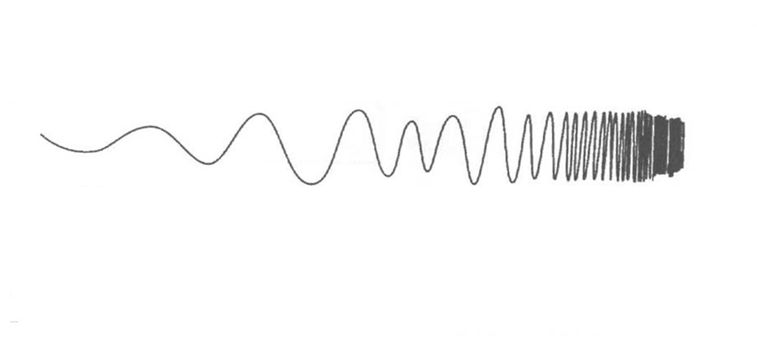

-- visible spectrum ranges from only ~400 to 750 nm (a very narrow band of spectrum)

Video

606

(8:07)

Light (in all its forms) is employed to analyze matter.



We know intuitively something about

the concentration of a solution just by

its visual appearance.

**concentrated dilute**

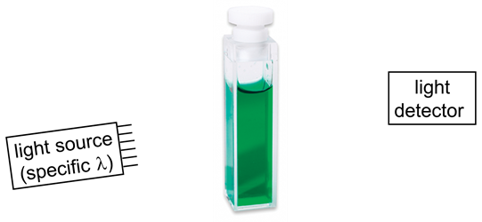

When light of a specific wavelength is

directed at a colored solution, some of

the photons are absorbed and some are

transmitted.

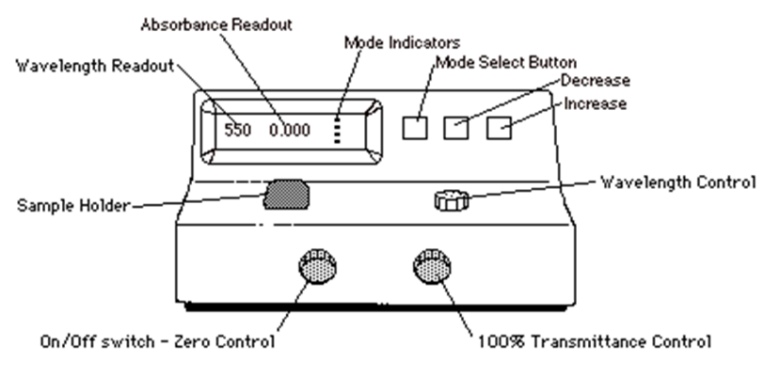

**Using a Spectrophotometer**

**to Determine an Unknown**

**Solution Concentration**

1. Learn to use a spectrophotometer.

2. Using a soln of your analyte of known conc., choose various s on your spectrophotometer, record the Abs for each, and make an Abs vs.  graph.

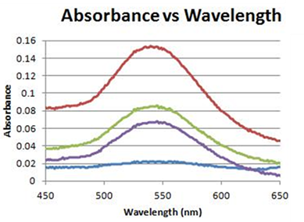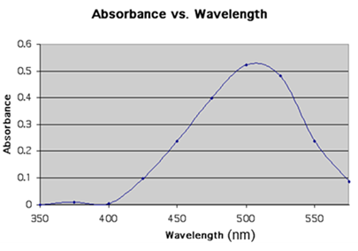

3. From the graph, choose the  for which Abs is maximized.

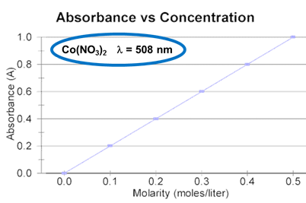 4. Using several known solns of your analyte and your

chosen , record the absorbance reading for each

soln, and make a graph of Abs vs. concentration.

5. Finally, place a cuvette with your unknown soln into the

spectrophotometer, record the absorbance, and go to your

Abs vs. concentration graph to determine your unknown concentration.

Video

609

(8:35)

**Beer’s Law**

Beer’s law (or the Beer-Lambert law) relates

the absorbance of a soln to its concentration:

Abs = absorbance

e/A = molar absorptivity

L/t = path length

c/M = soln molarity

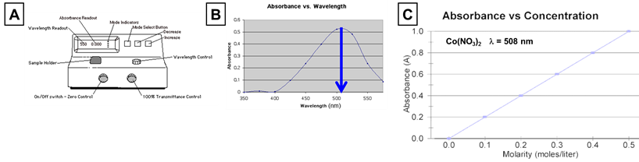

EX. For a given analyte at the max. Abs  of 425 nm,

a 0.42 M soln produces an Abs of 0.13. Using

Beer’s law, determine the conc. of a solution whose

Abs is 0.074 under the same experimental conditions.

The speed of light in a vacuum

Video

612

(8:14)

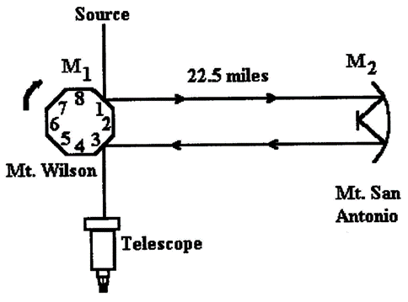

**Michelson’s**

**experimental setup**

(and in air) is constant: -- Equation:

In 1900, Max Planck assumed that energy can be absorbed or released

only in certain discrete amounts, which he called quanta. Later, Albert

Einstein dubbed a light “particle” that carried a quantum of energy a photon.

-- Equation:

EX. A radio station transmits at 95.5 MHz (FM 95.5). Calculate the wavelength of this light and

the energy of one of its photons.

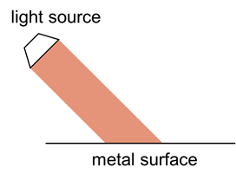In 1905, Einstein explained the

Video

615

(5:39)

photoelectric effect using Planck’s

quantum idea.

-- only light at or above a threshold

freq. will cause e– to be ejected

from a metal surface

Einstein also expanded Planck’s idea, saying that energy ***exists*** only in quanta.

Light has both wavelike and particle-like qualities, and...

Video

618

(6:58)

**Photoelectron Spectroscopy (PES)**

Photoelectron or (photoemission) spectroscopy (PES) employs ** PES data is...

the photoelectric effect to measure the binding energies of e– in

atoms. The data is most commonly communicated in graphical form.

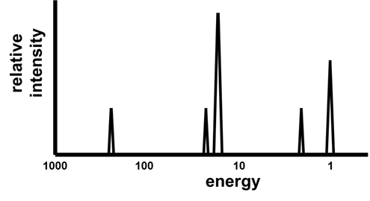**How to Read a PES Graph:**

1.

2.

EX. Determine the element represented EX. Draw an approximate PES

by the following PES graph. graph for chlorine.

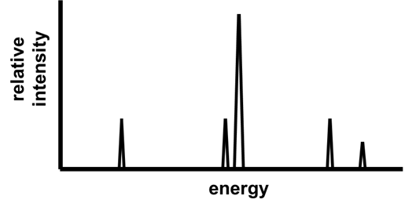

**Line Spectra**

Video

621

(2:36)

Ordinary white light is dispersed by a prism into a...

 From the gas in a nearly-evacuated gas-discharge tube, we instead get a...

Video

624

(7:43)

Niels Bohr took Planck’s quantum idea and applied it to the e– in atoms.

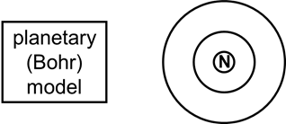 --

--

-- Bohr assumed that the e–’s in his circular orbits had particular energies, given by:

RH = Rydberg constant = 2.18 x 10–18 J

n = 1, 2, 3, ... (the principal quantum number)

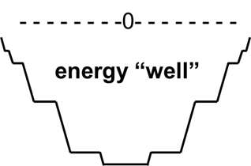 The more/less (–) an electron’s energy is...

When *n* is very large, E*n* goes to zero, which

is the most energy an e– can have because…

-- Bohr stated that e– could move from one level to another, absorbing light of a

particular freq. to “jump up” and releasing light of a particular freq. to “fall down.”

-- Bohr’s model (i.e., its specific equation) worked only for atoms with…

Video

627

(5:22)

Find the wavelength, frequency, and energy of a photon of the emission line produced

when an e– in a hydrogen atom makes the transition from n = 5 to n = 2.

Video

630

(4:32)

**The Wave Behavior of Matter**

Since light (traditionally thought of as a wave) was found to behave as both a wave and

a particle, Louis de Broglie suggested that matter (traditionally thought of as particles)

might also behave like both a wave and a particle. He called these…

-- The wavelength of a moving

sample of matter is given by:

EX. A proton moving at 1200 m/s would be associated with a matter wave of how many nm?

A wave is smeared out through space, i.e., its location is not precisely defined. Since

Video

633

(6:28)

matter exhibits wave characteristics, there are limits to how precisely we can define a

particle’s (e.g., an e–’s) location.

-- the limitation also applies to a particle’s...

-- Heisenberg’s uncertainty principle:

Video

636

(4:28)

Schrodinger’s wave equation (1926) accounts

for both wave and particle behaviors of e–.

-- Solutions to the wave equation yield wave functions, symbolized by , which have no

physical meaning, but 2 at any point in space gives the probability that you’ll find an

e– at that point. 2 is called the probability density, which gives the electron density.

-- Orbitals describe a specific distribution of electron density in space.

Each orbital has a characteristic shape and energy.

Video 639 (11:13)

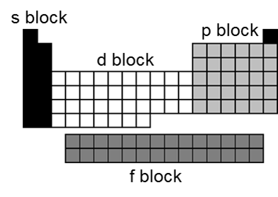**Electron Configurations**: Where are the e–? (probably)

H

He

P

Fe3+

Aufbau Principle: e– will take the lowest-energy orbital that is available

Al3+

O2– isoelectronic species:

F–

N3–

Hund’s Rule: each degenerate orbital must have one e– before any take a second

**Orbital Diagrams**…show spins of e– and which orbital each is in

paired e–

O unpaired e–

1s 2s 2p 3s 3p valence e–

P

1s 2s 2p 3s 3p

**Shorthand Electron Configuration** (S.E.C.)

1. Put symbol of noble gas that precedes element in brackets.

2. Continue writing e– config. from that point.

S

Co

**Anomalies in the Electron Configurations**

Video

642

(3:26)

Your best guide to writing e– configs is “The Table,” but there are a few exceptions.

e.g., Cr: Cu:

These exceptions are due to the closeness in energy of the upper-level orbitals.

Other exceptions are…

All of these exceptions have a single valence-level s electron.

Video

645

(11:23)

In a many-electron atom, each e– is attracted to the nucleus and repelled by the other e–.

-- effective nuclear charge, Zeff: the net (+) charge attracting an e–

Equation:

-- Within a given electron shell, s e–s have the greatest Zeff, f e–s the least.

For Fe, the 3p e– s have Zeff =

the 3d e– s have Zeff =

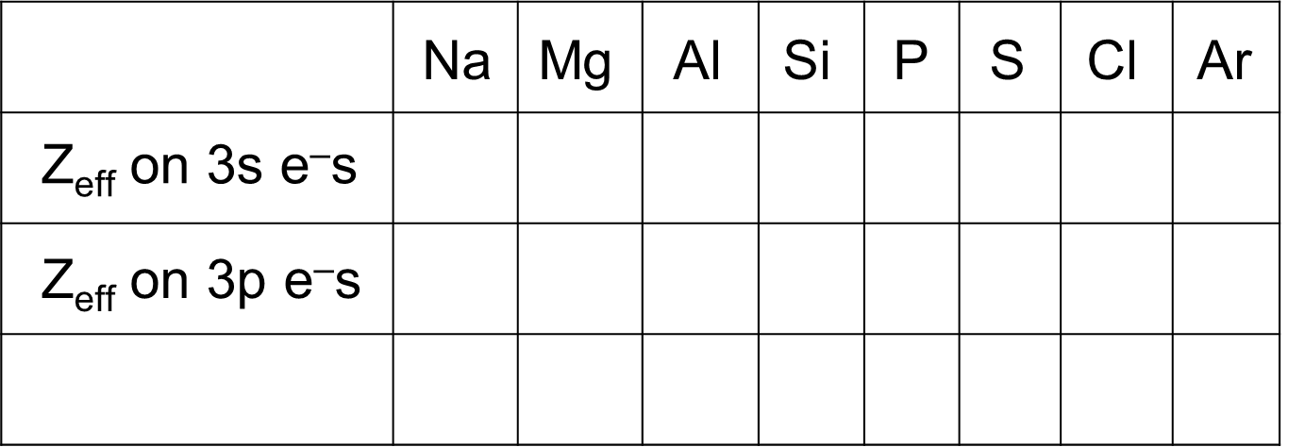

These Zeffs have implications with

regard to...

-- The (+) charge “felt” by the outer e–

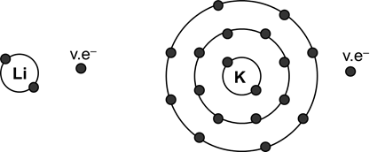 is always less than the nuclear charge.

This effect, due to the core

(or kernel) electrons, is called

the...

Quantum numbers are used to describe where an e– is in an atom.

Video

648

(12:04)

1. principal quantum number, *n* (*n* = integers 1, 2, 3,...)

-- correspond to the energy level of the electrons

-- All orbitals having the same *n* are called an electron shell (e.g., 2s and 2p).

2. angular momentum quantum number, *l*  (*l* = integers from 0 up to (*n* – 1))

-- This number defines the type of subshell:

-- For a given shell, the energies of orbitals go:

3. magnetic quantum number, *ml* (*ml* = integers from *–l* to *l*)

-- describes the orientation

of an orbital in space

-- You should know the shapes and

orientations of the s, p, and d orbitals:

s, px, py, pz, dyz, dxz, dxy, dx2–y2, dz2

4. electron spin quantum number, *ms*

-- only two values: +½ or –½ (“spin-up” and “spin-down”)

-- Pauli exclusion principle: No two electrons in an atom may have the same set

of four quantum numbers (i.e., an orbital may hold only

two electrons, and they must have opposite spins).

EX. What are the values of *n* and *l* for the following sublevels?

2s 3d 4p 5s 4f

EX. Write the possible sets of the four Write the four quantum numbers of each

quantum numbers for a 4p electron. of the six 3d electrons of an iron atom.