###### Electrochemistry Name: __________________________

*AP Chemistry Lecture Outline*



Video

2003

(7:16)

**Introduction to Electrochemistry**

During oxidation-reduction (redox) reactions,

the oxidation states of two substances change.

oxidation =

reduction =

**Rules for Assigning Oxidation Numbers**

1. Atoms in their elemental form have an oxidation number of zero.

2. For a monatomic ion, the oxidation number is the charge on the ion.

3. Nonmetals can have variable oxidation numbers.

a. Oxygen is usually 2–, but in the peroxide ion (O22–) it is 1–.

b. Hydrogen is 1+ when bonded to nonmetals, 1– when bonded to metals.

**

c. Fluorine is 1–. Other halogens are usually 1–, but are + when combined w/oxygen.

4. The sum of the oxidation numbers in a neutral compound is zero.

EX. Determine the oxidation number of nitrogen in each of the following.

N2O4 NH3 N2 KNO3

Video

2006

(9:38)

**Redox Reactions**

oxidizing agent (oxidant): is reduced (or has a component that is reduced)

reducing agent (reductant): is oxidized (or has a component that is oxidized)

e.g., Zn(s) + 2 H+(aq) 🡪

It goes without saying that... From this point on, we will omit...

anything with a charge...

EX. Identify the oxidant and the reductant. 2 H2O + Al + MnO4– 🡪 Al(OH)4– + MnO2

**NOTE**: A substance is oxidized/reduced if...



Strong oxidizers are good at being...

i.e., they are greedy for...

The strongest oxidizer is…

Other strong oxidizers (besides ___) are…

and oxyanions in which the central atom has a large ___ charge, e.g.,

 Strong reducers are good at being...

i.e., they would rather that at least one of their e–s would...

The strongest reducing agent is…

Other strong reductants are...

Video

2009

(9:42)

**Introduction to Half-Reactions**

Balancing Oxidation-Reduction Reactions

-- We must conserve mass AND conserve charge.

half-reaction:

EX. Write half-reactions for… Sn2+ + 2 Fe3+ 🡪 Sn4+ + 2 Fe2+

In an electrochemical setup, one half-cell contains the ‘before’ and

‘after’ varieties of the oxidized substance and the OTHER half-cell

contains the ‘before’ and ‘after’ varieties of the reduced substance.

In line notation, the oxidation half-cell is on the left and the reduction half-cell is on the right. The

typical pattern includes these various species... ***oxidation*** half-cell REDUCTION half-cell

There are several variations on line notation, but what NEVER changes is that...

EX. The simplest line notation for the last problem... Sn2+ + 2 Fe3+ 🡪 Sn4+ + 2 Fe2+...would be:

EX. Write the simplest line notation for the reaction between magnesium and hydrochloric acid.

Video

2012

(9:31)

**Steps in Balancing Equations by the Method of Half-Reactions**

1. Break overall equation into two half-reactions.

2. a. Balance everything but H and O.

b. Balance O by adding H2O as needed.

c. Balance H by adding H+ as needed (assuming acidic solution).

d. Add e– as needed.

e. Multiply each half-reaction by integers to cancel e–.

3. Add the two half-reactions and simplify.

*4. IF IN BASIC SOLN: Now, add enough OH– to cancel any H+. Simplify again.

EX. Balance this reaction, which takes place in acidic solution.

Cr2O72– + Cl– 🡪 Cr3+ + Cl2

EX. Balance this reaction, which takes place in basic solution.

Video

2015

(9:07)

CN– + MnO4– 🡪 CNO– + MnO2

**Introduction to Electrochemical Cells**

Video

2018

(5:50)

Suppose we place a bar of BEFORE AFTER

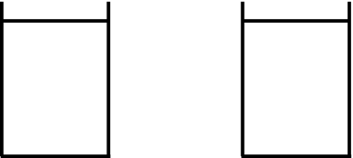zinc in a soln of CuSO4.

Over time, we observe that a

redox reaction occurs...

Net reaction:

No useful work/energy can be harnessed here because...

In line notation, we would write:

The above reaction takes place spontaneously; i.e., we set it up and...

From previous studies of thermodynamics, you recall that the SIGN of the change in the

Gibbs free energy for such thermodynamically favorable processes is...

If, instead of zinc, we placed a bar BEFORE AFTER

 of silver in a soln of CuSO4...

For THIS case, G is...

So...If an electrochemical process is spontaneous, can we somehow...

And if it ISN’T, is it possible for us to...

On both counts, the answer is...

We obtain useful work from spont. electrochemical reactions by setting up...

We force NONspontaneous electrochemical reactions to ‘go’ by setting up...

Video

2021

(10:59)

**Setting Up a Useful Electrochemical Cell**

Each half-reaction of any electrochemical cell (whether galvanic or electrolytic) needs

an electrode: a solid (usually metal) surface that acts as a means of getting e– into

and out of the reacting species.

anode: the electrode where __________ takes place, e.g.,

Assuming it isn’t an inert electrode,

the mass of the anode ___________ over time.

cathode: the electrode where __________ takes place, e.g.,

Typically, mass of cathode ___________ over time.

We are concerned with two types of conduction in setting up any electrochemical cell.

metallic conduction: involves electrons flowing through a metal, e.g.,

--

--

ionic conduction: involves motion of ions flowing in a salt soln or molten liquid

**A Spontaneous Electrochemical Cell**

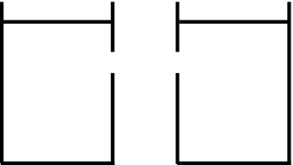If ‘D’ has very low resistance, it is...

If ‘D’ has a higher resistance, it is...

In a galvanic/voltaic cell, we definitely need the anode and cathode compartments to be separated.

-- We want the e–s to have...

A salt bridge or porous disk...

**A NONspontaneous Electrochemical Cell**

Here, ‘D’ is an external power supply, which...

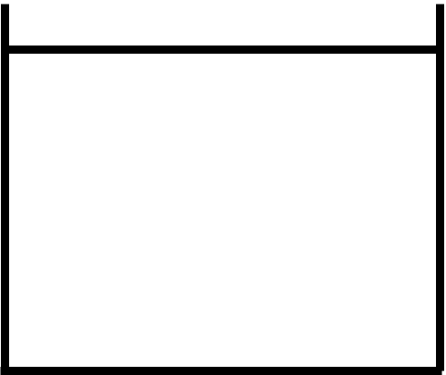

In an electrolytic cell, it is NOT as essential to physically separate the anode and cathode

compartments because we often don’t care WHAT mixes with WHAT, as long as we

accomplish what we want, i.e.,

Video

2024

(6:49)

**Galvanic/Voltaic Cells: What’s the Use?**

‘Oxidized thing’ and ‘reduced thing’ are

NOT in direct contact, so we use wires

to connect them and then...

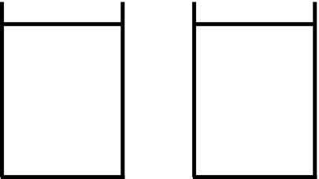

‘D’ never...

Electrodes are connected by ______, solns by ____________.

The most familiar galvanic/voltaic cells are ________.

We can think of the PEanode’s e– PEcathode’s e–.

**Electrolytic Cells: What’s the Use?** Electrolytic cells (and its process,

Video

2027

(8:57)

electrolysis) have many practical uses.

1. electrorefining of metals

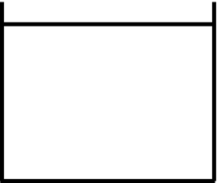An impure anode (of, say, Cu or Zn) with an

ultrapure cathode of...

Typically, only the desired metal plates out because...

Soluble impurities...

Insoluble impurities...

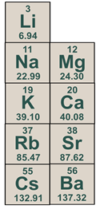

2. reducing the active metals

Less-active metals (e.g., _____) can be reduced via cheaper chemical reduction.

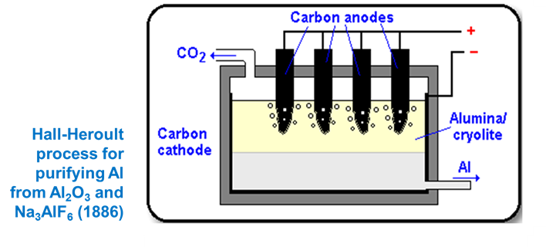Isolating the active metals requires

electrolytic reduction because...

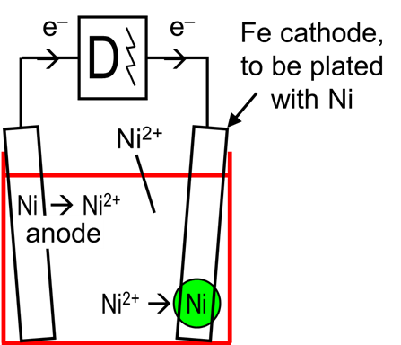

3. electroplating of metals

In electroplating, we deposit a neutral metal onto

the cathode by reducing metal ions from a soln,

i.e.,

Video

2030

(7:22)

**The Stoichiometry of Electrolysis**

In his work with electrolysis, Michael Faraday found that the mass of metal reduced was:

1. directly proportional to the current that flows through the liquid

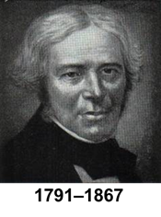

2. directly proportional to time

3. directly proportional to molar mass

4. inversely proportional to the metal ion’s oxidation #

To solve electrolysis problems...

EX. For how long must a 50.0 A current be passed through molten BaBr2 in order to produce

500. g of barium?

EX. Using a current of 31.2 A for 1.92 h will plate out on the cathode 38.7 g of a metal. If the ions

have a valence of 3+, what is the metal?

Video

2033

(9:10)

**The Standard Hydrogen Electrode**

Suppose we set up an electrochemical

cell with a Zn electrode in a 1 M ZnSO4

soln and a Cu electrode in a 1 M CuSO4 soln.

We observe that current flows spontaneously, that Zn is the

anode, and Cu the cathode, i.e.,

We also find that if we connect a voltmeter to the electrodes, it reads a potential of 1.10 V.

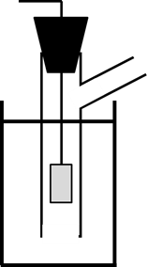It’s reasonable to surmise that the 1.10 V value is due partially to what’s happening to the Zn (________) and partially to what’s happening to the Cu (________).

We can’t know, because...

Enter the standard hydrogen electrode (SHE)...

By international agreement, the potential for

the SHE – by itself – is...

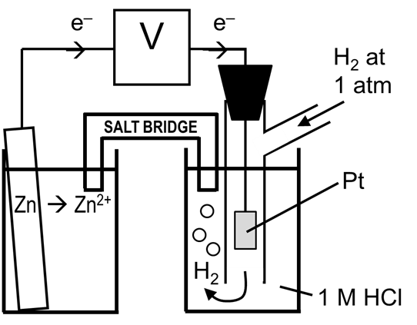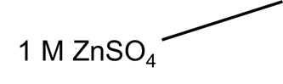

So let’s hook up our Zn half-cell to the SHE. We make

the [Zn2+] in the soln 1 M, just like the 1 M [H+] in the

other half-cell. We observe Zn being oxidized to Zn2+

( ) and H+ being reduced to

H2 gas, because we notice...

The voltmeter reads...

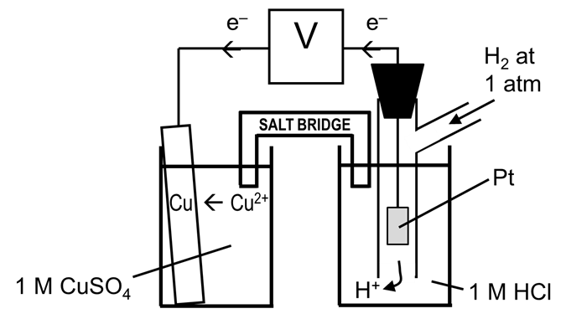

Now we hook up our Cu half-cell to the SHE.

Again, we make the [Cu2+] in the soln 1 M. We

observe that Cu2+ ions are being reduced on the

Cu electrode, so that must be the ________.

The H2 gas must be being oxidized, because we

notice that...

The voltmeter reads...

Voltmeter readings for half-cells paired up with a SHE are standard potentials, Eo.

Here, ‘standard’ means: 1.

2.

3.

We measured: Zn 🡪 Zn2+ + 2 e– Eo =

Cu2+ + 2 e– 🡪 Cu Eo =

By convention, all Eo values are written as reductions: Zn2+ + 2 e– 🡪 Zn Eored =

Cu2+ + 2 e– 🡪 Cu Eored =

All half-cell rxns have been tested relative to a SHE, and their standard reduction potentials tabulated.

**The Standard Reduction Potentials Table**

Video

2036

(6:28)

The standard reduction potentials can be found in a table. Let’s examine the

structure of this table...

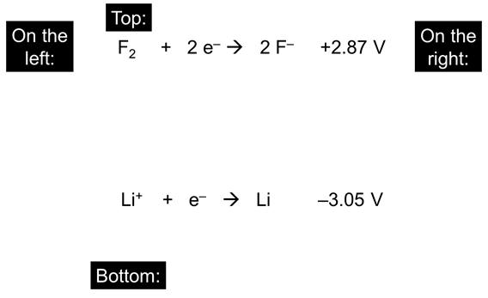

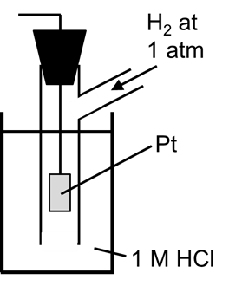

As mentioned previously, the reference point for reduction

potentials is the standard hydrogen electrode (SHE):

2 H+ + 2 e– 🡪 H2

Multiples of coefficients DON’T affect Eored.

e.g.,

We use the standard reduction potentials when finding the cell potential for a given cell,

i.e., the potential of the two connected half-cells in an electrochemical setup.

The simplest cell potential is the standard cell potential, which is the potential (i.e., the ‘voltage’)

when all substances are in their standard states, i.e., 1. any [soln] =

2. any reacting gas =

3. temperature =

The standard cell potential depends on the two half-cells that are involved.

ONE of the half-rxns will be an oxidation and will thus have...

**Calculating Standard Cell Potentials**

Video

2039

(10:52)

EX. Determine the standard cell potential for the cell given by the equation:

Cr + Cu2+ 🡪 Cr2+ + Cu

The relevant equations from the table are: (a) Cu2+ + 2 e– 🡪 Cu

(b) Cr2+  + 2 e– 🡪 Cr

From the given overall equation, we see that (a)...

Thus, (b)...

You then...

So Eocell =

EX. Determine the standard cell potential for the cell given by the equation:

3 Fe + 2 Cr3+ 🡪 3 Fe2+ + 2 Cr

The relevant equations from the table are: (a) Fe2+ + 2 e– 🡪 Fe

(b) Cr3+  + 3 e– 🡪 Cr

From the given overall equation, we see that (a)...

Thus, (b)...

So Eocell =

EX. A voltaic cell has the half-rxns: (a) Al3+  + 3 e– 🡪 Al Eored = –1.66 V

(b) Ba2+ + 2 e– 🡪 Ba Eored = –2.90 V

Calculate Eocell and write the balanced equation.

EX. In acidic solution, will Fe3+ spontaneously oxidize NO to NO3–, or will NO3– oxidize Fe2+ to

Fe3+? Also, determine Eocell.

The relevant equations from the table are: (a) Fe3+ + e– 🡪 Fe2+

(b) NO3– + 4 H+ + 3 e– 🡪 NO + 2 H2O

**Cell Potential and Free Energy**

Video

2042

(7:31)

 Previously, we introduced Faraday’s constant:

...and thus also represent Faraday’s constant as...

If we multiply this by the # of moles of e– moved (n) and also by the cell potential

(E, which is in the unit __), we will obtain the unit __, i.e., we get a quantity of...

For a known cell potential E and a known reaction (i.e., we know the number of moles of

e– transferred), we can thus easily determine the...

And since we know... thermodynamically favorable: ...the general equation

NOT thermodynamically favorable: is:

This is an easy way to...

NOTE: This equation applies at both standard and non-standard conditions,

i.e., it could be used as either...

EX. Determine the # of moles of e– transferred and the standard change in Gibbs free energy for

the rxn... 5 Fe2+ + MnO4– + 8 H+ 🡪 5 Fe3+ + Mn2+ + 4 H2O

The relevant equations from the table are: Fe3+ + e– 🡪 Fe2+ Eored = +0.77 V

MnO4– + 8 H+ + 5 e– 🡪 Mn2+ + 4 H2O Eored = +1.51 V

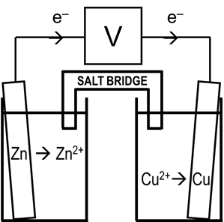

Video

2045

(9:32)

**The Nernst Equation**

Dependence of E on Concentration

Standard potentials (Eo) occur under standard conditions: 1 M solns,

1 atm pres., and 25oC. Let’s consider conceptually how E will be

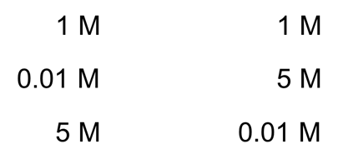affected by [ ]s other than 1 M. Here we have:

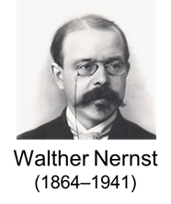**Derivation of the Nernst Equation**

While we can tell conceptually how a cell potential E will be affected by

nonstandard [ ]s, the Nernst equation allows us to determine E under

ANY nonstandard conditions, whether they be [ ]s, temps, or gas pressures.

In units on thermodynamics, the change in the Gibbs free energy under

nonstandard conditions was found using...

We’ve previously learned that...

Substituting yields...

Dividing through by –nF produces the Nernst equation:

where R = 8.314 J/mol-K

T = absolute temp. n = # of mol of e–

F = 96,485 J/V-mol e–  Q = rxn. quotient

Consider again the Zn/Cu cells above, at 25oC:

When [Zn2+] = 1 M and [Cu2+] = 1 M...

When [Zn2+] = 0.01 M and [Cu2+] = 5 M...

When [Zn2+] = 5 M and [Cu2+] = 0.01 M...

Video

2048

(5:04)

EX. Fe + Cd2+ 🡪 Cd + Fe2+ Find the cell potential at 55oC when

[Cd2+] = 2.0 M and [Fe2+] = 0.030 M.

The relevant equations from the reduction table are: Fe2+ + 2 e– 🡪 Fe

Cd2+  + 2 e– 🡪 Cd

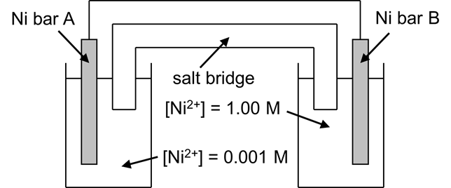 **Concentration Cells**

Video

2051

(7:58)

concentration cell:

-- Eo for a [ ] cell =

-- Charge flows until...

-- In the above example, cell will act to equalize [Ni2+]s, so… Bar A:

Bar B:

Add...

Thus, in general…

At equilibrium…

EX. A [ ] cell has Cell A with [Fe3+] = 2.35 M and Cell B with [Fe3+] = 2.25 x 10–3 M. Identify the

anode and cathode, and calculate the emf, at 37oC.

Video

2052

(5:34)

**Go, Eo, and the Equilibrium Constant K**

In this unit, we have already used the equation G = Go + RT ln Q (with help

from G(o) = –nFE(o)) to derive the Nernst equation:

In units on thermodynamics, it is often shown that,

at equilibrium (where G = 0 and Q = K) the same

equation (G = Go + RT ln Q) will yield the results:

These are two versions of a single equation that relates the standard change

in Gibbs free energy to the value of the equilibrium constant. We now add to this...

Using once again the fact that Go = –nFEo, Similarly, we change

we now turn Go = –RT ln K into...

and finally into... into...

Armed with these equations, if we know any ONE of Go, Eo, or K...

EX. Determine the value of the equilibrium constant at 25oC for the reaction:

2 Ag+ + Fe 🡪 Fe2+ + 2 Ag

The relevant equations from the table are: Fe2+ + 2 e– 🡪 Fe Eored = –0.44 V

Ag+ + e– 🡪 Ag Eored = +0.80 V

Video

2054

(4:47)

 **Basics of Corrosion**

Most metals oxidize rather easily in air.

-- There are some exceptions, e.g.,

Au3+ + 3 e– 🡪 Au Eored = + 1.50 V

O2 + 4 H+ + 4 e– 🡪 2 H2O Eored = + 1.23 V

corrosion: spontaneous redox rxns in which metals react w/something

in the environment to form...

e.g, Ag2S

 Galvanic corrosion can Within a given metal, corrosion is

occur when two different initiated most readily at points of strain.

metals are in contact. --

--

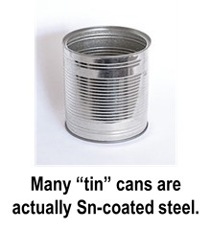 **Protecting Against Corrosion**

Video

2057

(9:57)

“How do we try to protect metals from corrosion?”

1. painting

2. plate with a thin layer of less-easily-oxidized metal

e.g., ____ and ____ form durable oxide coatings when plated onto steel

** When/if the less-easily-oxidized metal is breached, corrosion occurs...

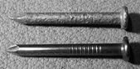3. galvanizing: coating with more-active Zn

--

** Once Zn has corroded away...

4. Some metals (e.g., Al and Mg) naturally form a protective metal-oxide coating.

-- Coating is thin and thus transparent, but it is very tough and...

The oxide coating is sometimes

called a passive film, and the

formation of the film is termed...

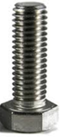

5. Some alloys have corrosion-resistance.

-- Stainless steels contain ___ and ___, which form passive oxide films on the surface.

-- We can also produce corrosion-resistant surface alloys over top of...

The ultimate goal is passivation, using...

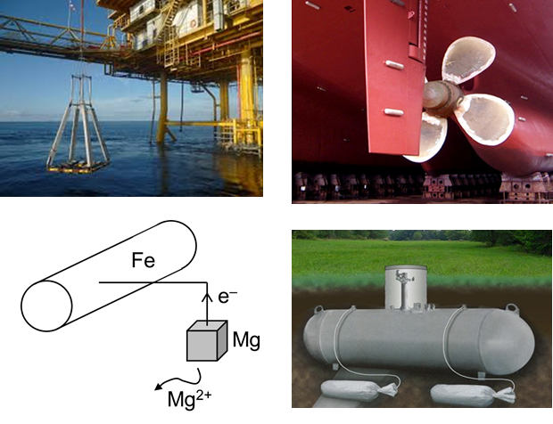6. cathodic protection: protecting a metal by connecting

it to a more active metal; the more

active metal corrodes...

-- The protected metal becomes the cathode.

-- The more active metal is oxidized and

is called the ___________________.

-- Metals often sacrificed:

examples of cathodic protection:

**Primary Cells**

Video

2060

(8:07)

Strictly speaking, a battery consists of _________ electrochemical cells arranged

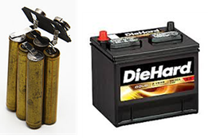 together to provide a source of direct current, but the term is also commonly used to

denote...

Examples of batteries-in-the-strict-sense:

Primary cells...

D-cells AAs AAAs 12-V battery 9-V battery

Once the reactants in a primary cell have been altered in the reaction, further chemical action

is impossible, and their properties are such that...

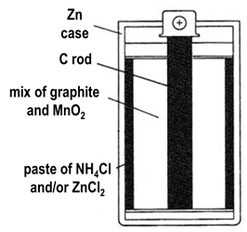**Types of Primary Cells**

Zinc-carbon cells were the first commercial cells to be developed.

-- The outer casing of Zn is the anode, so the Zn is...

-- A rod of carbon in the center is the cathode, but the reduction half-reaction

actually involves...

If the paste is primarily ZnCl2, the cells are marketed as ____________.

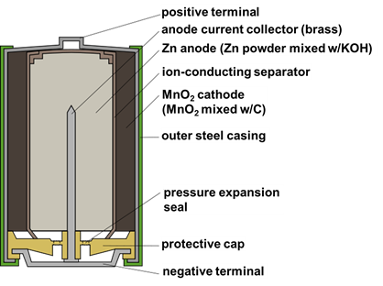--

Alkaline cells are so-named because they contain the

basic substance KOH instead of the acidic NH4Cl found

in Zn-C cells. They also have a...

Compared to “heavy-duty” Zn-C cells, alkaline cells have

a service life that is about...

They also have...

All single Zn-C cells and alkaline cells have a potential of about _____ because the same basic chemicals (namely, ____ and ______) are used. We say ‘about’ because there can be...

--



For a battery (i.e., several single cells in series), we simply…

-- A 9-volt battery is...

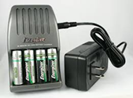 **Secondary Cells**

Video

2063

(10:09)

Secondary cells...

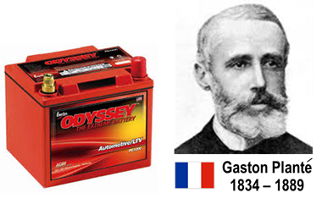-- The orig. reactants can be regenerated by forcibly passing direct current...

Let’s go into some detail about the lead-acid battery, or lead storage battery.

-- first rechargeable cell

-- well-known today for their use in...

Lead-acid batteries in cars consist of alternating plates of ___ and

_____, usually divided into six cells. The anode is the ___; the cathode the _____. Thus, electrons depart the battery from the ___, flow through the external circuit, and re-enter at the _____.

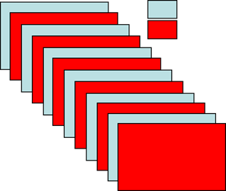

Each cell yields a

potential of about

____, so the battery

(i.e., the six cells

Each of the six separate wired in series) yields

cells is bathed in... a total potential of ____.

The oxidation and reduction Pb + HSO4– 🡪 PbSO4 + H+ + 2 e–

half-reactions are, respectively: PbO2 + HSO4– + 3 H+ + 2 e– 🡪 PbSO4 + 2 H2O

The overall rxn eq is thus:

When a car is running, its ________ applies a potential in the opposite direction, forcing the rxn...

We see that in the reverse reaction, PbSO4 acts as a necessary reactant. The problem

is that the PbSO4 has to be...

And after many charge/discharge cycles and physical jarring from bumpy roads...

Then the [HSO4–] ___, and the battery...



We can gauge the remaining useful life of a lead-acid battery

by measuring the _______ of the acid in each cell.