**Weak Acids and Bases**Name: _______________________

*AP Chemistry Lecture Outline*

Video

1603

(10:25)

**Weak Acids**

-- most acids are weak

-- For a weak acid HX... HX(aq) H+(aq) + X–(aq)

-- acid-dissociation constant Ka =

large Ka:

small Ka:

The % of a weak acid that is ionized is given by the equation:

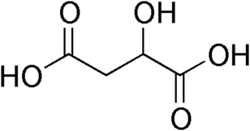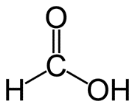For organic acids (containing only C, H, and O),

the “donated” H was connected to...

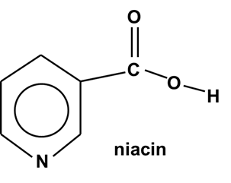

EX. A 0.020 M niacin solution has pH 3.26. (a) What % of the acid is ionized?

(b) What is Ka?

Video

1606

(6:50)

EX. If Ka for niacin is 1.6 x 10–5, find the pH of a 0.010 M niacin solution.

The conc. of a weak acid affects its % ionization.

Video

1609

(4:31)

As [acid] conc. , % ion. ____; as [acid] conc. , % ion. ____.

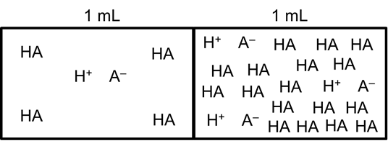

-- more ___________ -- more ___________

-- ____ ionized = ____ -- ____ ionized = ____

(i.e., _______ % of (i.e., _______ % of

H+s popped off) H+s popped off)

-- has ______ [H+], -- has ______ [H+],

(i.e., _____ per _____) (i.e., _____ per _____)

and thus... and thus...

Video

1612

(8:50)

EX. Calculate the % of HF molecules ionized in

– and the pH of – a 0.10 M HF solution. (Ka = 6.8 x 10–4)

EX. Calculate the % of HF molecules ionized in – and the pH of – a 0.010 M HF solution.

(Ka = 6.8 x 10–4)

Polyprotic acids – like sulfurous acid, H2SO3 – have more than one ionizable H.

Video

1615

(8:15)

H2SO3(aq) H+(aq) + HSO3–(aq) (Ka1 = 1.7 x 10–2)

HSO3–(aq) H+(aq) + SO32–(aq) (Ka2 = 6.4 x 10–8)

--

-- Usually, Ka2 is at least 1000X smaller than Ka1. In such cases, one can calculate [H+]

and pH based only on Ka1 (i.e., ignore Ka2 and pretend you have a monoprotic acid).

EX. Find the pH of a 0.0037 M carbonic acid solution. (Ka1 = 4.3 x 10–7, Ka2 = 5.6 x 10–11)

Video

1618

(7:56)

**Weak Bases**

weak base + H2O conjugate acid + OH– Kb =

Weak bases are often nitrogen-containing

molecules (“amines”) or anions.

**..**

H

H

H

+

Example: H–N–CH3 (aq) + H2O(l) H–N–CH3 (aq) + OH–(aq)

EX. What is the equilibrium concentration of ammonia in a solution of pH 9.35? Ammonia’s

Kb = 1.8 x 10–5.

**The Ka / Kb Relationship for Conjugates**

Video

1621

(10:04)

(1) NH3

(2) NH4+

Ka = Kb =

Then Ka x Kb =

For an acid and its conj. base:

Because they are easily calculated from Ka Just like pH = –log [H+],

values, reference tables are often “short” on Kb values.

EX. For hydrofluoric acid, Ka = 6.8 x 10–4.

a. Write the formula of the conjugate base.

b. Write the equation for which Kb applies.

c. Write the equation for which Ka applies.

d. Find pKa, pKb, and Kb.

Video

1624

(6:30)

Ions related to weak acids or bases can themselves exhibit acidic or basic properties.

which is related The ion would ...and would

One such to ____, which tend to thus exhibit

ion is... is a ‘weak’. _____ H+... _____ properties.

CO32–

HCO3–

ClO–

ClO2–

NH4+

CH3COO–

** NOTE: The ions we are dealing with here MUST be related to weaks, NOT strongs. Thus,

ions such as Cl– or NO3– or K+ or Sr2+ do NOT exhibit acidic or basic properties.

Because weak-related ions transfer H+s (as mentioned above, strong-related

ions DO NOT), solutions of salts containing ‘weak’ ions can be acidic or basic.

For example, consider adding a spoonful of the salt sodium hypochlorite to water.

The salt immediately does this...

The strong-related ion has no effect on H+ transfer, but the

weak-related ion DOES, in this way...

We expect a solution of sodium hypochlorite to have a pH...

Video

1627

(6:24)

EX. What mass of solid potassium fluoride is required to make 5.0 L of a pH 8.35

solution?

To predict the pH of a salt solution, look at the formula of the salt.

Video

1630

(6:30)

For salts with ions related to a...

(1) ...strong base and a weak acid, e.g.,

we predict a pH...

(2) ...weak base and a strong acid, e.g.,

we predict a pH...

(3) ...strong base and a strong acid, e.g.,

we predict a pH...

(4) ...weak base and a weak acid

--

e.g.,

Video

1633

(4:02)

EX. Would we predict an NH4CN soln to be acidic or basic?

What related info is found in the ref. tables?

But we have _____, not ____, and _____ would _____ a proton, so we need its ___.

And we have _____, not ____, and _____ would _____ a proton, so we need its ___.

Anions that still have ionizable protons (e.g., HSO3–) are amphoteric.

Video

1636

(5:34)

--

Equation for Ka:

Equation for Kb:

EX. Does KHSO3 form an acidic or a basic solution in water?

From a reference table, we find... (a) H2SO3 H+ + HSO3–

(b) HSO3– H+ + SO32–

*General Factors Affecting Acid Strength*

Video

1639

(7:13)

1. To transfer H+, acid must have the polarity...

-- ionic hydrides don’t

-- C–H bonds don’t

As polarity increases, acid strength *generally* increases. BUT...

2. ...if H–X bond is too strong.. (e.g., )

3. Stable (i.e., weak) conjugate bases (e.g., ) indicate a...

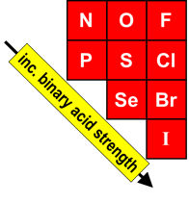For binary acids:

(1) In a group, bond strength is the determining factor.

As we go down a group... H2S

...charge separation ___,

so bond strength ___

and acid strength ___. H2Se

(2) In a period, bond polarity governs.

As we go L to R across a period... H2O HF

...bond polarity ___ and acid strength ___.

oxyacids:

Video

1642

(8:24)

Consider H2SO4 (an acid) and Ca(OH)2 (a base).

O

H–O–S–O–H H–O–Ca–O–H

O

The EN between S and O is The EN between Ca and O is

__________ than that between O __________ than that between O

and H. This means that... and H. This means that...

When comparing related **Anything that draws e– density AWAY from**

oxyacids, remember this... **the “donate-able” H makes for a stronger acid.**

Related-Oxyacids *For oxyacids with the same # of O atoms, acid strength*

Comparison #1: *increases with increasing electronegativity of the central atom.*

e.g., HClO

HBrO H2SeO3

HIO H2SO3

Related-Oxyacids *For oxyacids with the same central atom, acid strength increases*

Comparison #2: *as the # of oxygens attached to the central atom increases.*

e.g., HBrO HIO3

HBrO2 HIO2

Related-Oxyacids This comparison deals with carboxylic acids, which

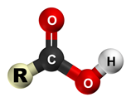 Comparison #3:contain the ________________________.

-- these are the largest category of organic acids

-- acid strength increases from adding add’l high-EN atoms

e.g., CH3COOH

CHF2COOH

CF3COOH

**Lewis Acids and Lewis Bases**

Video

1645

(7:42)

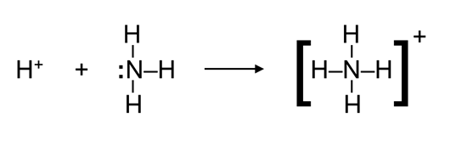

The Lewis definitions greatly broaden the range of acids because many

species other than H-containing ones can accept an e– pair.

Another example:

The simple term “acid” suggests that we are referring to an Arrhenius or a

Bronsted-Lowry acid, i.e., an H-containing substance in an aqueous solution.

If you are referring to a Lewis acid, then use the term “Lewis acid.”

Substances with an incomplete octet (e.g., BF3) or ones having

vacant orbitals (e.g., Fe3+) can function as Lewis acids.

--

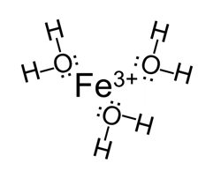-- The (+) charge attracts (i.e., accepts) the lone pairs of e–

on the O of a water molecule. This process is hydration:

the “glomming” of H2O m’cules onto metal ions.

Cation size and cation charge determine the extent to which the pH is affected.

Fe3+

K+

-- short distance -- larger distance

-- strong interaction -- weaker interaction

-- --