**Chemical Kinetics** Name: _______________________

*AP Chemistry Lecture Outline*

Video

1403

(9:31)

**Introduction to Reaction Rates**

collision model: addresses how/why particles react and

how various factors affect reaction rate

Under applicable conditions, the reaction rate for a given system will ***increase*** when…

...temperature...

--

...reactant concentration...

...reactant surface area...

(i.e., as particle size… )

…extent of reactant mixing…

activated complex:

Ea of reverse reaction

Ea

E

**Energy**

**Time**

**R**

**P**

About E...

-- it is ___ for endo.

and ___ for exo.

--

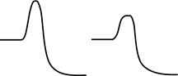

catalyst:

For a reaction to occur, collisions must take place with particles oriented in a certain way.

e.g., Cl + NOCl Cl2 + NO

Reaction rates are usually expressed in M/s.

**Conc. of Substance x v. Time**

Video

1406

(7:05)

[x] is (–) if x is a…

[x] is (+) if x is a…

instantaneous rate: the reaction rate at any given time

**Conc. of Substance x v. Time**

-- it is equal to the slope of the [ ] – time curve at any point

For point P, one finds the instantaneous rate by:

-- constructing a tangent line

-- picking two points on the line

-- finding their coordinates

-- calculating the slope as…

Coefficients in the balanced equation are used when comparing rates for substances in a reaction.

EX. At a given time, the instantaneous rate of appearance of nitrogen dioxide is 3.2 x 10–6 M/s.

Find the instantaneous rates of disappearance of nitrogen monoxide and oxygen at that time.

Video

1409

(9:39)

**Finding Rate Laws from Experimental Data**

Reaction rates are proportional to the [ ] of reactants.

rate law:

-- contains a rate constant, k:

k is independent of reactant ___, but increases

w/increasing _____ and w/presence of ________.

-- A rate law has the form… where m and n are...

-- Usually, reaction orders are 0, 1, or 2,

but some are fractions or are (–).

If a reaction is zero order in a particular reactant, changing its concentration...

1st order: 2nd order: 3rd order:

|  |  |  |
| --- | --- | --- |
| **[H2] (M)** | **[Cl2] (M)** | **Init. rate of HCl formation (M s–1)** |
| 0.100 | 0.100 | 0.340 |
| 0.100 | 0.200 | 0.680 |
| 0.200 | 0.200 | 2.720 |

EX. H2(g) + Cl2(g) 2 HCl(g)

Find... (1) rxn order of each reactant (2) overall reaction order

(3) units of rate constant

**Integrated Rate Law: 1st Order Reactions**

Video

1412

(9:35)

Rate laws can be converted into equations that give the concentrations

of substances at any time during the course of a reaction.

***First-Order Reactions***

-- Rate laws for 1st order rxns have the form:

-- To find rxn [ ]s over time, use…

Plotting ln [A]t v. t gives a straight line w/slope…

EX. (CH3)2O(g) CH4(g) + H2(g) + CO(g) If this is a first-order process, with

k = 6.8 x 10–4 s–1 and w/the initial

pressure of (CH3)2O being 256 torr, find

the partial pressure of (CH3)2O after

36.5 min.

Half-life of a reaction, t1/2: the time required for a reactant’s [ ] to drop to ½ of its orig. value

For 1st order rxns: For 1st order reactions:

-- t1/2 is independent of initial concentration

-- the [ ] of reactants is cut in half...every half-life

EX. Find the half-life for the decomposition of dimethyl ether (CH3)2O, based on data from the

previous problem.

Video

1415

(10:00)

***Second-Order Reactions***  (that are 2nd order in just one reactant)

i.e.,

and

Plotting 1/[A]t v. t gives a straight line w/slope…

EX. Data were taken on the decomposition of an initial 2.45 M solution of reactant X. Several

graphs were made. The [X] vs. time graph was curved, with a generally (–) slope; the ln [X]

vs. time graph, too, was curved with a generally (–) slope; the 1/[X] vs. time graph was linear,

with a (+) slope of 4.33 x 10–3 M–1s–1. Determine the rxn’s initial half-life and the [X] at 105 s.

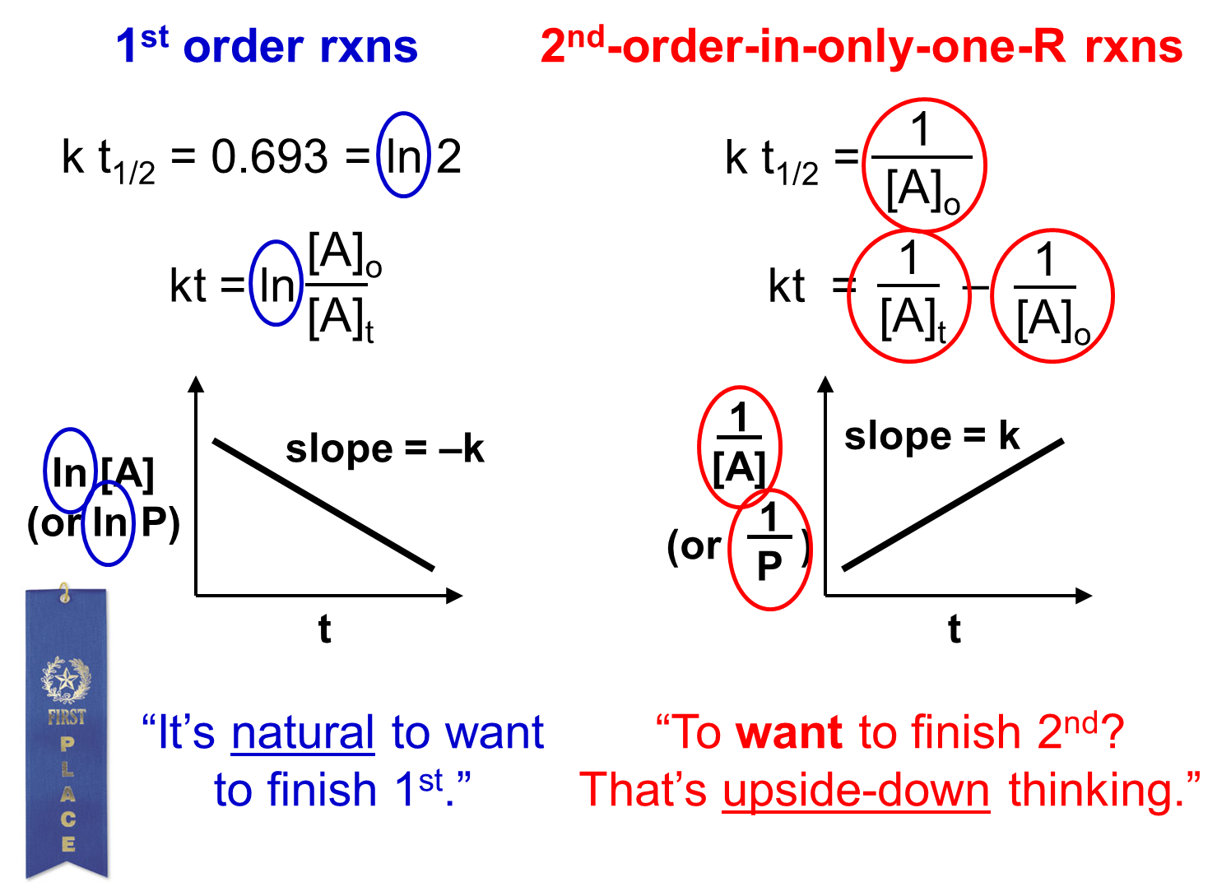

Video

1418

(5:23)

**The Maxwell-Boltzmann Distribution and Rates**

On a Maxwell-Boltzmann distribution of reactant particle velocities, all particles above

a certain threshold of energy have enough energy to potentially initiate a rxn.

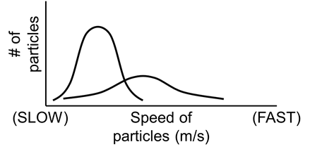

Video

1421

(6:35)

**The Arrhenius Equation** For a given reaction, the Ea relates rate constants

at two different temps WITH those temps.

Ea in J/mol

R = 8.314 J/mol-K

T = absolute temp.

EX. Using the following information, find... (1) ...Ea

T (oC) k (s–1)

189.7 2.52 x 10–5

251.2 3.16 x 10–3

(2) ...k at 430.0 K

Video

1424

(4:52)

**Reaction Mechanisms** -- the processes by which reactions occur

--

-- sometimes, mechanisms are dependent on temp.

elementary steps (or elementary reactions):

A reaction’s molecularity is defined by unimolecular

the number of particles that participate bimolecular

as reactants in an elementary step. termolecular

Rate laws for the elementary steps are found as follows...

|  |  |  |
| --- | --- | --- |
| **Molecularity** | **Elementary Step** | **Rate Law for that**  **Elementary Step** |
| uni- | A 🡪 P |  |
| bi- | A + A 🡪 P |  |
| bi- | A + B 🡪 P |  |
| ter- | A + A + A 🡪 P |  |
| ter- | A + A + B 🡪 P |  |
| ter- | A + B + C 🡪 P |  |

In other words, IF we know that “HERE is an equation for an elementary reaction”, THEN

(and ONLY then) we can write the rate law for that step based solely on the balanced equation.

**Multistep Mechanisms**

Video

1427

(9:05)

For multistep mechanisms, sequences of

elementary steps are needed to go from R to P.

e.g., For the reaction NO2 + CO NO + CO2

Elem. Step 1:

Elem. Step 2:

Above, NO3 is an intermediate. All multistep mechanisms have them.

Most reactions have multiple elementary steps. The slowest of these is the...

The correct rate law for a reaction must: 1) be based on…

2) have ONLY…

EX. CHCl3(g) + Cl2(g) CCl4(g) + HCl(g) has the following elementary steps:

E. S. 1: Cl2 2 Cl (fast, eq)

E. S. 2: CHCl3 + Cl 🡪 CCl3 + HCl (slow)

E. S. 3: CCl3 + Cl 🡪 CCl4 (fast)

State the rate law and the units on the rate constant.

**Catalysis** the process by which a catalyst changes the

Video

1430

(7:57)

rate and mechanism of a chemical reaction

-- a catalyst is…

-- Catalyzed and uncatalyzed reactions have…

Homogeneous catalysts are present in the same phase as the reacting molecules.

Heterogeneous catalysts exist in a different phase than the reacting molecules.

--

The first step in catalysis is _____________ of the reactant molecules onto

the _______________ (i.e., the “docking points”) on the catalyst molecules.

--

-- then, the products detach from the catalyst

enzymes:

-- large protein molecules -- names end in... “____”

-- usually very specific -- substrates: substances (i.e., reactants) that

react at the active sites of enzymes

-- The lock-and-key model explains how an enzyme affects a substrate molecule and changes it

into a new substance.

**Lock-and-Key Model**

turnover number:

Enzyme inhibitors bind to the active site or alter the unique shape of an enzyme molecule, destroying

the enzyme’s activity. e.g.,